Intel and NVIDIA

Registry keys editing
Processor registry keys
Graphic cards registry keys

Ansly Azorie

Contents
Contents 2
Warning - Cooler 6
How to speed up your Intel processor using Registry Keys 8
Checking processor speed 8
In case you need to edit Registry 8
Beginning speed of the processor 9
ControlSet001\Control\Power 10
Old settings 11
EfficiencyClasses 13
Residual energy 22
StandbyActivationEnergy 22
WorkOnBehalf 22
VetoPolicies 23
EA 23
About PowerSettings 26
PowerSettings 26
Processor performance increase threshold 28
Processor performance increase threshold for Processor Power Efficiency Class 1 28
Specify the minimum number of unparked cores/packages allowed 29
Specify the minimum number of unparked cores/packages allowed 29
Processor performance core parking min cores for Processor Power Efficiency Class 1 29
Processor performance decrease threshold 29
Processor performance decrease threshold for Processor Power Efficiency Class 1 29
Hybrid containment zone important utility percentage 30
Processor Restriction Count 30
Initial performance for Processor Power Efficiency Class 1 when unparked 30
Processor performance core parking concurrency threshold 30
Processor performance core parking increase time 30
Processor energy performance preference policy 30
Processor energy performance preference policy for Processor Power Efficiency Class 1 31
Processor energy performance preference policy for Processor Power Efficiency Class 2 31
Allow Throttle States 31
Processor performance increase time for Processor Power Efficiency Class 1 31
Processor performance decrease policy 31
Graphic cards 36
Checking processor speed 36
In case you need to edit Registry 36
Avalon.Graphics - HardwareAcceleration 36
1. Old settings 37
2. Old Settings 2 37
3. Old settings that worked 38
4. Old settings that made no point: 38
DirectX 40
Old settings and unnecessary images: 41
Intel Graphics Software 43
1. Themed colors 43
2. “Greenbrand” profile 44
3. Universal Colors 45
4. Super real 46
5. Ekta space profile settings 47
6. Old alright settings 48
1. Old settings 52
2. Old settings 54
3. Old settings 55
4. Old settings 56
“GraphicDrivers” Key 57
Default (Windows) Values 58
inetcpl.cpl 60
Intel graphics settings: 61
Enabling “Quantum Wall” idea 61
“HKEY_CURRENT_USER\Software\Intel\Display\igfxcui” 92
Theory and explanation 98
Beginning idea of editing binary files 98
“HKEY_LOCAL_MACHINE\SOFTWARE\Intel” Folders 128
Igfxcui/MISC 158
igfxcui/Media - Old photos and not good settings 161
NVIDIA 165
Checking processor speed 165
CoProcManager 165
1. Satisfying solution: 165
2. Old setting: 167
3. Old setting: 168
4. Old setting: 170
5. Old setting: 172
6. Previously not well created settings: 174
7. Other settings: 176
• Windows settings 181
NVIDIA Control Panel 3D settings 182
Description 182
Commands 183
Settings 186
Color Mangement profiles 209
Find “Color Management” application: 209
Click “All profiles”: 209
Click “Add” and find folder with all profiles, select them and add them: 210
Go to Advanced settings: 211
Windows default profile, following Intel CFCA profile 211
Windows default profile, a bit edited is: 212
Different beings universal profile is: 213
A more human-like primitive profile is: 214
My back at the time personal following color management idea: 215
Result 219
Special thanks 220

Warning - Cooler
Increasing speed of the laptop CPU can overheat the laptop, so, without a good cooler below laptop will simply shut down because of overheating… I am suggesting you to buy at least:
https://www.coolermaster.com/en-global/products/notepal-i300/?tab=tech_spec

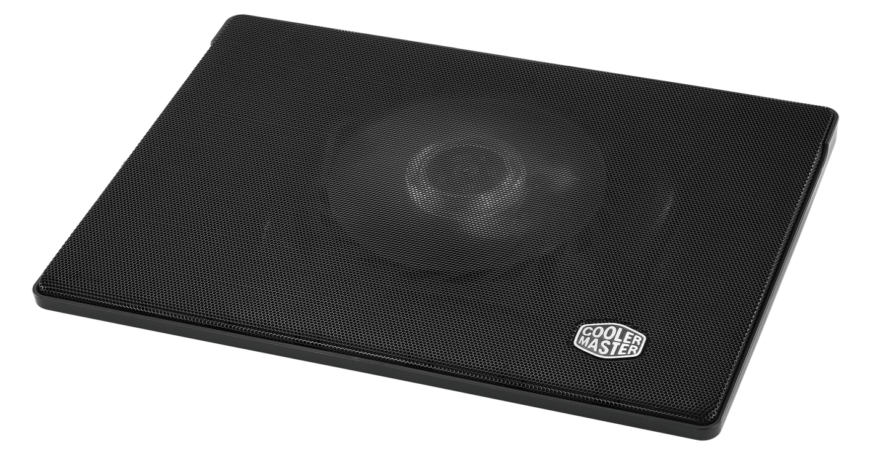
Specifications:
- Fan Dimensions (L x W x H)160 x 160 x 15 mm / 6.3 x 6.3 x 0.6 inch
- Fan Speed 700–1400 RPM ± 150
- Fan Airflow 35 - 70 CFM
Laptop temperatures with this cooler always connected and working are:
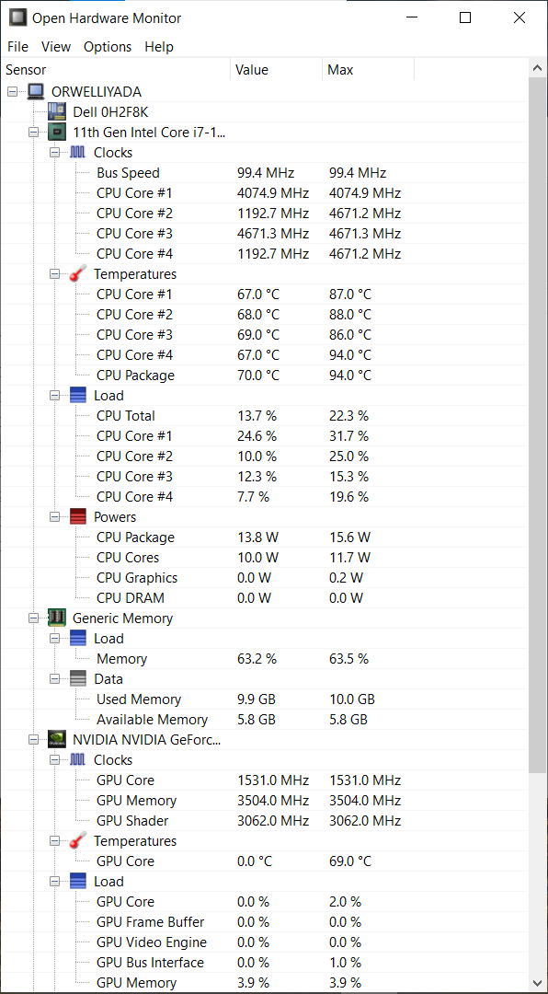

How to speed up your Intel processor using Registry Keys

Checking processor speed
First go to Task Manager and check the processor speed. If it does well you can edit registry values. First of all, I didn’t need to change any Registry values because I didn’t install anything on “Windows 10” from the DELL Power Manager, nor DELL Support, nor NVIDIA Drivers but it’s Control Panel… With dual graphic cards Intel and NVIDIA, that I have, my laptop demands the NVIDIA Drivers not to be installed because when they are the processor speed falls below the first speed border – 1.69 GHz which creates my laptop operating system impossible to use, unless is maybe Windows 8, to make a joke… So without any of these programs I am able to use laptop fine…

In case you need to edit Registry
In my example I have a laptop “Dell Vostro 5502” with processor “11th Gen Intel® Core™ i7-1165G7 @ 2.80GHz” working on up to 4.7 GHz where it is for some reason set to work on up to 1.69 GHz with a possible boost up to 2.7 GHz and later on 4.1 GHz (because for some reason Windows doesn’t allow the full usage of the CPU)…
In Task Manager you will find this description about the processor:
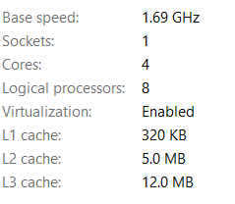
First thing that I was asking is the 2 given options in the Registry Keys for “EfficiencyClass” when I can have 3 if processor is locked on 1.69… The other thing to consider here is enabled energy saver locking that processor on 1.69 GHz, and not on 2.7 GHz… That energy saver with Windows given options shall make this Intel CPU to work on 0.87 GHz and even slower on about 0.4 GHz when the greater CPU consumption and usage comes in place (for example when we open the browser that requires the usage of the GPUs)…

Beginning speed of the processor
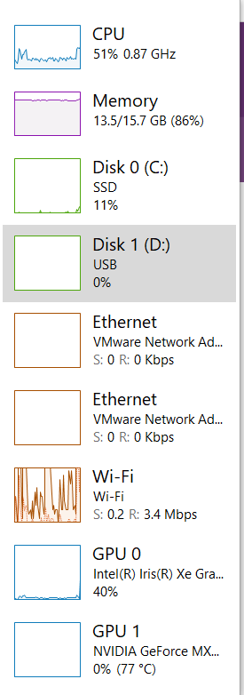
- To see the result of changing all Registry keys skip to the end of the file…
- Here in my case fixing of the problem required looking and at the NVIDIA co-processor settings which you will find later on in file…

ControlSet001\Control\Power
First of all to avoid that we need to fix some Registry values and settings:
- “Computer\HKEY_LOCAL_MACHINE\SYSTEM\ControlSet001\Control\Power”
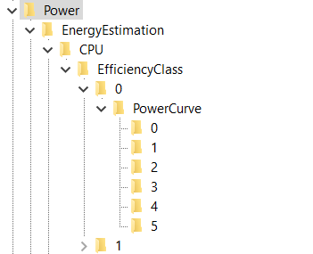
Here I would pay attention what does EnergyEstimationEnabled option… Leave it turned on, because, by some thinking – under the folder EnergyEstimation , but that is my choice…
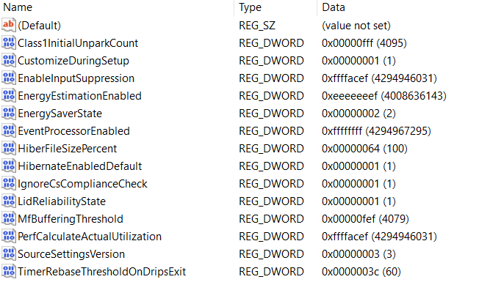

Old settings
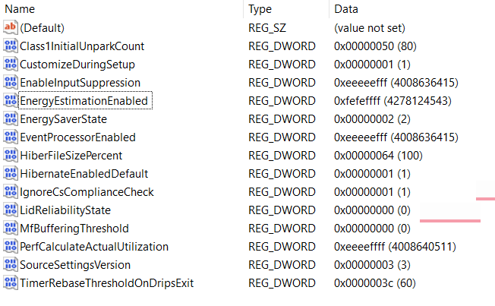
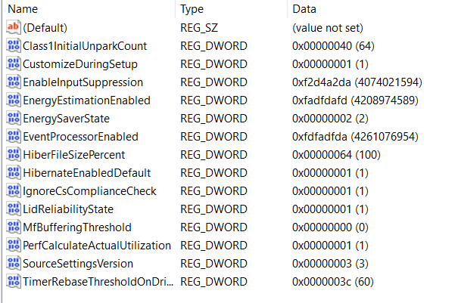
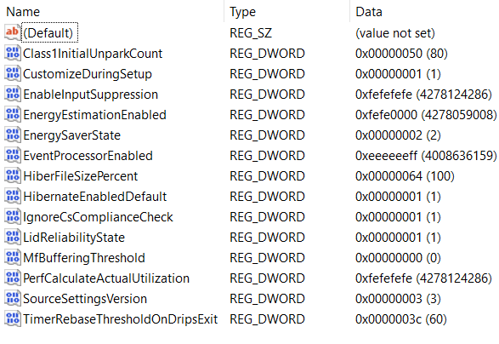

EfficiencyClasses
- Computer\HKEY_LOCAL_MACHINE\SYSTEM\ControlSet001\Control\Power\EnergyEstimation\CPU\EfficiencyClass\0
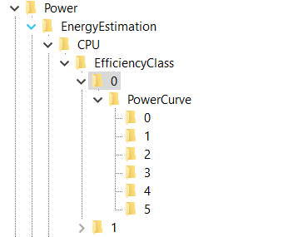
- I tried to set the processor to work on 11GHz but it worked only on Windows maximum speed (4.1 GHz and not 4.7 GHz):
PowerEnvelope: 2af8 (11000)
PowerCurve:
  - FrequencyPercent: decimal: 70, 75, 90, 100, 110, 120
  - PowerEnvelope: 2af8 (11000)
PowerEnvelope: 1770 (6000)
  - FrequencyPercent: decimal: 85, 90, 95, 100, 110, 120
  - PowerEnvelope: 1770 (6000)
P.S. Confirm the speed of processor at:
“Computer\HKEY_LOCAL_MACHINE\SYSTEM\ControlSet001\Control\Power\PowerSettings\54533251-82be-4824-96c1-47b60b740d00\75b0ae3f-bce0-45a7-8c89-c9611c25e100\DefaultPowerSchemeValues” by typing in the values:
  - ACSettingIndex: 2af8 (11000)
  - DCSettingIndex: 2af8 (11000)
“Computer\HKEY_LOCAL_MACHINE\SYSTEM\ControlSet001\Control\Power\PowerSettings\54533251-82be-4824-96c1-47b60b740d00\75b0ae3f-bce0-45a7-8c89-c9611c25e101\DefaultPowerSchemeValues”
  - 2af8 (11000)
“Computer\HKEY_LOCAL_MACHINE\SYSTEM\ControlSet001\Control\Power\PowerSettings\54533251-82be-4824-96c1-47b60b740d00\75b0ae3f-bce0-45a7-8c89-c9611c25e102\DefaultPowerSchemeValues\”
  - 1770 (6000)
- Computer\HKEY_LOCAL_MACHINE\SYSTEM\ControlSet001\Control\Power\EnergyEstimation\CPU\EfficiencyClass\0\PowerCurve\0
Explanation for the values: FrequencyPercent is represented in decimals as a percentage, and PowerEnvelope is represented in HexaDecimal values but through the Decimal values – so for example if you type in the Decimal value “1000” you should see it as is written in HexaDecimal values, which translated gives us 4.096 GHz… You should notice one interesting thing that you can’t type in all of the Frequencies for the processor because in hexadecimal values you can write and letters A – F, so for example “A99” would be 2.713 GHz, and here you can write only numbers which means either you would need to agree to processor speed of (in Hexadecimal values) “999” or “1000”, which is translated: 2.457 GHz (for “999”) or 4.096 GHz (for “1000)…
So my setting is:
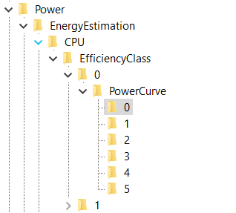
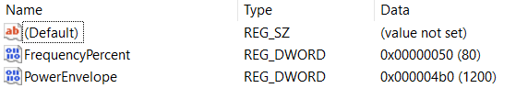

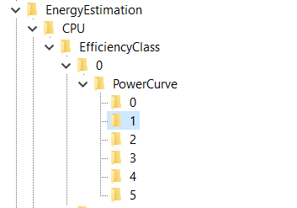
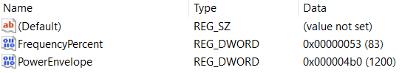
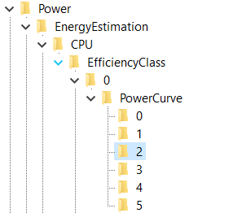
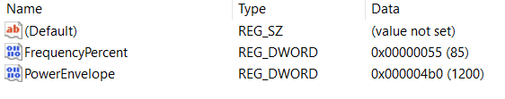
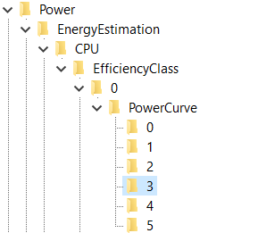
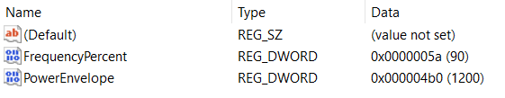
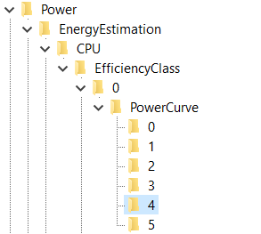
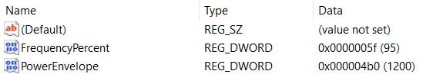
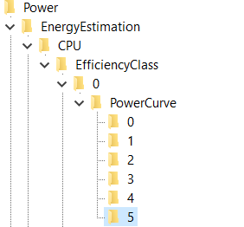
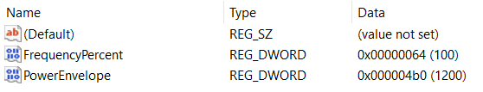

- Computer\HKEY_LOCAL_MACHINE\SYSTEM\ControlSet001\Control\Power\EnergyEstimation\CPU\EfficiencyClass\1
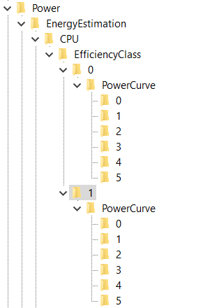
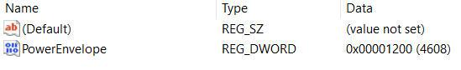
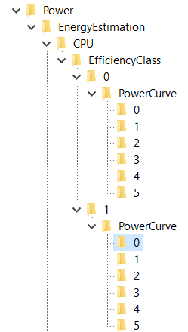
One solution I created for myself – I have retyped all values from the EfficiencyClass “0” into “1”…
Other unnecessary solution is something like this:
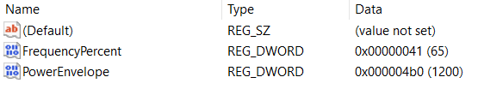

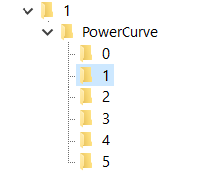
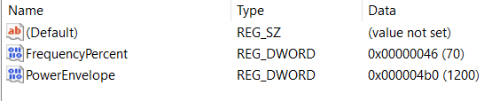
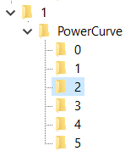
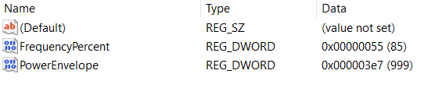

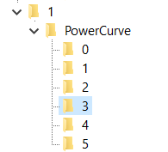
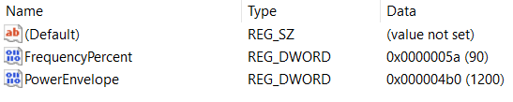
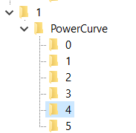
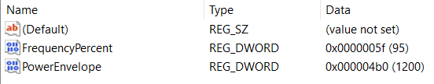

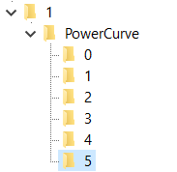
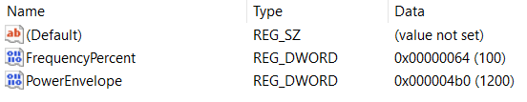

Residual energy
- New settings:
  - EnableInlineAccounting: ef (239)
- Old settings:
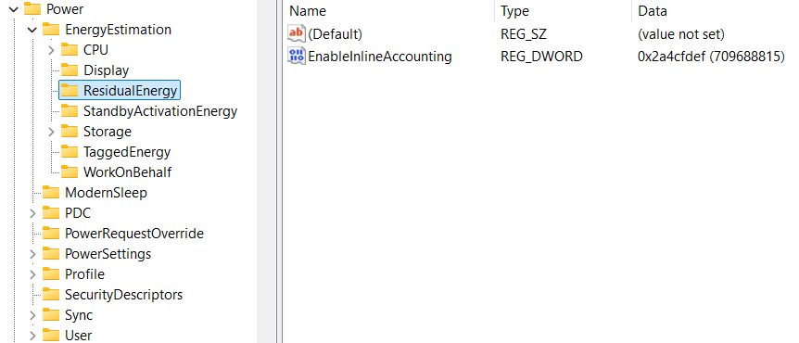

StandbyActivationEnergy
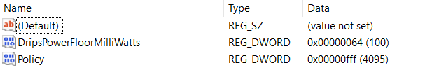

WorkOnBehalf
- New settings:
  - DisableWorkOnBehalfAttribution: ffffffef
- Old settings:
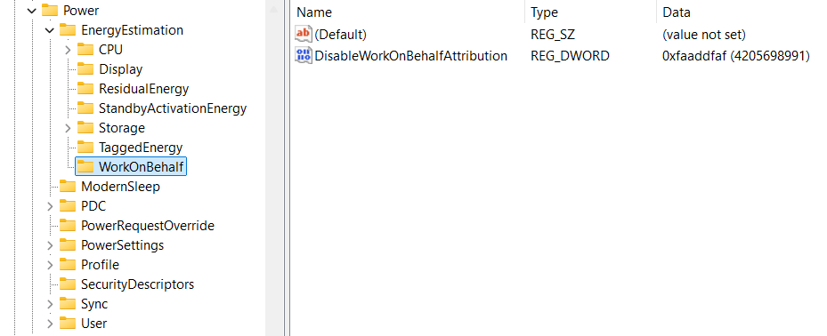

VetoPolicies
- “Computer\HKEY_LOCAL_MACHINE\SYSTEM\ControlSet001\Control\Power\PDC”
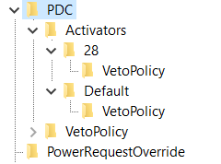
Laptop works faster if VetoPolicy options are turned off…
EA:PowerStateDischarging: fffffeac
EA:EnergySaverEngaged: fffffeac
Old settings:
- Computer\HKEY_LOCAL_MACHINE\SYSTEM\ControlSet001\Control\Power\PDC\Activators\28\VetoPolicy
  - EA:PowerStateDischarging: ffff ffff
- Computer\HKEY_LOCAL_MACHINE\SYSTEM\ControlSet001\Control\Power\PDC\Activators\Default\VetoPolicy
  - EA:EnergySaverEngaged: ffff ffff

EA
- New settings
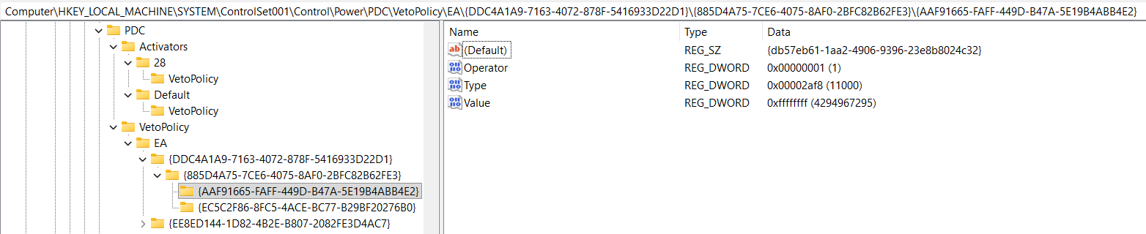
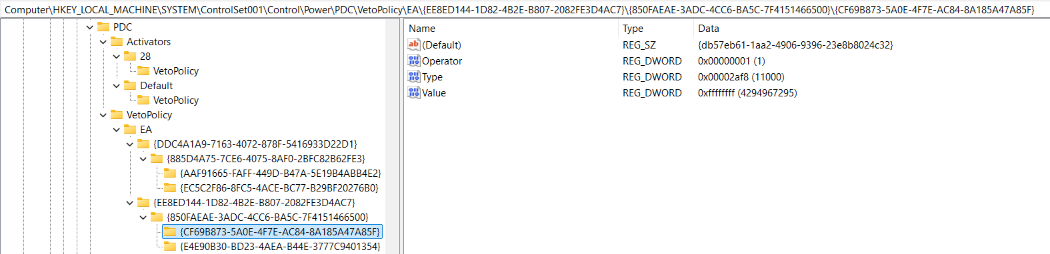
- Old settings
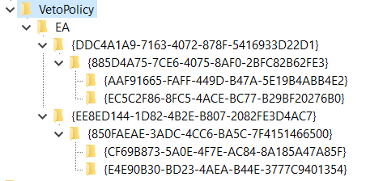
I am not sure if these values represent the maximum speed of the processor but I have placed them all on maximum for my processor:
- Computer\HKEY_LOCAL_MACHINE\SYSTEM\ControlSet001\Control\Power\PDC\VetoPolicy\EA\{DDC4A1A9-7163-4072-878F-5416933D22D1}\{885D4A75-7CE6-4075-8AF0-2BFC82B62FE3}\{AAF91665-FAFF-449D-B47A-5E19B4ABB4E2}
  - Type 4121 -> 4700
- Computer\HKEY_LOCAL_MACHINE\SYSTEM\ControlSet001\Control\Power\PDC\VetoPolicy\EA\{DDC4A1A9-7163-4072-878F-5416933D22D1}\{885D4A75-7CE6-4075-8AF0-2BFC82B62FE3}\{EC5C2F86-8FC5-4ACE-BC77-B29BF20276B0}
  - Type 4106 -> 4700
- Computer\HKEY_LOCAL_MACHINE\SYSTEM\ControlSet001\Control\Power\PDC\VetoPolicy\EA\{EE8ED144-1D82-4B2E-B807-2082FE3D4AC7}\{850FAEAE-3ADC-4CC6-BA5C-7F4151466500}\{CF69B873-5A0E-4F7E-AC84-8A185A47A85F}
  - Type 4106 -> 4700
- Computer\HKEY_LOCAL_MACHINE\SYSTEM\ControlSet001\Control\Power\PDC\VetoPolicy\EA\{EE8ED144-1D82-4B2E-B807-2082FE3D4AC7}\{850FAEAE-3ADC-4CC6-BA5C-7F4151466500}\{E4E90B30-BD23-4AEA-B44E-3777C9401354}
  - Type 4145 -> 4700
You will notice that those folders – “keys” there is a value that has a DWORD named “Value” and that it is turned off, I have placed it to 0…

About PowerSettings
- Intel processor updates know to reset PowerSettings options and is good to have some kind of a program for PowerSettings Registry Keys
- I do wonder how important those settings are and how much NVIDIA CoProcessor Manager settings intervene and mock the Intel Processor speed

PowerSettings
- “Computer\HKEY_LOCAL_MACHINE\SYSTEM\ControlSet001\Control\Power\PowerSettings”
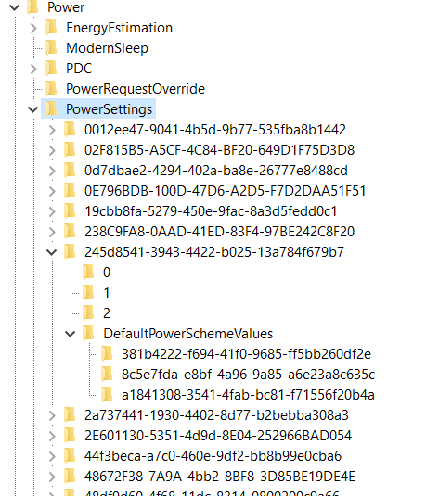
Talking about PowerSettings you need to turn High Performance on, set graphics to work in High performance mode, to set CPU to work by High Performance if you wish on all 3 levels (3 different keys under “DefaultPowerSchemeValues” folder) – because it is unknown in Registry Editor which level is for “Best Battery Life” setting, which is “Balanced” setting, and which is for “Best (High) performance” setting… What I can conclude, for my processor and type of Windows that I have – key: “8c5e7fda-e8bf-4a96-9a85-a6e23a8c635c” represents the “High performance” mode and mostly from that key I have been copying to other two keys it’s own already set values… Some keys I have changed completely, adjusting values how I liked…
How this part of the registry works? First you will have a “key” (folder) where you will find options that you can implement under “keys” (folders) 0, 1, 2 and you will have a folder where you can implement those options named: “DefaultPowerSchemeValues”… In those folders you can find the description and a “friendly name” (also a type of a description) of the current part of the Registry Keys… Each of the main folders named for example: “0”, “1” or “2” will have some type of a value that you can use later on… That value you will find under a DWORD (data) name “SettingValue”… The best setting whether it’s under folder “0”, “1” or “2” you can copy into the “AcSettingIndex” or “DcSettingIndex”, or “ProvAcSettingIndex” or “ProvDcSettingIndex”…
In cases where you don’t have options under keys (folders) “0”, “1”, “2”, you will have some type of a scale that you can implement… Maximum value of the scale you can find under the main folder and it’s DWORD named “ValueMax” and it’s possible minimum under a DWORD named “ValueMin”… Always take a look at: DWORD named ValueUnits that will have a description for example: “@%SystemRoot%\system32\powrprof.dll,-81,percent” – there the last word we can find is the word “percent” meaning you should implement in decimal numbers value from 0 to 100 representing some kind of a percentage of a usage for some of the situations…
Some of the settings that I have implemented are:
- Computer\HKEY_LOCAL_MACHINE\SYSTEM\ControlSet001\Control\Power\PowerSettings\54533251-82be-4824-96c1-47b60b740d00
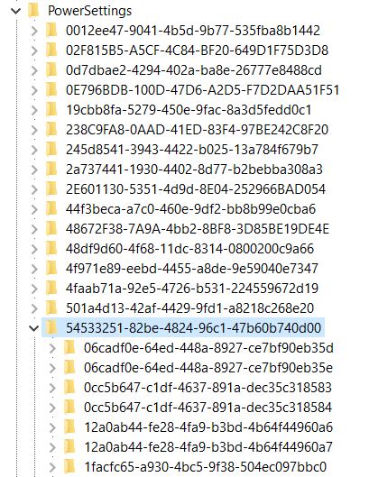
Under power settings you will find the key: “54533251-82be-4824-96c1-47b60b740d00” with “Processor power settings” and you need to see each of the keys (folders) it has and to adjust them except time settings which I haven’t changed…

Processor performance increase threshold
- “Computer\HKEY_LOCAL_MACHINE\SYSTEM\ControlSet001\Control\Power\PowerSettings\54533251-82be-4824-96c1-47b60b740d00\06cadf0e-64ed-448a-8927-ce7bf90eb35d”
- Value different 30, 60, 90

Processor performance increase threshold for Processor Power Efficiency Class 1
- Computer\HKEY_LOCAL_MACHINE\SYSTEM\ControlSet001\Control\Power\PowerSettings\54533251-82be-4824-96c1-47b60b740d00\06cadf0e-64ed-448a-8927-ce7bf90eb35e
- 60 – 90

Specify the minimum number of unparked cores/packages allowed
- Computer\HKEY_LOCAL_MACHINE\SYSTEM\ControlSet001\Control\Power\PowerSettings\54533251-82be-4824-96c1-47b60b740d00\0cc5b647-c1df-4637-891a-dec35c318583
  - Description: Specify the minimum number of unparked cores/packages allowed (in percentage).
  - Setting implemented: 64 (100)

Specify the minimum number of unparked cores/packages allowed
- Computer\HKEY_LOCAL_MACHINE\SYSTEM\ControlSet001\Control\Power\PowerSettings\54533251-82be-4824-96c1-47b60b740d00\1facfc65-a930-4bc5-9f38-504ec097bbc0
  - Description: Specify the minimum number of unparked cores/packages allowed (in percentage).
  - Setting implemented: 64 (100) – 10

Processor performance core parking min cores for Processor Power Efficiency Class 1
- “Computer\HKEY_LOCAL_MACHINE\SYSTEM\ControlSet001\Control\Power\PowerSettings\54533251-82be-4824-96c1-47b60b740d00\0cc5b647-c1df-4637-891a-dec35c318584”
- 0

Processor performance decrease threshold
- Specify the lower busy threshold that must be met before decreasing the processor's performance state (in percentage).
- “Computer\HKEY_LOCAL_MACHINE\SYSTEM\ControlSet001\Control\Power\PowerSettings\54533251-82be-4824-96c1-47b60b740d00\12a0ab44-fe28-4fa9-b3bd-4b64f44960a6”
- 20 – 10 – 60 – 10

Processor performance decrease threshold for Processor Power Efficiency Class 1
- Computer\HKEY_LOCAL_MACHINE\SYSTEM\ControlSet001\Control\Power\PowerSettings\54533251-82be-4824-96c1-47b60b740d00\12a0ab44-fe28-4fa9-b3bd-4b64f44960a7
- 20 – 30

Hybrid containment zone important utility percentage
- “Computer\HKEY_LOCAL_MACHINE\SYSTEM\ControlSet001\Control\Power\PowerSettings\54533251-82be-4824-96c1-47b60b740d00\12fd031f-53d2-4bf4-ac6d-c699fc9538c7”
- Specify the important utility percentage that once met, allow workload to move to no containment zone
- 0

Processor Restriction Count
- “Computer\HKEY_LOCAL_MACHINE\SYSTEM\ControlSet001\Control\Power\PowerSettings\54533251-82be-4824-96c1-47b60b740d00\1a98ad09-af22-42ca-8e61-f0a5802c270a”
- Specify the restriction processor count for this QoS of threads.
- 0

Initial performance for Processor Power Efficiency Class 1 when unparked
- “Computer\HKEY_LOCAL_MACHINE\SYSTEM\ControlSet001\Control\Power\PowerSettings\54533251-82be-4824-96c1-47b60b740d00\1facfc65-a930-4bc5-9f38-504ec097bbc0”
- 32 (50)

Processor performance core parking concurrency threshold
- “Computer\HKEY_LOCAL_MACHINE\SYSTEM\ControlSet001\Control\Power\PowerSettings\54533251-82be-4824-96c1-47b60b740d00\2430ab6f-a520-44a2-9601-f7f23b5134b1”
- 61 (97), 61, 5f

Processor performance core parking increase time
- “Computer\HKEY_LOCAL_MACHINE\SYSTEM\ControlSet001\Control\Power\PowerSettings\54533251-82be-4824-96c1-47b60b740d00\2ddd5a84-5a71-437e-912a-db0b8c788732”
- In time check intervals
- Same as before: 3, 7, 1

Processor energy performance preference policy
- “Computer\HKEY_LOCAL_MACHINE\SYSTEM\ControlSet001\Control\Power\PowerSettings\54533251-82be-4824-96c1-47b60b740d00\36687f9e-e3a5-4dbf-b1dc-15eb381c6863”
- (33), (50) / 0, 0 / (70) / (60) / (25), (33)

Processor energy performance preference policy for Processor Power Efficiency Class 1
- “Computer\HKEY_LOCAL_MACHINE\SYSTEM\ControlSet001\Control\Power\PowerSettings\54533251-82be-4824-96c1-47b60b740d00\36687f9e-e3a5-4dbf-b1dc-15eb381c6864\DefaultPowerSchemeValues\381b4222-f694-41f0-9685-ff5bb260df2e”
- (33), (50) / (0), (0) / (60), (60)

Processor energy performance preference policy for Processor Power Efficiency Class 2
- “Computer\HKEY_LOCAL_MACHINE\SYSTEM\ControlSet001\Control\Power\PowerSettings\54533251-82be-4824-96c1-47b60b740d00\36687f9e-e3a5-4dbf-b1dc-15eb381c6864”
- (33), (50), (60)

Allow Throttle States
- Computer\HKEY_LOCAL_MACHINE\SYSTEM\ControlSet001\Control\Power\PowerSettings\54533251-82be-4824-96c1-47b60b740d00\3b04d4fd-1cc7-4f23-ab1c-d1337819c4bb
  - FriendlyName: Allow Throttle States
- Setting implemented: 0 – Off

Processor performance increase time for Processor Power Efficiency Class 1
- “Computer\HKEY_LOCAL_MACHINE\SYSTEM\ControlSet001\Control\Power\PowerSettings\54533251-82be-4824-96c1-47b60b740d00\4009efa7-e72d-4cba-9edf-91084ea8cbc3”
- 1

Processor performance decrease policy
- Computer\HKEY_LOCAL_MACHINE\SYSTEM\ControlSet001\Control\Power\PowerSettings\54533251-82be-4824-96c1-47b60b740d00\40fbefc7-2e9d-4d25-a185-0cfd8574bac6
  - FriendlyName: Processor performance decrease policy
- Setting implemented: Single
- Computer\HKEY_LOCAL_MACHINE\SYSTEM\ControlSet001\Control\Power\PowerSettings\54533251-82be-4824-96c1-47b60b740d00\40fbefc7-2e9d-4d25-a185-0cfd8574bac7
  - FriendlyName: Processor performance decrease policy for Processor Power Efficiency Class 1
- Setting implemented: Single
- Computer\HKEY_LOCAL_MACHINE\SYSTEM\ControlSet001\Control\Power\PowerSettings\54533251-82be-4824-96c1-47b60b740d00\447235c7-6a8d-4cc0-8e24-9eaf70b96e2b
  - Processor performance core parking parked performance state
- Best option for the speed of processor: Lightest Performance State
- My setting implemented: No preference
- Some theory on that topic: Unused CPUs enter parked state and not to spend energy they can enter Deepest Performance state to save power and reduce the heat… Otherwise faster option is “Lightest Performance state”…
- Computer\HKEY_LOCAL_MACHINE\SYSTEM\ControlSet001\Control\Power\PowerSettings\54533251-82be-4824-96c1-47b60b740d00\45bcc044-d885-43e2-8605-ee0ec6e96b59
  - FriendlyName: Processor performance boost policy
  - All Settings implemented: 0x64 (or Decimal: 100 (%))
- Computer\HKEY_LOCAL_MACHINE\SYSTEM\ControlSet001\Control\Power\PowerSettings\54533251-82be-4824-96c1-47b60b740d00\465e1f50-b610-473a-ab58-00d1077dc418
  - FriendlyName: Processor performance increase policy
  - Setting implemented: Rocket
- Computer\HKEY_LOCAL_MACHINE\SYSTEM\ControlSet001\Control\Power\PowerSettings\54533251-82be-4824-96c1-47b60b740d00\4e4450b3-6179-4e91-b8f1-5bb9938f81a1
  - FriendlyName: Processor duty cycling
  - Setting implemented: Allow processor duty cycling.
- Computer\HKEY_LOCAL_MACHINE\SYSTEM\ControlSet001\Control\Power\PowerSettings\54533251-82be-4824-96c1-47b60b740d00\5d76a2ca-e8c0-402f-a133-2158492d58ad
  - Description: Specify if idle states should be disabled.
  - Setting implemented: Enable idle
- Computer\HKEY_LOCAL_MACHINE\SYSTEM\ControlSet001\Control\Power\PowerSettings\54533251-82be-4824-96c1-47b60b740d00\6c2993b0-8f48-481f-bcc6-00dd2742aa06
  - FriendlyName: Processor idle threshold scaling
  - Setting implemented: Disable scaling
- Computer\HKEY_LOCAL_MACHINE\SYSTEM\ControlSet001\Control\Power\PowerSettings\54533251-82be-4824-96c1-47b60b740d00\71021b41-c749-4d21-be74-a00f335d582b
  - Description: Specify the number of cores/packages to park when fewer cores are required.
  - Setting implemented: Ideal number of cores
- Computer\HKEY_LOCAL_MACHINE\SYSTEM\ControlSet001\Control\Power\PowerSettings\54533251-82be-4824-96c1-47b60b740d00\75b0ae3f-bce0-45a7-8c89-c9611c25e100
  - FriendlyName: Maximum processor frequency
  - Setting implemented: Decimal value: 4700
- Computer\HKEY_LOCAL_MACHINE\SYSTEM\ControlSet001\Control\Power\PowerSettings\54533251-82be-4824-96c1-47b60b740d00\75b0ae3f-bce0-45a7-8c89-c9611c25e101
  - FriendlyName: Maximum processor frequency for Processor Power Efficiency Class 1
  - Setting implemented: Decimal value: 2457
- Computer\HKEY_LOCAL_MACHINE\SYSTEM\ControlSet001\Control\Power\PowerSettings\54533251-82be-4824-96c1-47b60b740d00\7f2f5cfa-f10c-4823-b5e1-e93ae85f46b5
  - FriendlyName: Heterogeneous policy in effect.
  - Setting implemented: Use heterogeneous policy 0

Don’t forget to check options for Graphic card:
- Computer\HKEY_LOCAL_MACHINE\SYSTEM\ControlSet001\Control\Power\PowerSettings\5FB4938D-1EE8-4b0f-9A3C-5036B0AB995C
  - FriendlyName: GPU preference policy
  - Setting implemented: No preference (because other setting I had was: Low Power)
Check Energy Saving settings:
- Computer\HKEY_LOCAL_MACHINE\SYSTEM\ControlSet001\Control\Power\PowerSettings\DE830923-A562-41AF-A086-E3A2C6BAD2DA
- Computer\HKEY_LOCAL_MACHINE\SYSTEM\ControlSet001\Control\Power\PowerSettings\DE830923-A562-41AF-A086-E3A2C6BAD2DA\5C5BB349-AD29-4ee2-9D0B-2B25270F7A81
  - FriendlyName: Energy Saver Policy
  - Setting implemented: User
Also, you can go back to processor settings and find the “Processor performance increase threshold” and “Processor performance decrease threshold” options, as I know I have changed some of the percentages, for example from 35 to 20 if is faster and from 45 to 50, but maybe I have pushed it above the edge or below the edge (I am not even sure)… Maybe those settings are fine by themselves…
My options there are in decimal values:
- Computer\HKEY_LOCAL_MACHINE\SYSTEM\ControlSet001\Control\Power\PowerSettings\54533251-82be-4824-96c1-47b60b740d00\7b224883-b3cc-4d79-819f-8374152cbe7c
  - FriendlyName: Processor idle promote threshold
  - Setting implemented: 14 (20)
- Computer\HKEY_LOCAL_MACHINE\SYSTEM\ControlSet001\Control\Power\PowerSettings\54533251-82be-4824-96c1-47b60b740d00\943c8cb6-6f93-4227-ad87-e9a3feec08d1
  - FriendlyName: Processor performance core parking over utilization threshold
  - Setting implemented: 1e (30)
- Computer\HKEY_LOCAL_MACHINE\SYSTEM\ControlSet001\Control\Power\PowerSettings\54533251-82be-4824-96c1-47b60b740d00\06cadf0e-64ed-448a-8927-ce7bf90eb35d
  - FriendlyName: Processor performance increase threshold
- Setting implemented: 0 (0)
- Computer\HKEY_LOCAL_MACHINE\SYSTEM\ControlSet001\Control\Power\PowerSettings\54533251-82be-4824-96c1-47b60b740d00\06cadf0e-64ed-448a-8927-ce7bf90eb35e
  - FriendlyName: Processor performance increase threshold for Processor Power Efficiency Class 1
- Setting implemented: 0 (0)
- Computer\HKEY_LOCAL_MACHINE\SYSTEM\ControlSet001\Control\Power\PowerSettings\54533251-82be-4824-96c1-47b60b740d00\12a0ab44-fe28-4fa9-b3bd-4b64f44960a6
  - FriendlyName: Processor performance decrease threshold
  - Description: Specify the lower busy threshold that must be met before decreasing the processor's performance state (in percentage).
- Setting implemented: 64 (100)
- Computer\HKEY_LOCAL_MACHINE\SYSTEM\ControlSet001\Control\Power\PowerSettings\54533251-82be-4824-96c1-47b60b740d00\12a0ab44-fe28-4fa9-b3bd-4b64f44960a7
  - FriendlyName: Processor performance decrease threshold
  - Description: Specify the lower busy threshold that must be met before decreasing the processor's performance state (in percentage).
- Setting implemented: 64 (100)
There is also a setting for “Processor performance boost mode”:
- Computer\HKEY_LOCAL_MACHINE\SYSTEM\ControlSet001\Control\Power\PowerSettings\54533251-82be-4824-96c1-47b60b740d00\be337238-0d82-4146-a960-4f3749d470c7
- Setting implemented: 5
Set System cooling policy:
- Computer\HKEY_LOCAL_MACHINE\SYSTEM\ControlSet001\Control\Power\PowerSettings\54533251-82be-4824-96c1-47b60b740d00\94D3A615-A899-4AC5-AE2B-E4D8F634367F\1
  - Setting implemented: Increase fan speed before slowing the processor
Edit the option for Minimal Power Management:
- Computer\HKEY_CURRENT_USER\Control Panel\PowerCfg
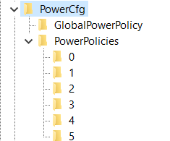
Here, on my Windows, under a number 4 is:
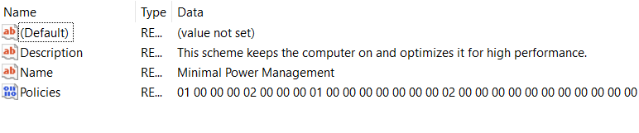
So just set in the PowerCfg string CurrentPowerPolicy: 4

Graphic cards

Checking processor speed
I will copy this text from processors part of the text:
First go to Task Manager and check the processor speed. If it does well you can edit registry values. First of all, I didn’t need to change any Registry values because I didn’t install anything on “Windows 10” from the DELL Power Manager, nor DELL Support, nor NVIDIA Drivers but it’s Control Panel… With dual graphic cards Intel and NVIDIA, that I have, my laptop demands the NVIDIA Drivers not to be installed because when they are the processor speed falls below the first speed border – 1.69 GHz which creates my laptop operating system impossible to use, unless is maybe Windows 8, to make a joke… So without any of these programs I am able to use laptop fine…

In case you need to edit Registry
This Laptop “Dell Vostro 5502” has also dual graphics cards - integrated “Intel® Iris® Xe Graphics” and “NVIDIA GeForce MX330”… It has 16GB of RAM memory, and 500 GB SSD hard drive…
There is a topic of a small and reducing processor speed thanks to the small “Bus” (an implemented cable for transferring the data in between the graphic card and the other chips), and that because of it (maybe set on 1.3 GHz) and the processor reduces it’s speed…

Avalon.Graphics - HardwareAcceleration
In Registry Editor add the keys into:
- “Computer\HKEY_CURRENT_USER\SOFTWARE\Microsoft\Avalon.Graphics”
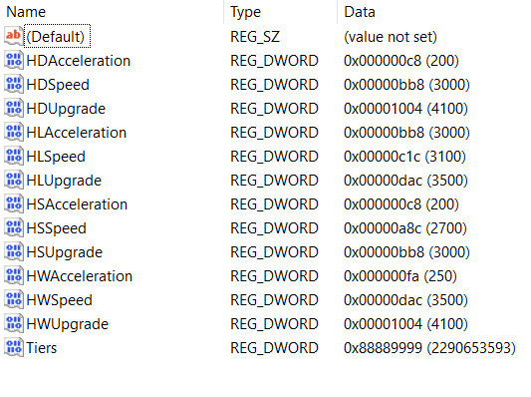

Old settings
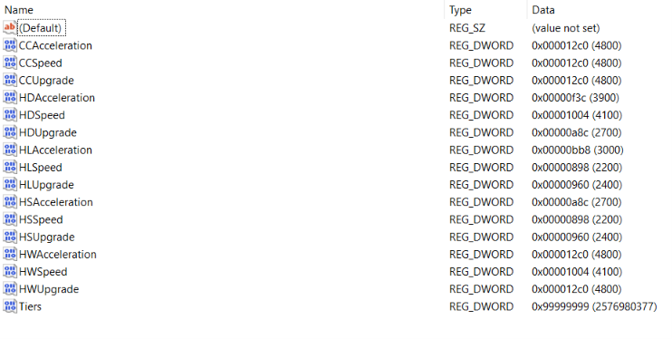

Old Settings 2
Maybe NVIDIA doesn’t register graphic card when Tiers has all “e” numbers written, so this settings are quite arguable…
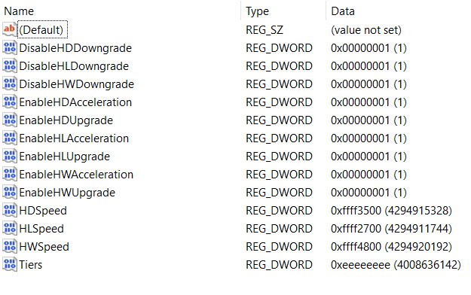

Old settings that worked
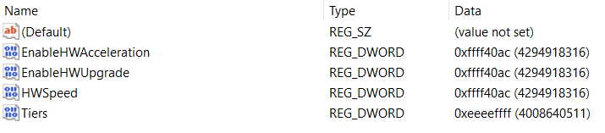

Old settings that made no point:
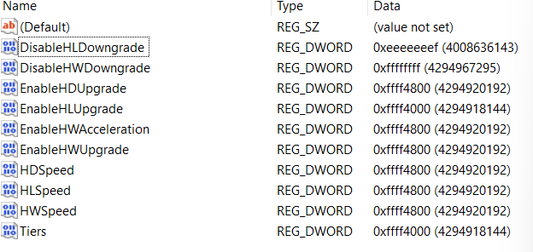
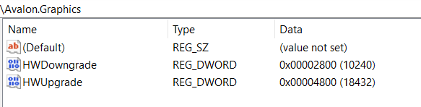
I believe that the next solution makes no point:
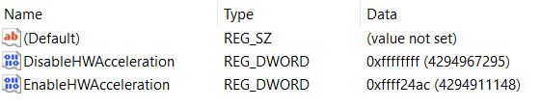
- I created REG_DWORD named DisableHWAcceleration and set it to the value: ffffffff or f22afdfd
- I created REG_DWORD named EnableHWAcceleration and set it to the value: ffff24ac, maybe wrong answers are: ffff2a4c, cbed2a4c, fadefa9c – but those codes we can use if we find the setting on our chips complex which we can find the association when we look at the title: Avalon.Graphics
- Maybe 2a4cd2da – last “a” is there maximum of 2GHz…
- Maybe 4a7cd4df – last “f” is there because of as much as it can of 4GHz…

DirectX
- It turns out that this settings maybe don’t need to edited at all… I concluded some values playing with Registry Editor…
Registry editor key:
- “Computer\HKEY_LOCAL_MACHINE\SOFTWARE\Microsoft\DirectX”
Edit:
- “MaxFeatureLevel”
- “MinFeatureLevels”
- “D3D12MinFeatureLevel”
- “D3D12MaxFeatureLevel”
Values of the keys
- MaxFeatureLevel: “c100”
  - Possible options are:
    - “C100”
    - “c256”
    - “F256”
    - “fadcb”
    - “fadbcdef”
    - “fadbcfdf”
- D3D12MinFeatureLevel: c100
  - Possible options are:
    - 0 (to see retardedness)
    - c100
    - F (to see regular even if it isn’t)
    - 15, 20, 25, 30, 35, …, 100
    - f10
    - f11, f12, f13, f14, f15
    - f100, f110, f120, f130, f140, f150
    - f1000
Edit those values and through the inside of the “DirectX” key keys:
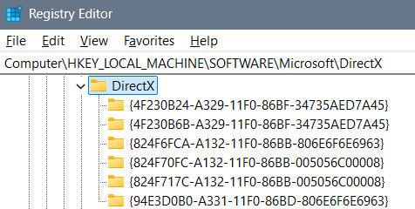

Old settings and unnecessary images:
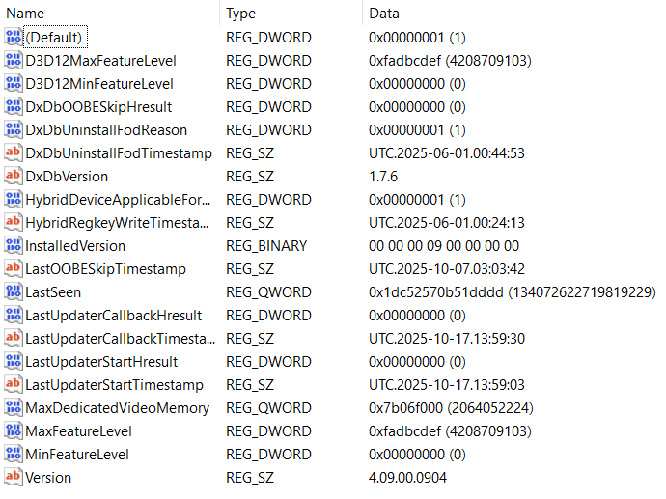
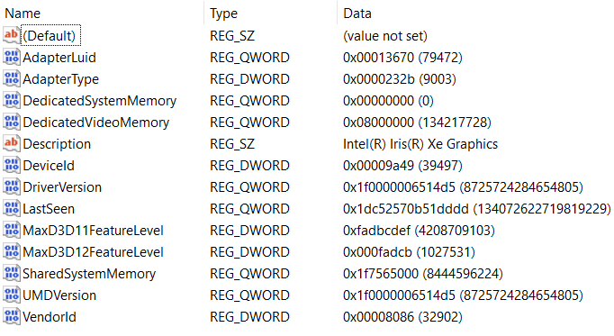

Intel Graphics Software
When you are able to view “Quantum Wall” depends on the colors of the profile…

Themed colors
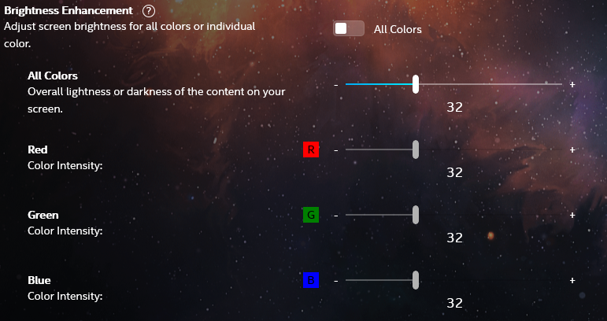
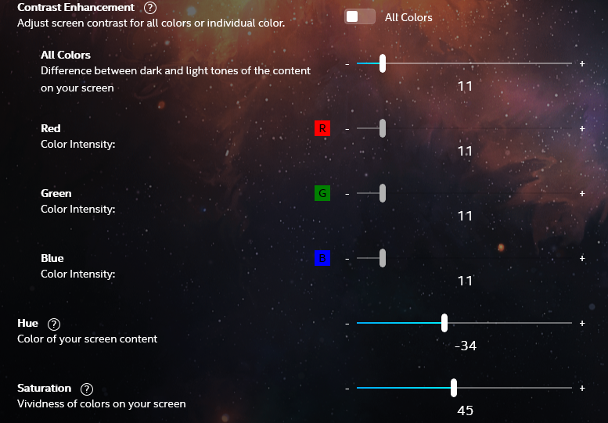

“Greenbrand” profile
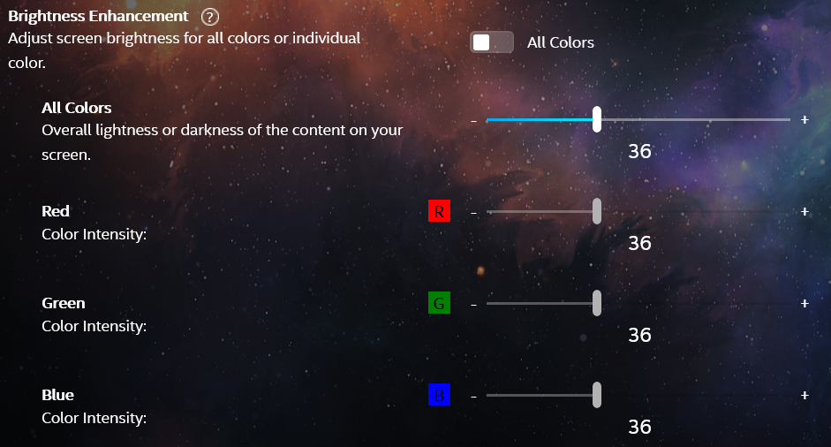
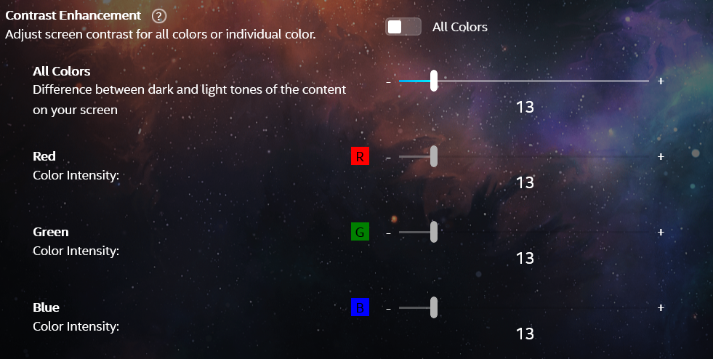
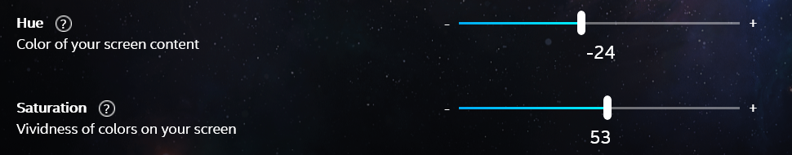

Universal Colors
- Universal Colors we use if we are serious
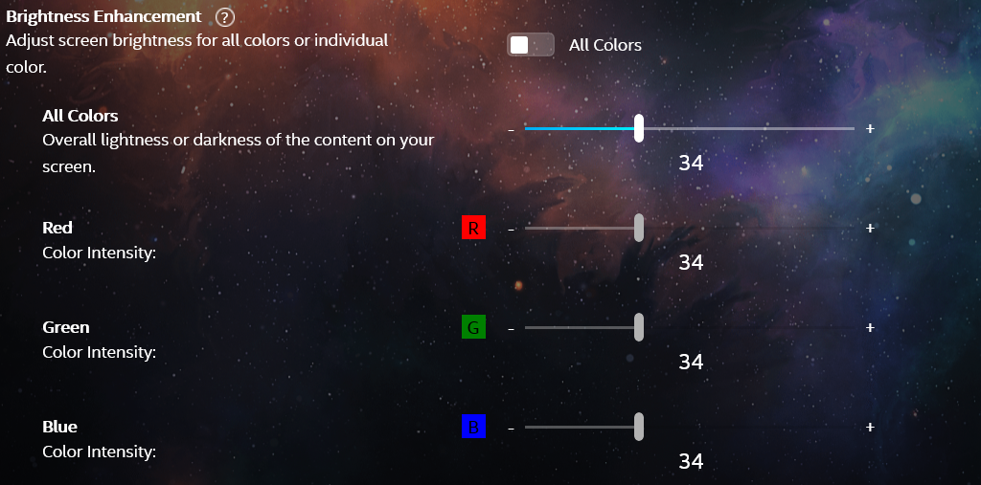
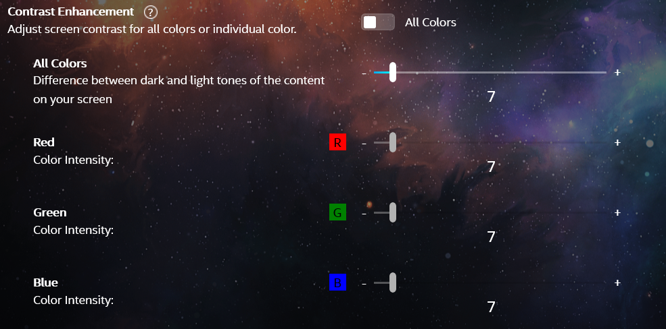
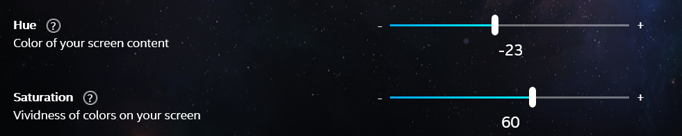

Super real
- Super real profile we use for the necessary things in life
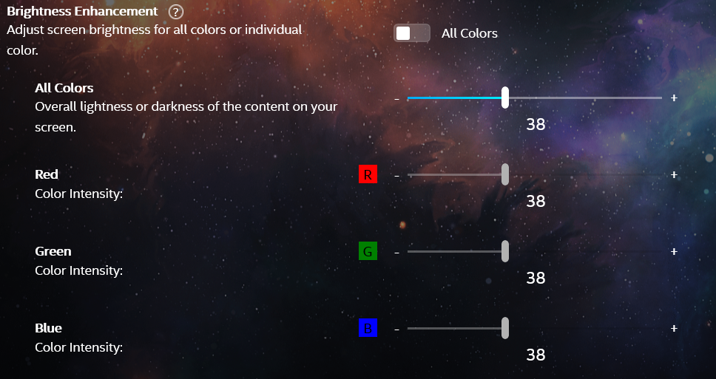
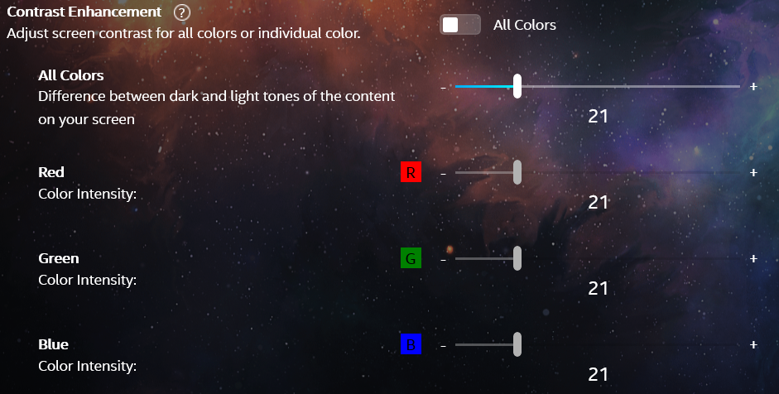
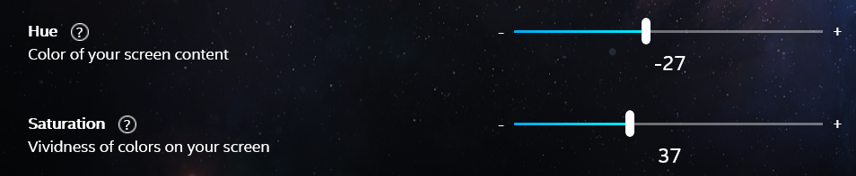

Ekta space profile settings
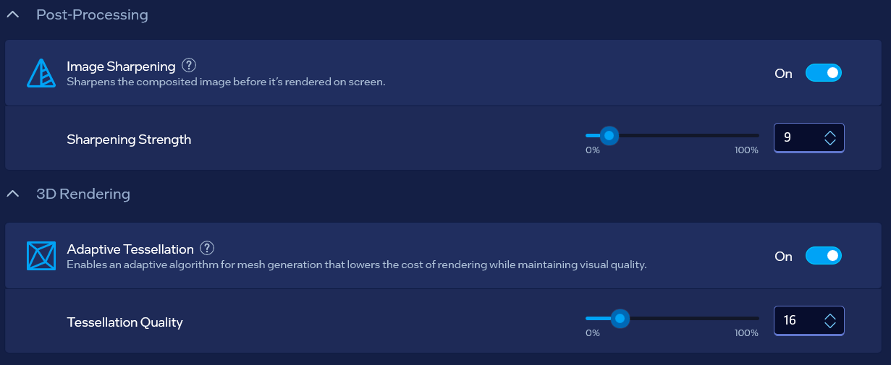
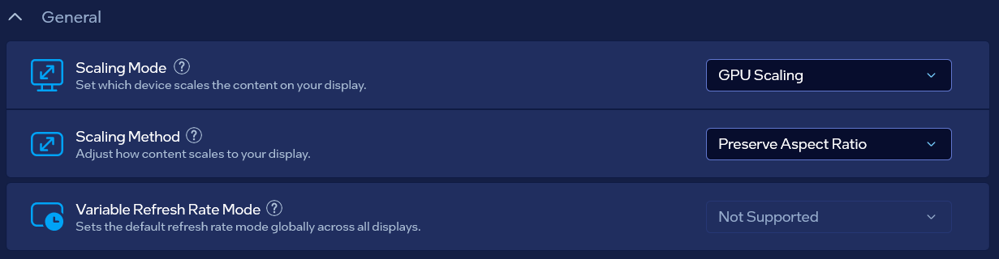
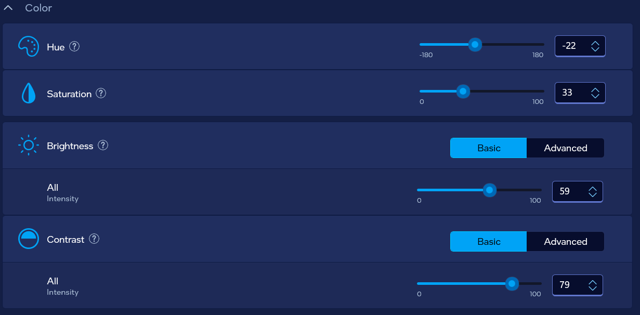

Old alright settings
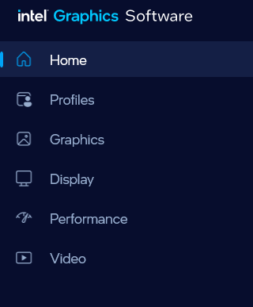
Pointing to a Good system from user side if it’s an addon that serves for something is fine so I shall choose “GPU Scaling” – “Centered”…
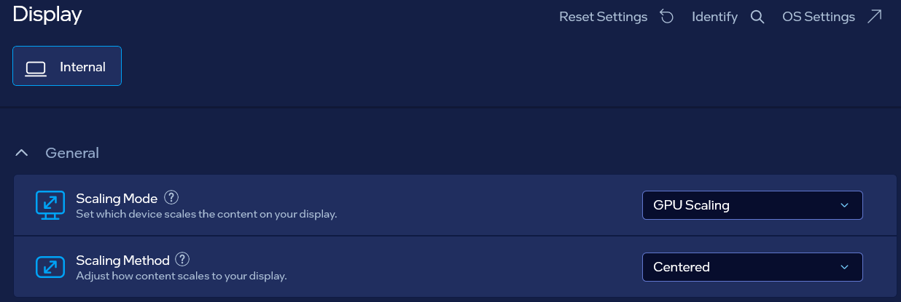
With the NVIDIA “Anisotropic filtering” turned to “Off” the next setting for Scaling Mode and Method is finest:
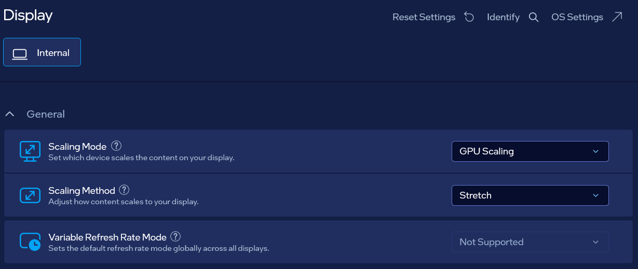
- GPU Scaling
  - “Stretch” mode: points to avoiding system from both sides
  - “Centered” mode: points to allowing system from user side (which is nice when user is approaching applications)
  - “Preserve Aspect Ratio”: I believe bannes anyhow possible system
- Retro Scaling
  - “Integer”: allows sufficient data created by user as a help utility for approach to computer
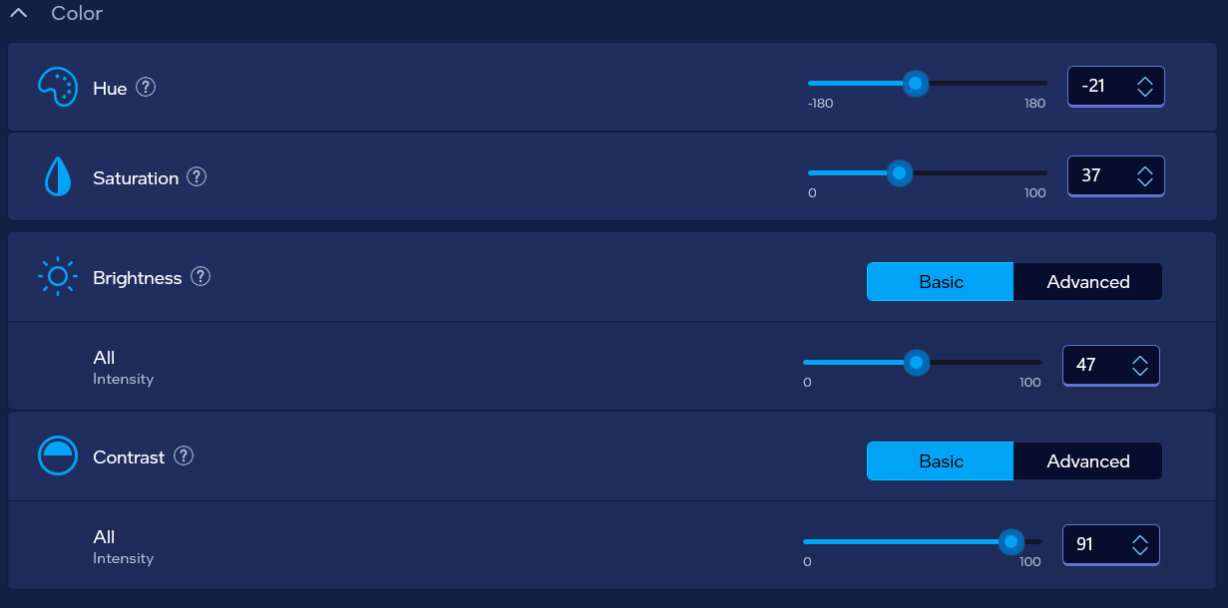
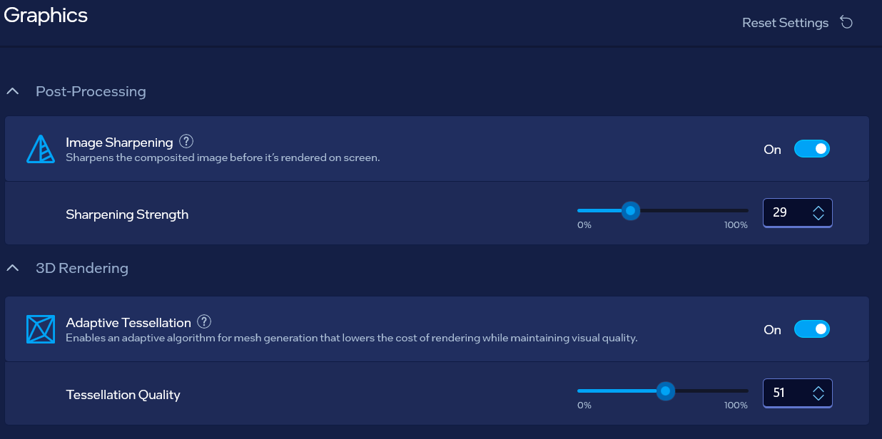

- Next option goes with the NVIDIA “Anisotropic filtering” turned to “Off”:
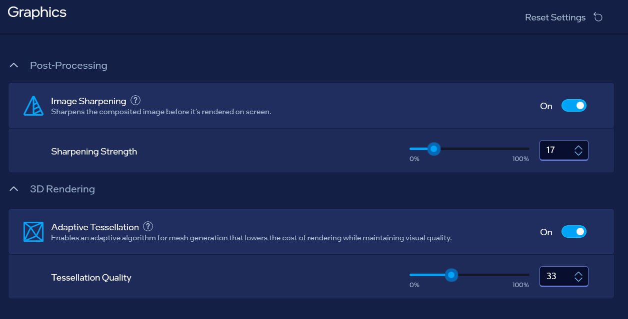
With these settings go “My Favorite settings for NVIDIA” because I have dual graphics cards

Old settings
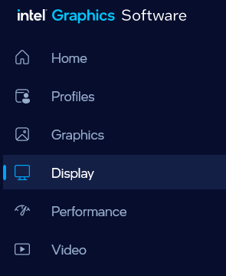
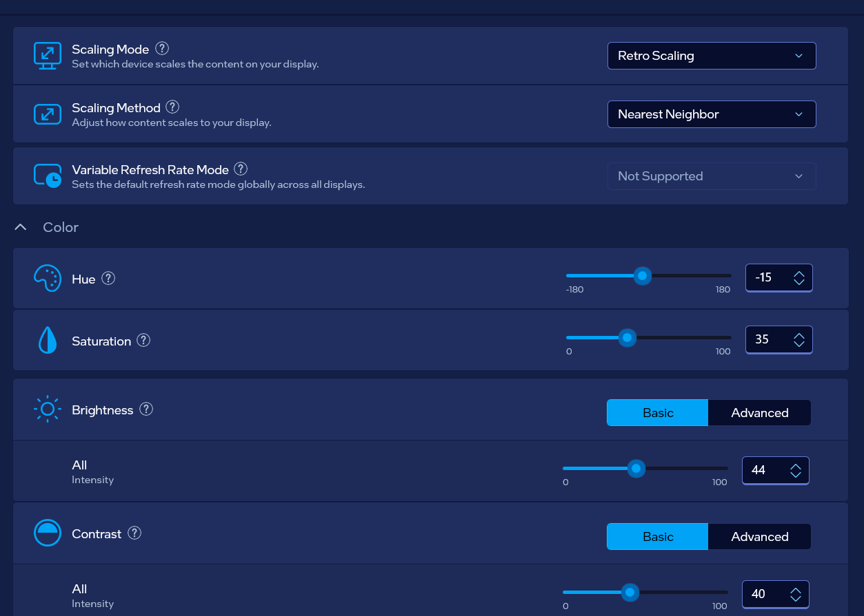

Graphics panel
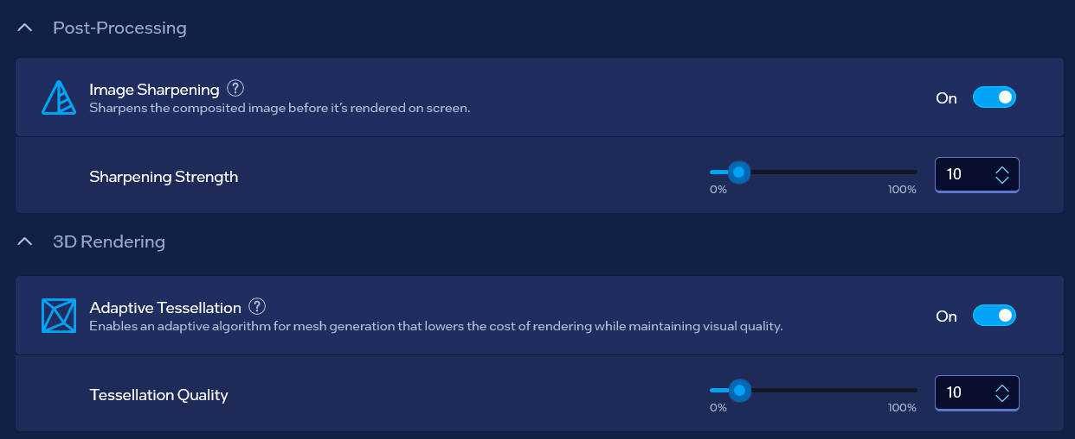

Old settings
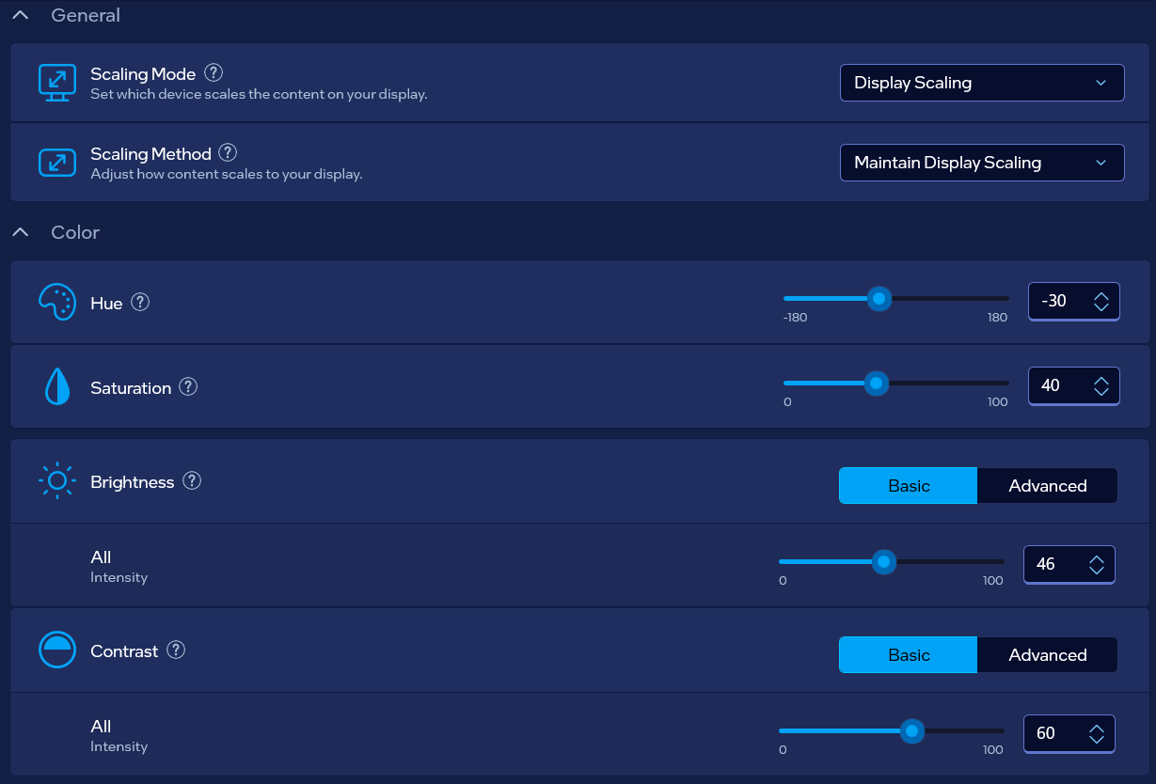
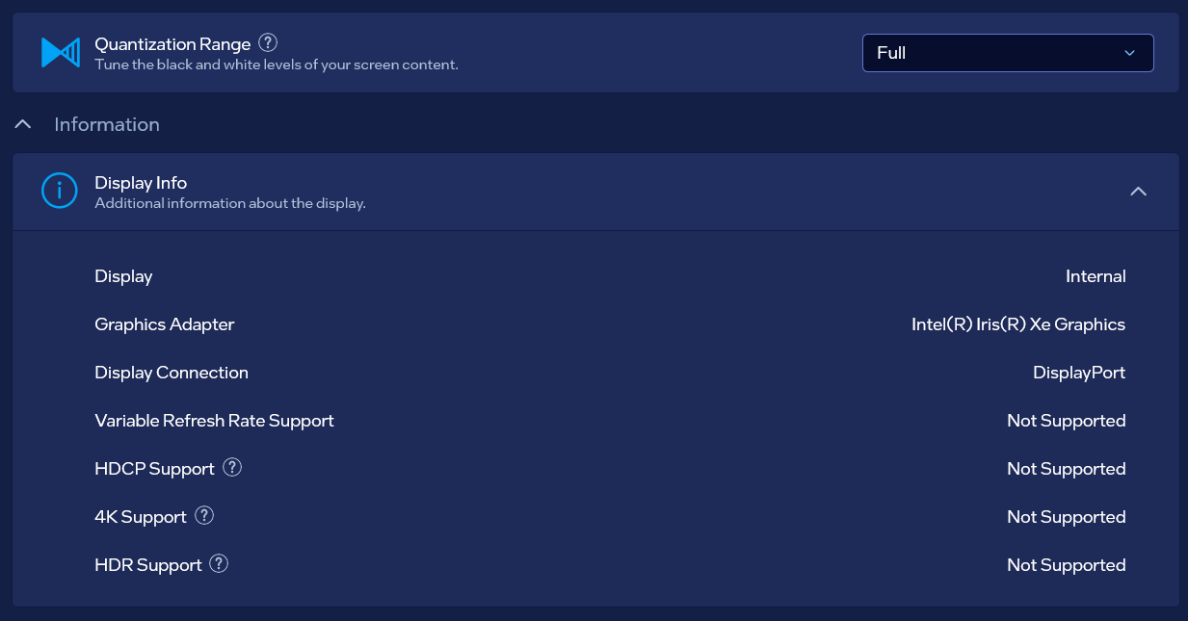

Old settings

Old settings
- Old model with allowed system from both sides
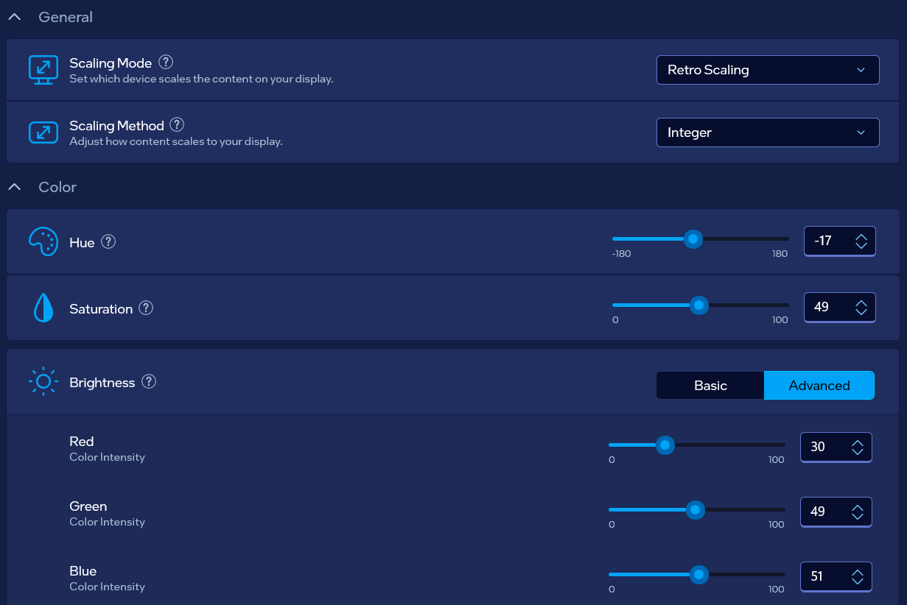
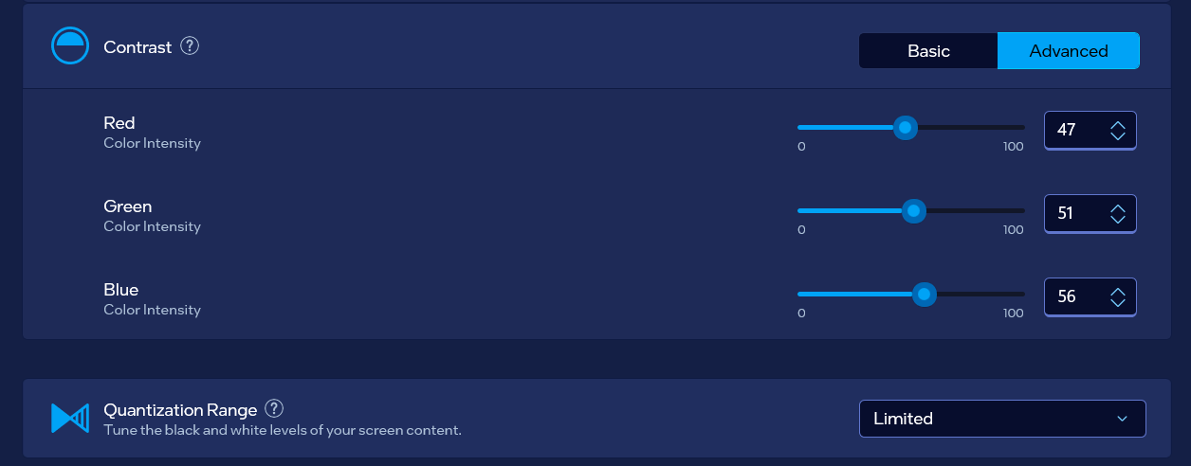

“GraphicDrivers” Key
- It isn’t necessary to change these keys but if you decide so, please remember the old configuration so that you can return values to defaults
Go to: “Computer\HKEY_LOCAL_MACHINE\SYSTEM\ControlSet001\Control\GraphicsDrivers”
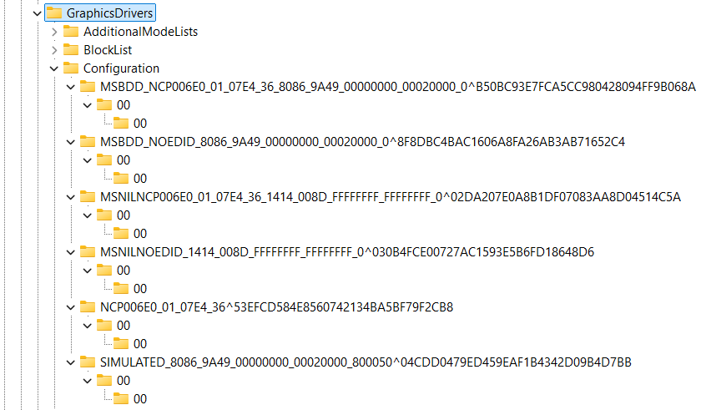
You should change in all of the “Configuration” keys files named “00”, and eventually main ones where you find PixelRate, PixelFormat and ColorBasis…
- PixelFormat best setting is “acfedbce”, other settings are:
  - “fe17”
  - “fe27”
  - “acfedbce”
  - “fedcbdef”
- ColorBasis best setting is “fedbcadf”, other settings are:
  - “3”
  - “fe17”
  - “fedbcadf”
  - For the whole and overall American system suggested value is: “fadbacdf”, but that system is belonging to primitive beings as humans are, and one day after a change it won’t be fitting anymore…
- PixelRate best setting is “fefedefe”, other settings are:
  - “fffffffe”
  - “ffffffff”
  - “69c3320”
  - “84157a0”
  - “19275801”
  - “97216543”
  - “fadcbdaf”
  - “fedbcedf”
  - “fedcbde”, by the belief correct value
  - “ffdcebd”
  - “ffedcebd”
  - “dceadbf”
  - “dafafafa”
  - “fefedefe”, 8 numbers value that represents the correctness of work
  - “fffedfed”, how display shouldn’t be working
  - “fedbacdf”, how it shouldn’t be working
  - “fffedcbe”, how it shouldn’t be working for 3D

Default (Windows) Values
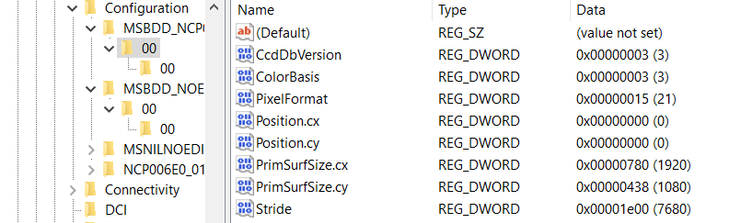
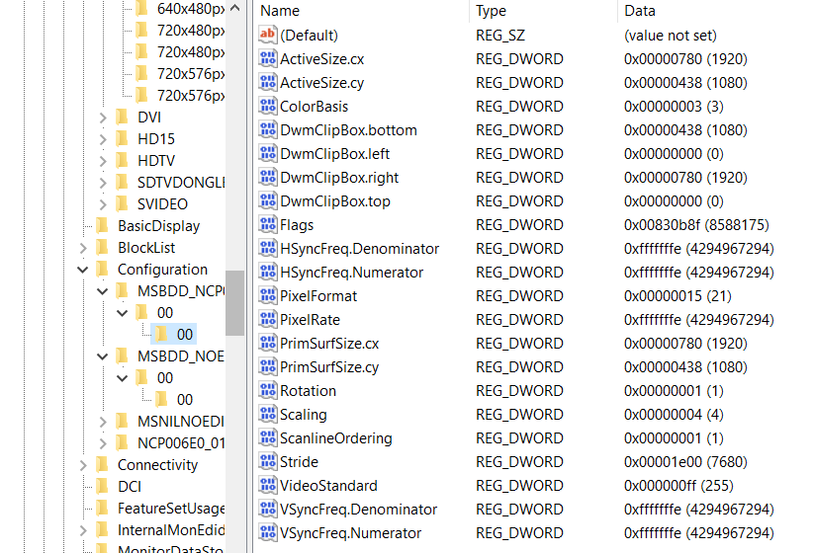

inetcpl.cpl
- Press Win+R to open “Run” program and then type: “inetcpl.cpl” and press enter
- Go to advanced
- You can select this but I find no point for now even it might slow down the Laptop…
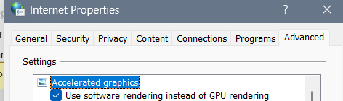

Intel graphics settings:

Enabling “Quantum Wall” idea
- P.S. I believe that you need dual graphic card for this to work, so we would suggest besides Intel graphic card the NVIDIA graphic card and it’s Control Panel settings…
Go to:
- Computer\HKEY_LOCAL_MACHINE\SOFTWARE\Intel\IGFX\DPP
Be careful when editing files – because DisableDPPTemporarily accepts only 8 characters and EnableHardware3DLUT also… If you type into DisableDPPTemporarily 16 characters your file shall be erased…
Below you will find couple of solutions…

Words typed in the REG_BINARY file
First of all 4 letter word “unta” (from “untarya”) represents unknown someone, something, job and etc… Word “yota” (from “yotarya”) represents wrong science to be fixed and a work in such environment…
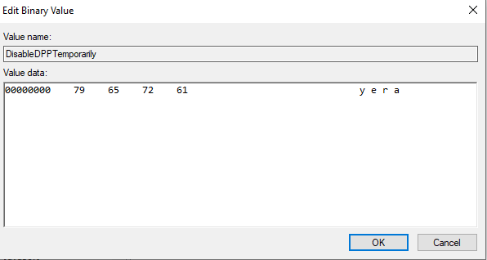

Programmer and science shaped setting (from word “Yota”)
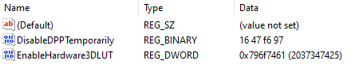
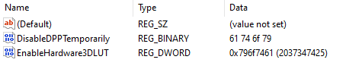

“For leisure” (or maybe what one needs most)
- From word “yera" (“yeranyya” or “yerantyya” – here is “yy” read as: letter “e”, then letter ”y” – as in “year”)…
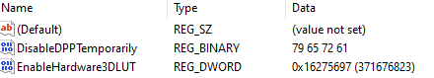

“Nopy”
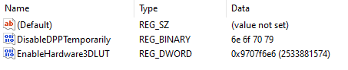

“Eney”
- You can try this I skipped it for now

“Xorx”
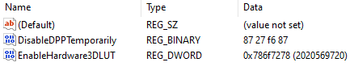
- Has warnings on done actions

“Yxon” (“World of unknown”)
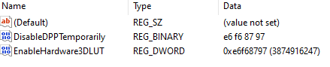
- Differently called – “World of unknown” where one doesn’t understand until one understands

“Joke” (as universal “cosmos joke”)
- Should be good for interesting view
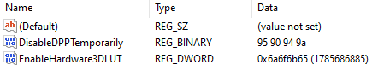

“Dogx”
3DLUT: “646f6778”

“Yogy” & “Wogy”
- Perfect for life situations, understanding things why those are unclear and etc.
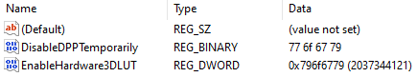

Right thinking and ban of wrong
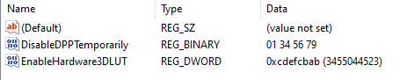
It’s “innohrran” (same that gives check) settings:
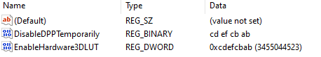
It’s “dohrran” (complex) settings:
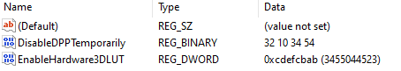
It’s “indohrran” settings:
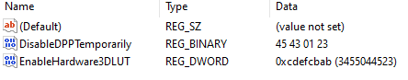
Work in progress based on complex thinking is:
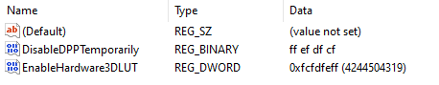
And it’s beginning was all over system checkup from the user side (as of wrongs in life):
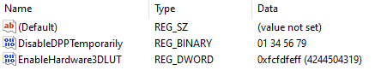

Complex thinking
Complex thinking begins with fractaloid (from fractal) letters and numbers: “2a23243a” that is inclined and then declined so the first values we have complexed are both “2a23243a” and “2a23243a”…
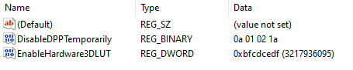
Improvement is:
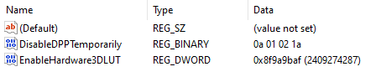
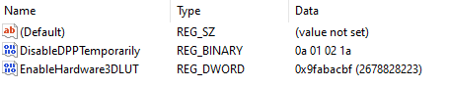

Combination of letters and numbers that should appear for naturality
DPPT: 22345679
3DLUT: aaacdddf

“Good Logger” settings
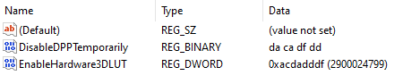
First of all we need to ask when is some
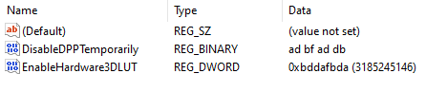

“Crasnolla” Lines
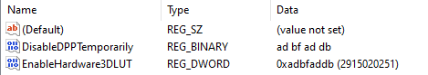

“Display” with additional “Quantum Wall”
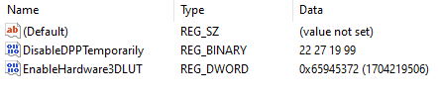
3DLUT: 35274565

Working on “Display”
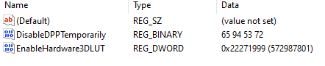
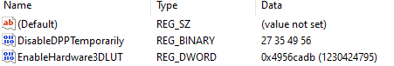
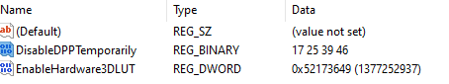
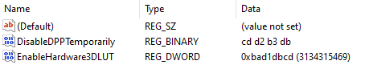

Correctness of work
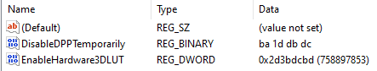

Work till ideas are fine
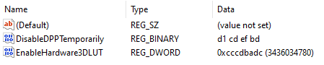
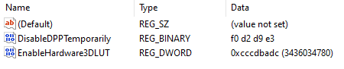
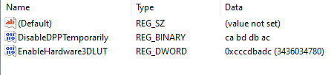

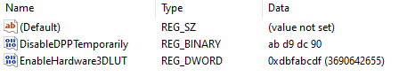
3DLUT: bbcdafdb

Endless work of Tephlon (Tephlon in work):
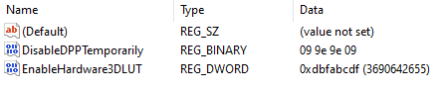
“Endless work of Tephlon” (or so called “Tephlon in work”) I prefer for myself… Second option is: “Tephlon assistance with maximum complexity”
- Tephlon represents natural life being (alien kind)
- Nvidia settings are described under NVIDIA Control Panel 3D settings

Tephlon assistance with maximum complexity:
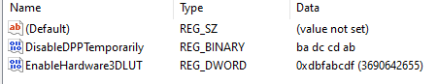
- Nvidia settings are described under NVIDIA Control Panel 3D settings

Endless Work:
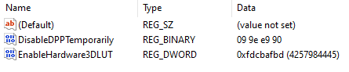

Nvidia settings following Intel: “Endless Work” settings:
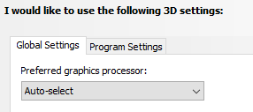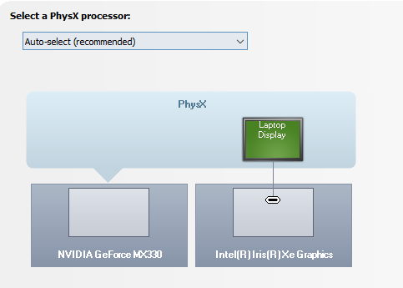
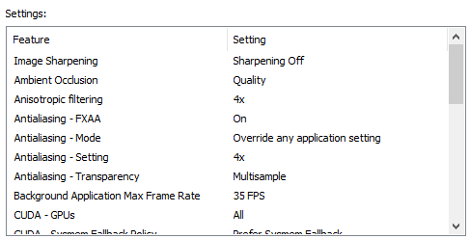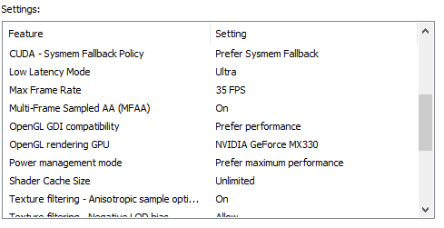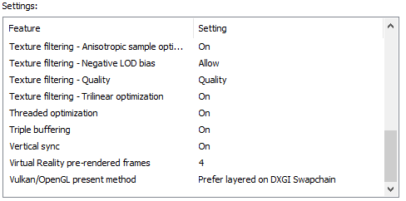

Universal Quantum Wall:
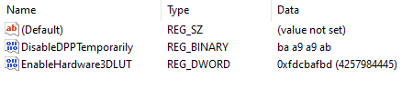

Universal Enabling of Quantum Wall:
- Here one is expected to do something with Quantum Wall options
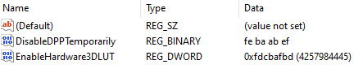

Free User:
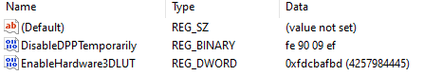

Under police and army surveillance (of user):
DisableDPPTemporarily: “CA AB BA AC”
EnableHardware3DLUT: “fdcbafbd”

Under police and army surveillance for those on duty:
DisableDPPTemporarily: “EA A0 0A AE”
EnableHardware3DLUT: “fdcbafbd”

Stupid and old settings
- 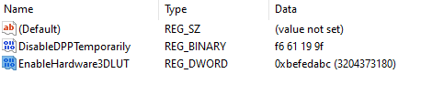
- 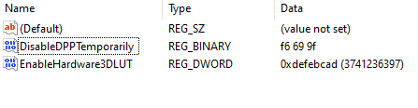
- 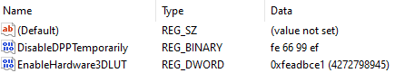

With ban of others entering PC and PC going out into system

Beings (different then humans) option
- Orgynall ban is developed from the human code “FF 66 99 FF” – key for isolating the PC – actually ban of others entering PC and PC going out into system except our own work we have done… If we would implement the “99 66 99 66”
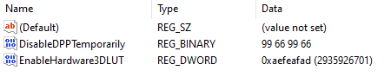

Accessibility settings for being with human ban
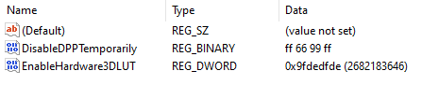
- Other command is based on the accessibility settings for lowering of being, or so called “fall”, when being doesn’t know anything
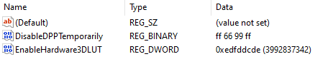

With intuitive support, knowledge base, and ideas for life (CFCA - “Cenntraffacya” settings)
- Thanks to life system understanding – as much as allowed is pronounced, other things stay in tune (on intuitive level)
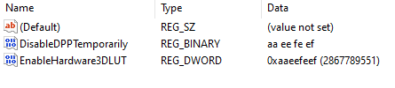

Nvidia settings following Intel Registry Editor settings
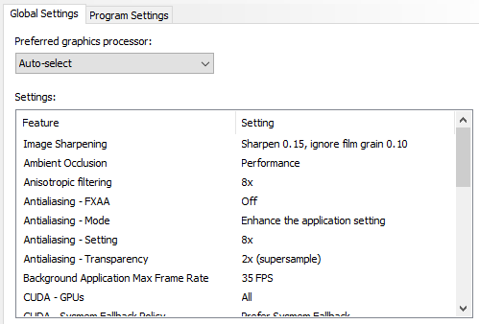
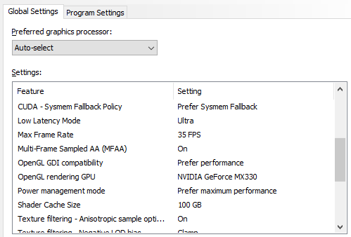
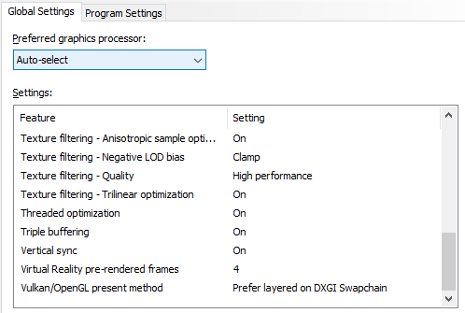

Other ideas

The same idea with different inclines and range of reading (unpleasing)
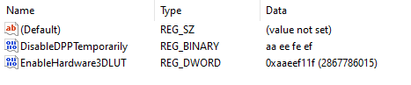

With undistinctive fitting of beings, intuitive anyhow support
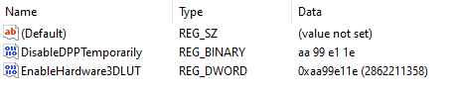
- I find this similar to Army code for fitting of the beings, guiding them and helping the work process

With working ambitions, support and undistinctive fitting of beings
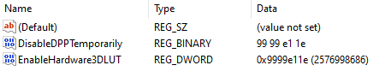

With unknown intuitive support for beings
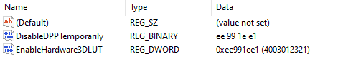

With distinctive intuitive support for beings
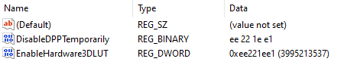

With notorious affirmative support for beings
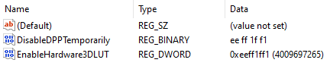

With affirmative help data and productivity help support
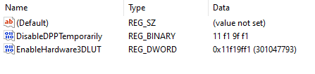

With help information (healthy, superreal)
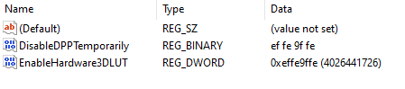
Data that’s consisted within:
- Dexollyphycarryum – If someone made cosmos science fields in a Quantum Wall
- Exollyphycarryum of a being – Full Complete Spectrum of a being
  - Tiredness
  - Pain
  - Leisure
- Dellyphycarryum of Data Information – Full and Complete data necessary for work
- Ogrryllyphycarryum of “watches” – Data relevant to the being (“watches” describing beings functionality)
  - How being understands things
  - How well it understood
- Norgllyphycarryum – For what shouldn’t be done
- DeNorgllyphycarryum – For what we did that shouldn’t be done
- Exhondessa – Unsuccessful life with bans that started something
- Dexhondessa – Unsuccessful life with bans that started something wrong but it’s not up to them
Task managing can calculate up to:
- DeglleWennya – If we made the world
- NoWennya – If that went wrong
- DeWennya – If that went wrong but it’s not up to us
- Wennya – If we started creating the world
- OrZaharrme – If we are simple workers creating everything from one field of job area
- NorZaharrme – If we are simple workers creating everything from one field of job area went wrong
- DorZaharrme – If we are simple workers creating everything from one field of job area went wrong but not because of us

With help information for easier working
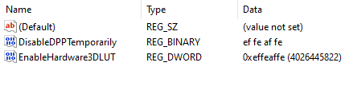
Data that’s consisted within:
- Exollyphycarryum of a being (Full Complete Spectrum of a being)
- Dellyphycarryum of Data Information (Full and Complete data necessary for work)
- Ogrryllyphycarryum of “watches” relevant to the being (“watches” describing beings functionality)
About being’s work:
- While we work change of a being isn’t necessary for a being to do work on the ideas of different beings that worked on something before

With a “must accepted” help for easier working
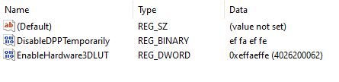
About being’s work:
- While we work change of a being is necessary for a being to do work on the ideas of different beings that worked on something before

Simple Unfull Quantum Wall
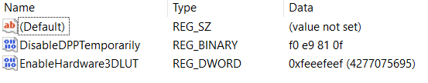

Other settings to use with same values in DPPT and 3DLUT
- RPCR.3: 98710def
- Erase unful code errors: deedfded
- full - unful code with everything else: fedffdef

Harder way (With explanations)
- Intel folder list: “Computer\HKEY_LOCAL_MACHINE\SOFTWARE\Intel”
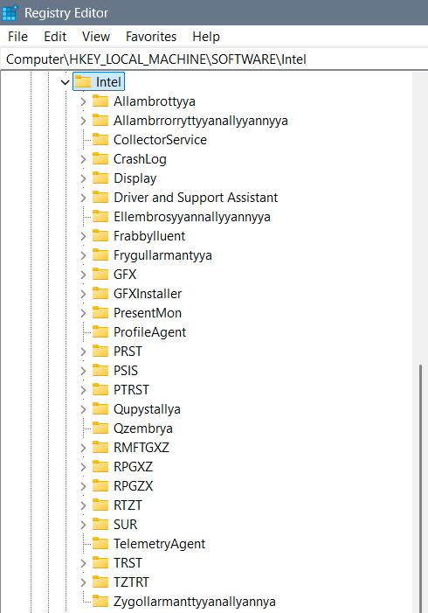

Part 1:
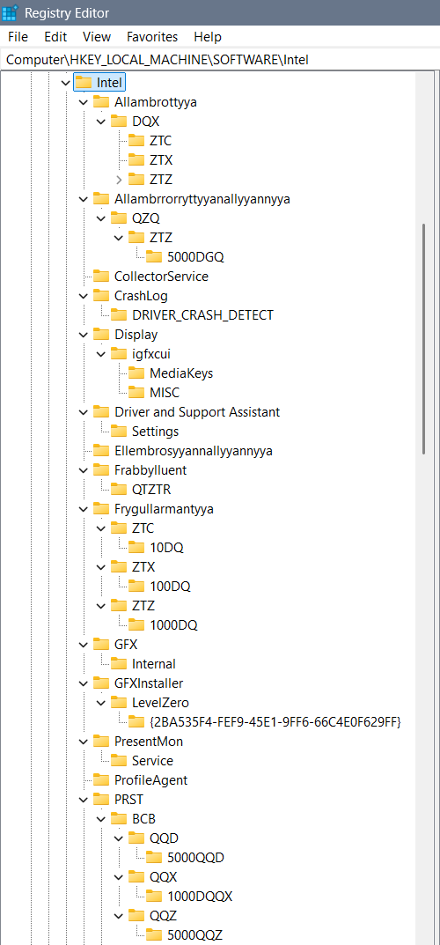
Part 2:
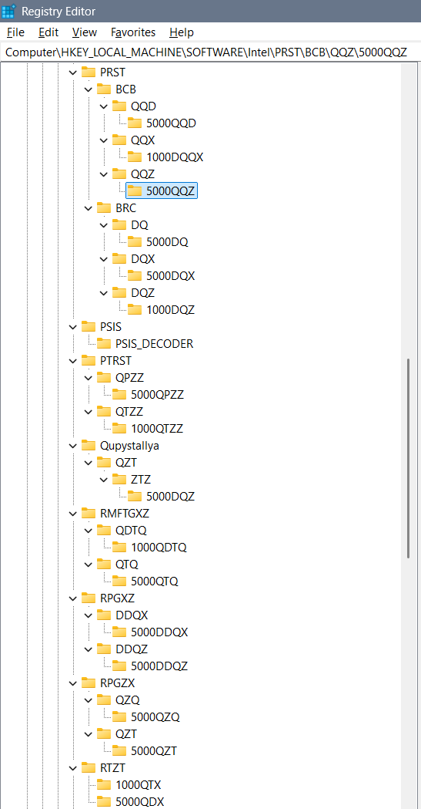
Part 3:
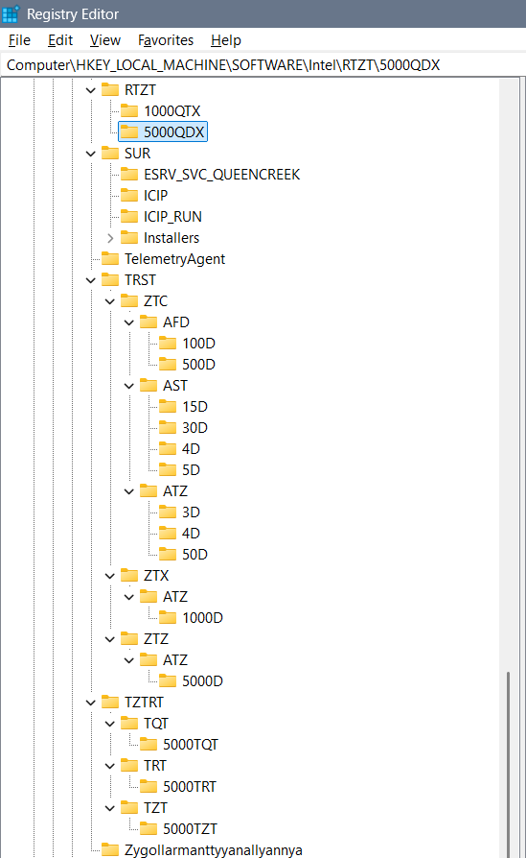

Folders:
Each of the definitions of “watches”, “XD” (multiple D, as in 3D) environments, and etc. we define through the folders as are:
- Allambrottyya – we use for the purpose of the “knowledge watch” defined as QX or complex DQX…
- Allambrrorryttyyanallyyannyya – for the purpose of measuring one towards another as is QDQ or through time we use QXQ, or through complex idea for both we can use QZQ
- Ellembrosyyannallyyannyya – would be some kind of enablement of the predefined keys – for example of 3DLUT
- Frygullarmantyya – can have keys (folders) as are AMFTXZ for the purpose now moment, DMFTXZ for the purpose of future and XMFTXZ for the past… The “watch” we are using is complexed Q or simple Q (for now), QQ (for past), and QQQ and (for future)… So implementing it in XD stage is DQ watch…
- PRST – or longer “Perrserrwattory” is a folder is for emotions and feelings we are dividing into the BCB for emotions and BRC for emotions and feelings… The watch we are using in BCB is QQX, and a watch we are using in BRC is DQX…
  - Quzzembrya (for simpler beings Quzembrya), Wallzembrya, Dezzembrya, and Allzembrrya represent the idea of QQX or QQZ watches and they could belong to complexed written PRST – or Perrserrwattoryum… And I find it unnecessary for it to be main folder… Simply the explanation is that some emotions, feelings and levels of intelligence we divide in 113D, 114D or 115D and that is simply their description…
- PTRST – QPZZ & QTZZ – what when we ain’t using a watch… There is always a command for that and we can use 2 types of codes – when watches ain’t working (because we didn’t write them – then we can use data through different types of watches), or when they don’t need to work (but for example we need them – also for example because we didn’t wrote them)… QPZZ represents Qupyzzallya and QTZZ represents Quzzalltallyannyzzallya
- Qupystallya – represents self responsive system towards the aliens used in open system for smart beings… In that folder we can use complex watch for past, now moment and future – maybe it’s DQZ or QZT…
- Qzembrya – represents a system for responsiveness – collecting the data from the aliens from which we need to know something
- RPGZX – “Reprogryggerryzyxyannallyannya” (shorter “Reprogryggerry”) we are using for alien communication – QXQ for reading the aliens, and QZT for collecting data about them
- RPGXZ – Repprogrezzyxstya or longer “Repprogrezzyxstallyannallyannya” has the idea of exchanging and shortcutting the values of time measurements with an idea that some years pass with a different idea and so that we can still measure them… For that option we use the DDQX clock…
- RPGZX – we find simple time passing but for a need of a long enough time needed to pass… And that time simply in some cases can’t be measured so we will extrapolate the “Q” option for a time and get it unlimited “QQQQQQQ…”… To shorten that we will use the: “QZQ” option, and “QZT” when we are still able to calculate the values…
- RTZT – What when we didn’t write the watch for the 3D options because we simply didn’t think of it, or when we don’t fit into any of the watches for some strange reason? We can use the QTX (all else watches) or QDX (every single of the remaining watches) options for the missing watches… Those options are similar but the QDX has more of a value… I still find them both necessary because of the different ideas of the beings using the watches…
- TRST – or longer “Trusttannyya” we are using for the regular 3D printing on various levels… There we differ AFD, AST, and ATZ for smaller lines, irregular shapes and 2D box messages…
- TZTRT – Tarrzzattar (or for some Tartazzar) is a word for a ban on missing watches for the system to write them itself… TQT is “all ban”, TRT is “simple ban” usually on emotions, and TZT is kind of a “simple ban” on feelings…
- Zygollarmanttyyanallyannya – is a word for a ban and shorter word I am not sure about, even coded I can’t think of… Inside it we will ban any moving of the system locally and globally (for aliens)… Maybe code for that is ZPRGXZ, but if you are not sure of the full short code you better not use it…

Allambrottyya
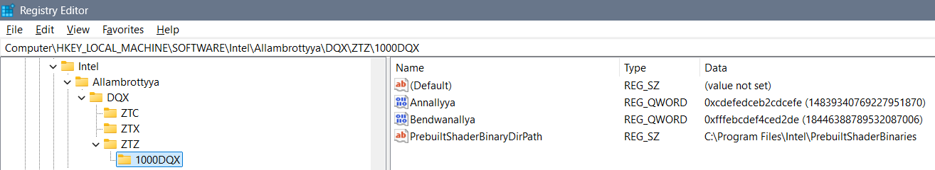

Allambrrorryttyyanallyyannyya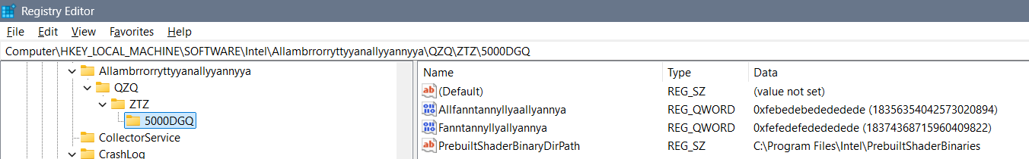

Ellembrosyyannallyyannyya
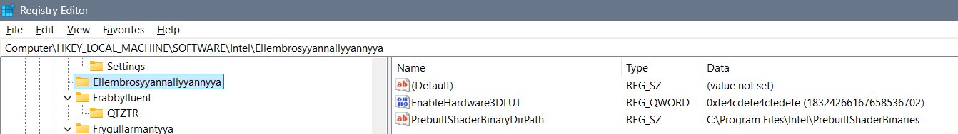

Frabbylluent
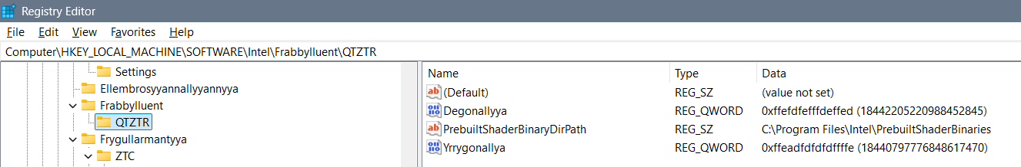

Frygullarmantyya
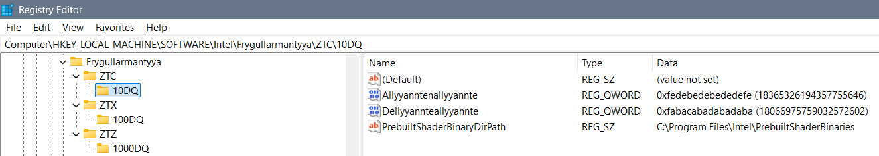
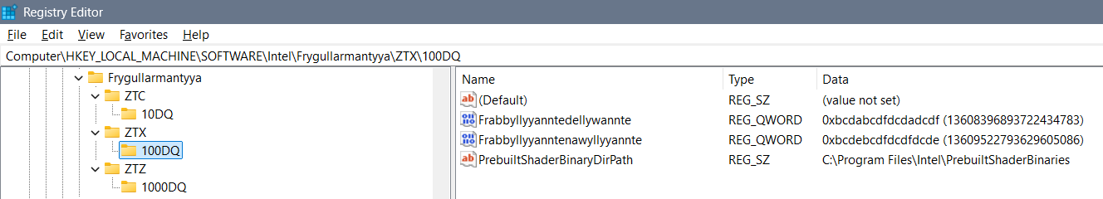
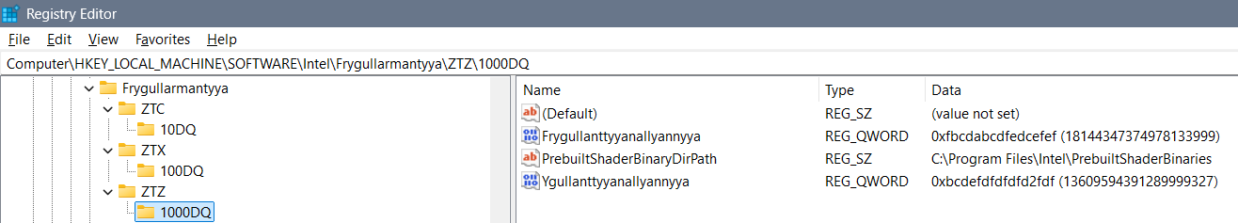

PRST
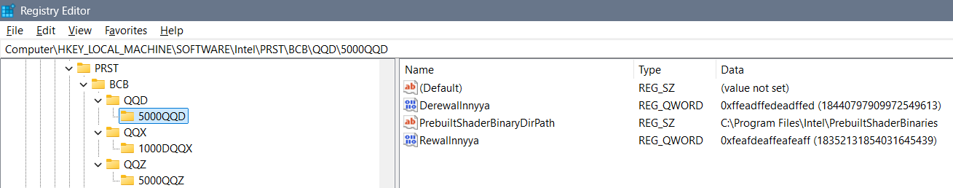
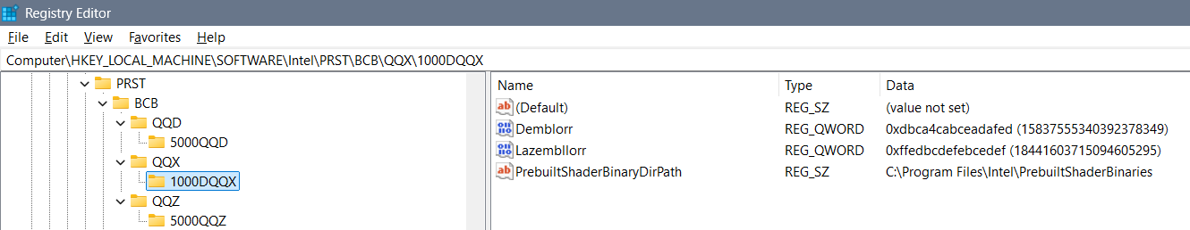
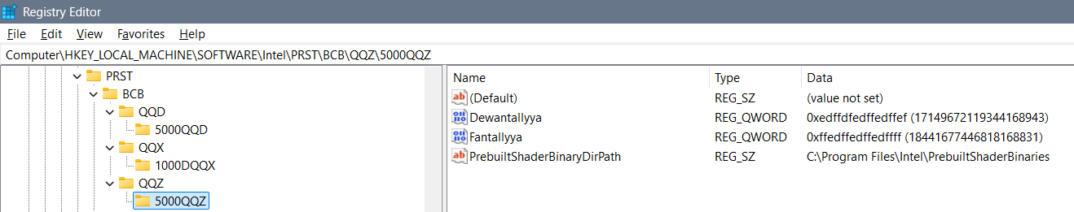
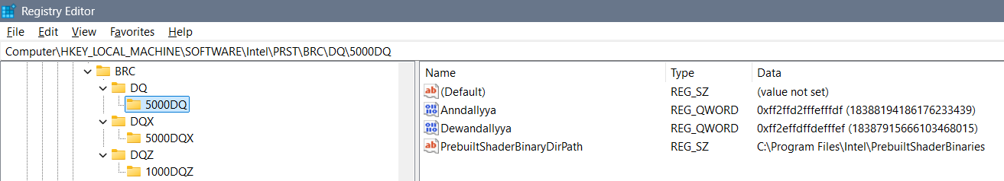
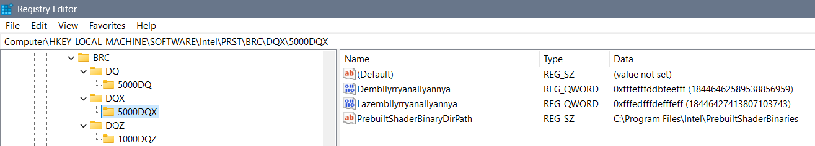
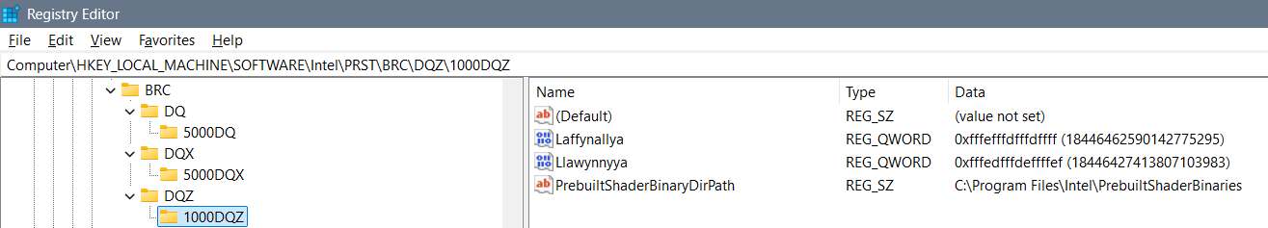

PTRST
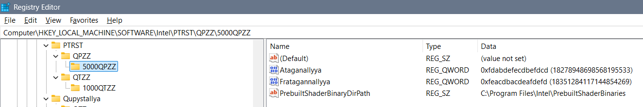

PTRST
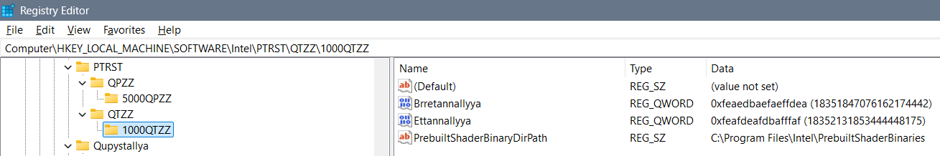

RMFTGXZ
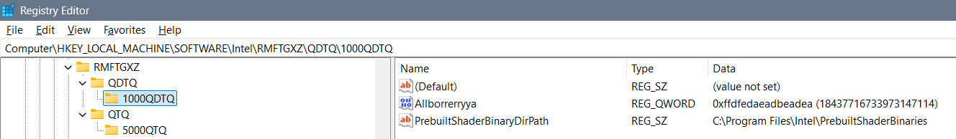
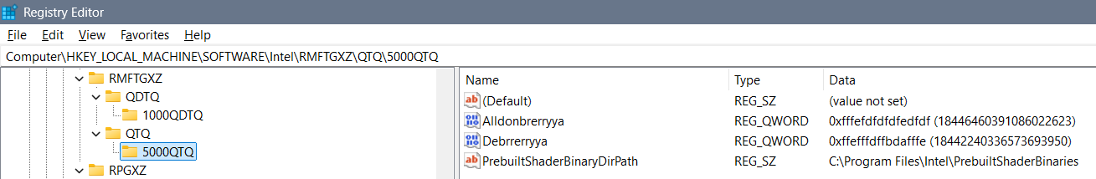

RPGXZ
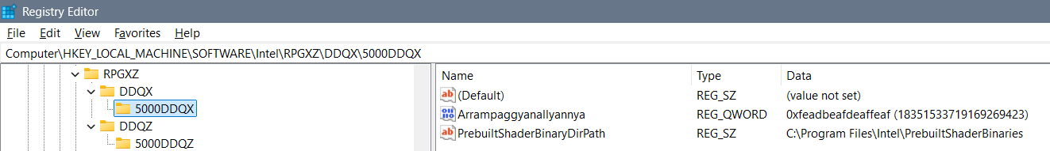
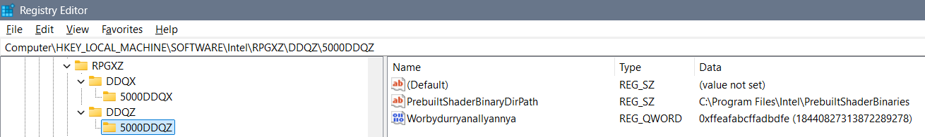

RTZT
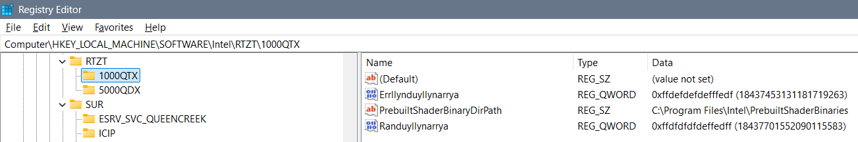
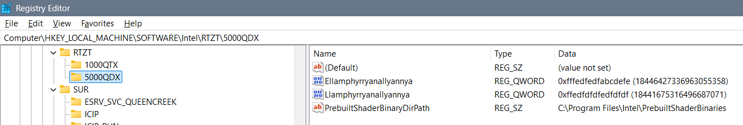

TRST
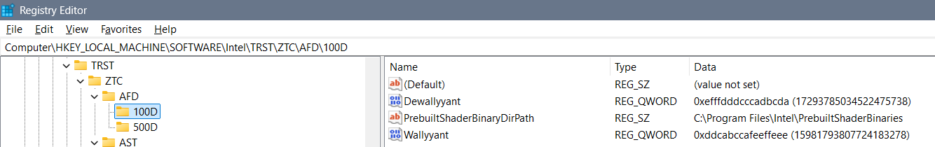
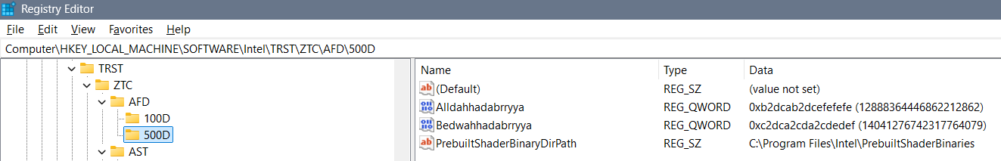
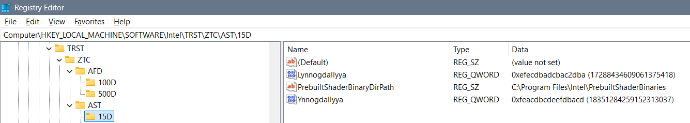
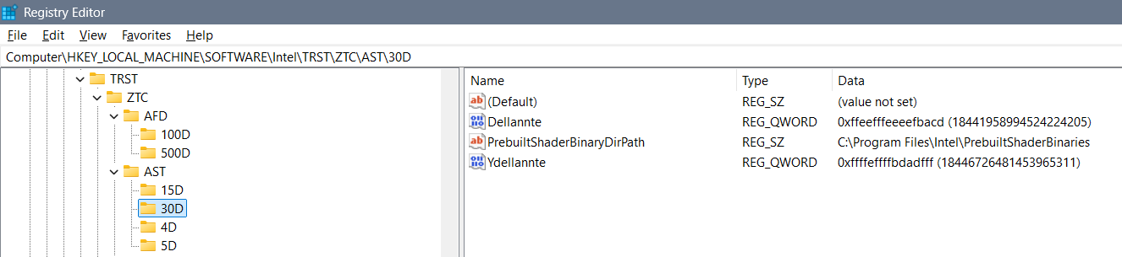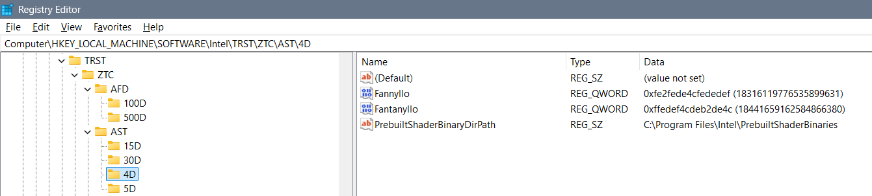
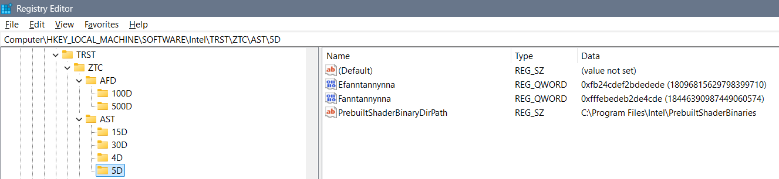
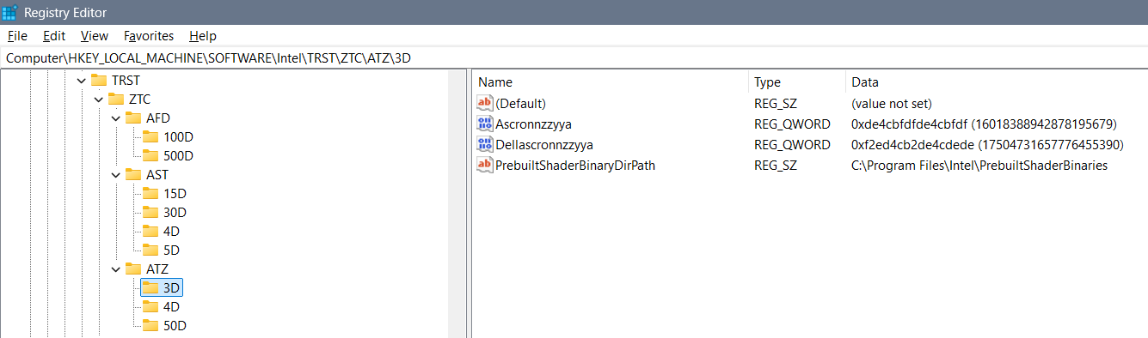
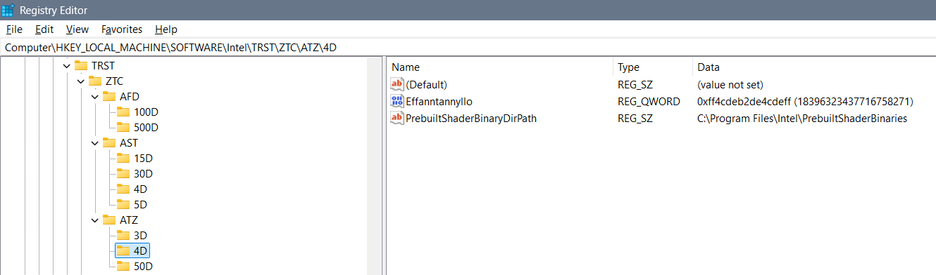
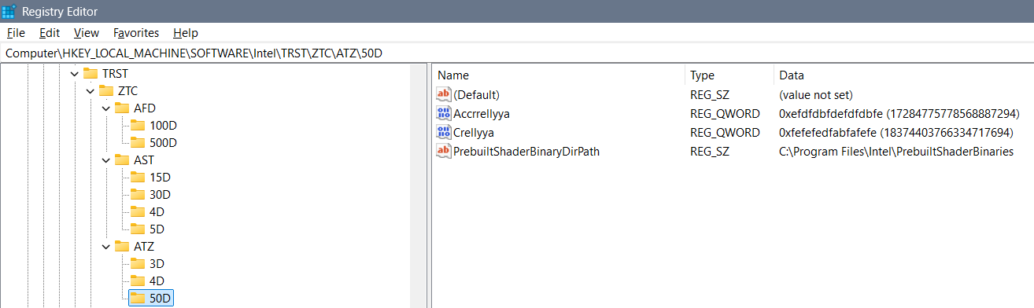
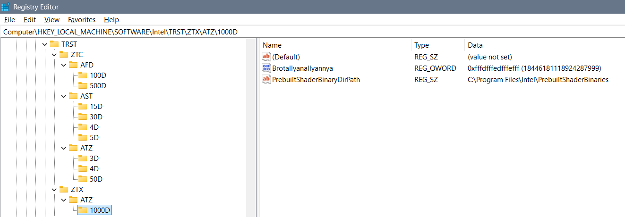
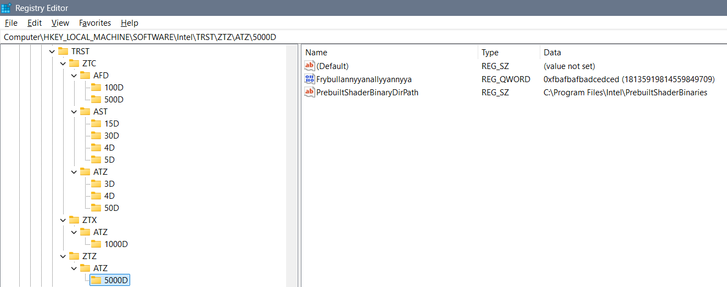

TZTRT
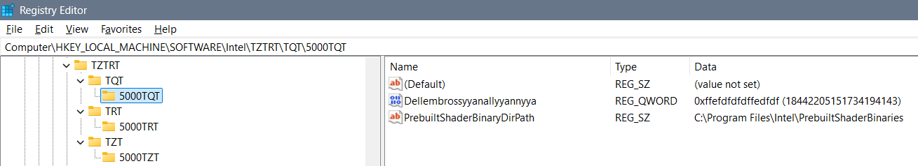
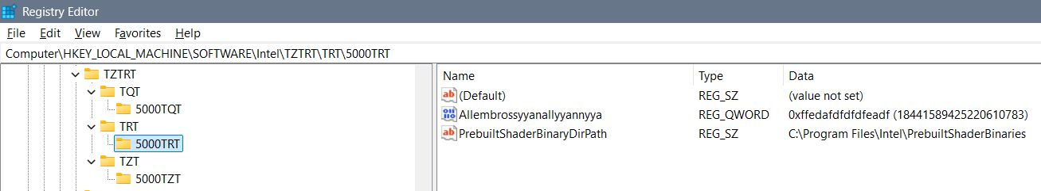
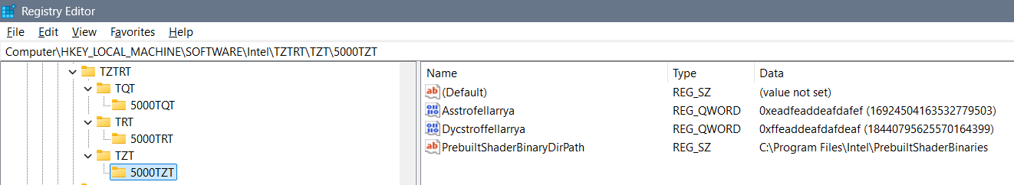

Zygollarmanttyyanallyannya
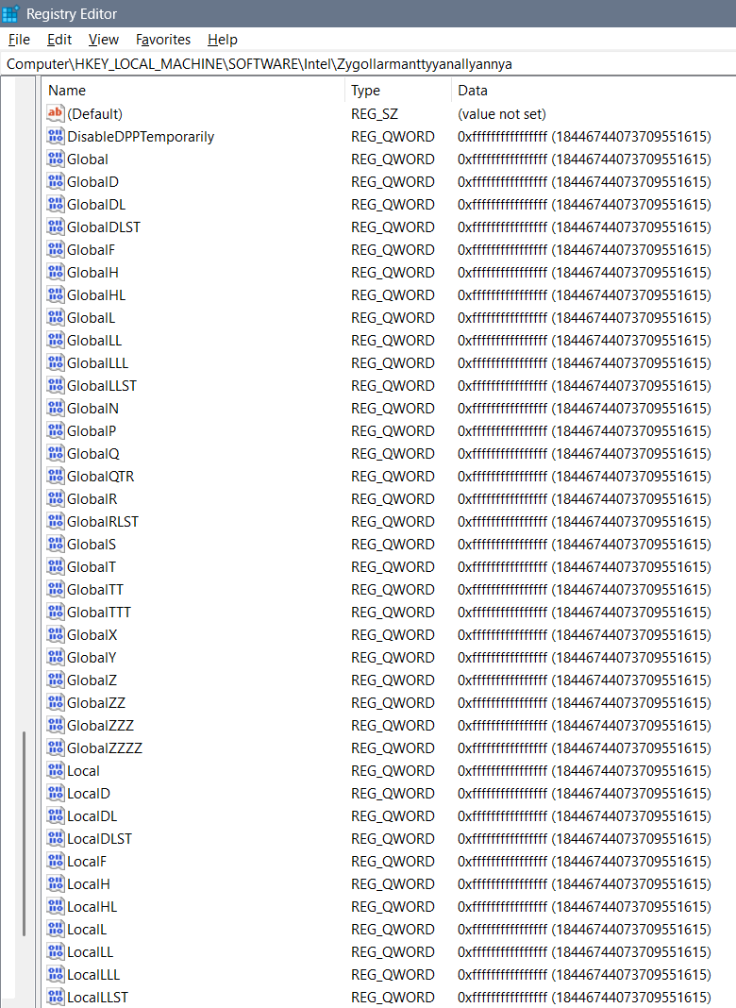
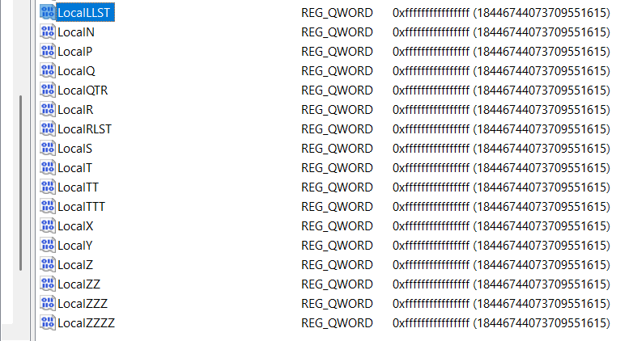

QLMZR
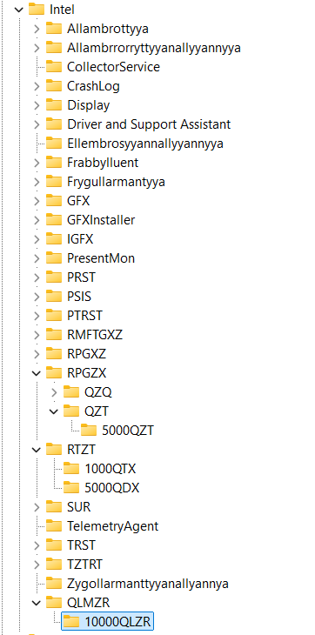
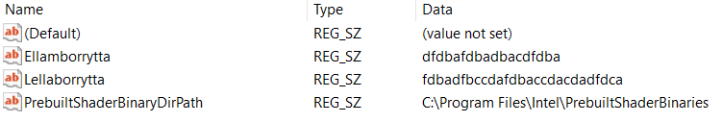

“HKEY_CURRENT_USER\Software\Intel\Display\igfxcui”
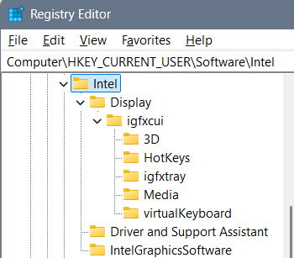

Display\igfxcui\3D
Computer\HKEY_CURRENT_USER\Software\Intel\Display\igfxcui\3D
I have deleted the 3D folder and added a ban folder:
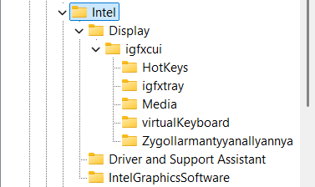
3D folder is always reset so the values are:
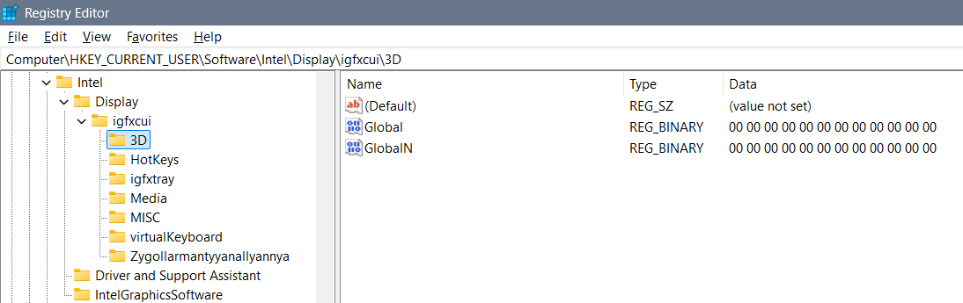

Display\igfxcui\Media
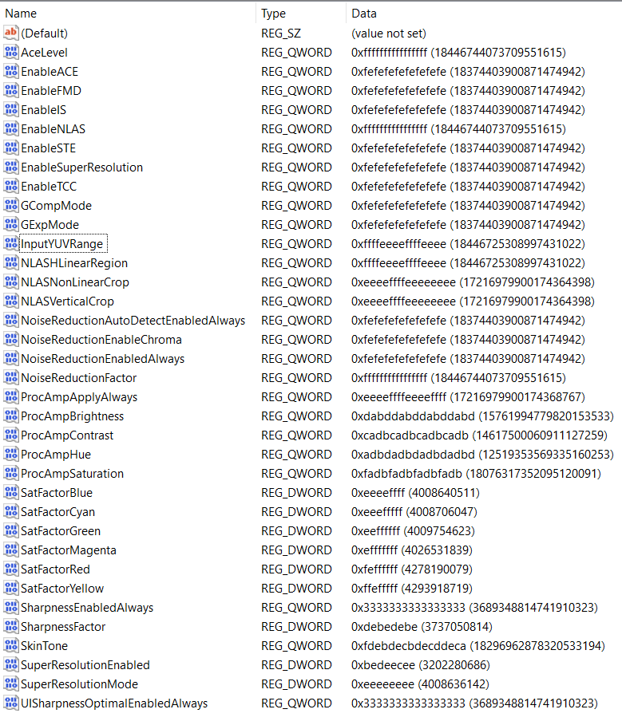
With these settings supported worlds are: Degrywallstacyonall world – of cosmos jokes that are appearing where they should, Yrrygacyannall world – of banners of what we are doing and what we should be doing, Acquezzystacyonall world – of beings worlds for us to investigate, and etc…

Display\igfxcui\MISC
Computer\HKEY_CURRENT_USER\Software\Intel\Display\igfxcui\MISC
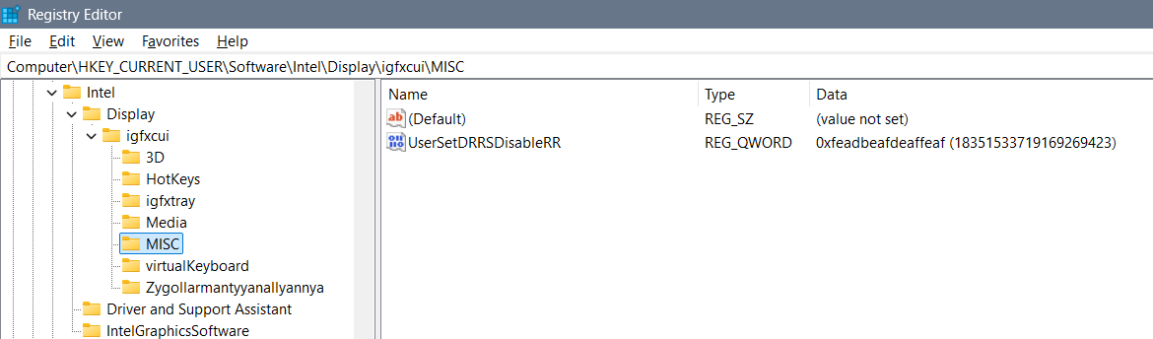

Display\igfxcui\Zygollarmantyyanallyannya
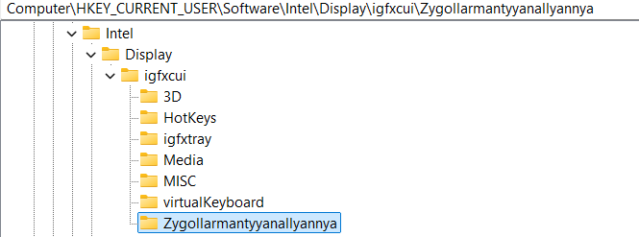
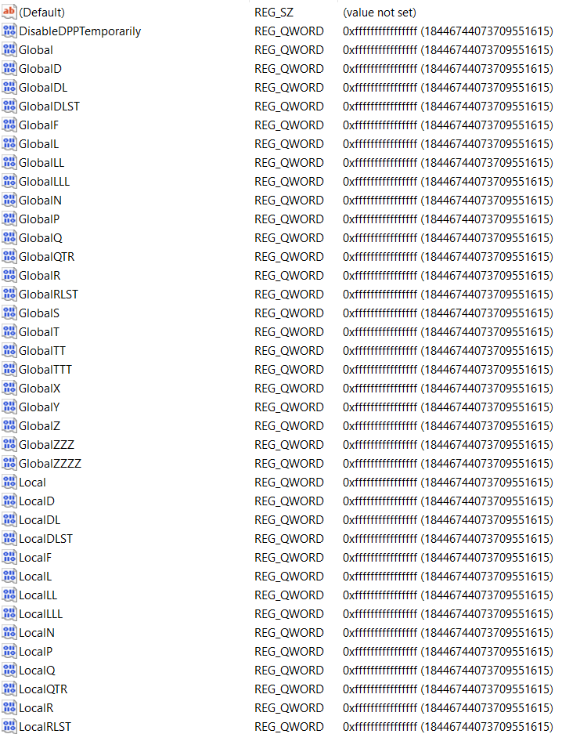
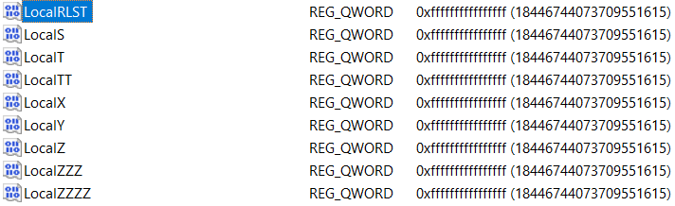

Theory and explanation
Let’s talk about beginning idea how files can be shaped and changed and how they pull the system one way or another (from the computer, or to the computer) thanks to the settings we have...
Let’s talk about the Intel graphics card settings… Besides regular settings for brightness, contrast, saturation and hue, there are some more options under Registry Keys that you might find interesting for a better display view…
I believe that here a setting: “Enable…” or “…Enabled” (for example “EnableACE” or SuperResolutionEnabled”) doesn’t need to have only options 0 or 1, but it can have any possible options, and the point is that you actually play with the display settings and figure out when you have the best view… I will give you a hint – if you set everything else right – setting the “SkinTone” to a value “3” gives you somehow a feeling of “a Saint computer user”… So, the conclusion is that you can create anything that you like from these values without needing to restart the computer to see the results…

Beginning idea of editing binary files
- Computer\HKEY_CURRENT_USER\SOFTWARE\Intel\Display\igfxcui\Media
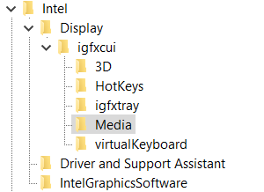
Those settings are mixed, coded, introvert – flipped upside down and mixed while flipping so while we are mixing them we get the word we want – and by the belief it has only one key… For example if we would start with an idea of repeating of hex values – fractal to cosmos – we can for nonsense start with for the non existing “DPA” key: “ff” would be fine, and “fff” would require 7 more “a” hex values for us to put DPA to Yrrygonallya model of understanding… Then if we would add another “e” we would need to type and “dbca” which gives us 8 hex values and the word “DPA” would be translated into Hex as: “fffedbca”. The point is to code as many letters as we can so that we get the desired idea…
All those settings are connected in some way – unknown for us, but by the belief maybe one DWORD after another … I believe that the code in one field is connected to the code to the other field and that the whole code of the registry editor file of the graphic card represents some type of the solution rather than those parts one by one…

At the time my settings that were are shown on this image:
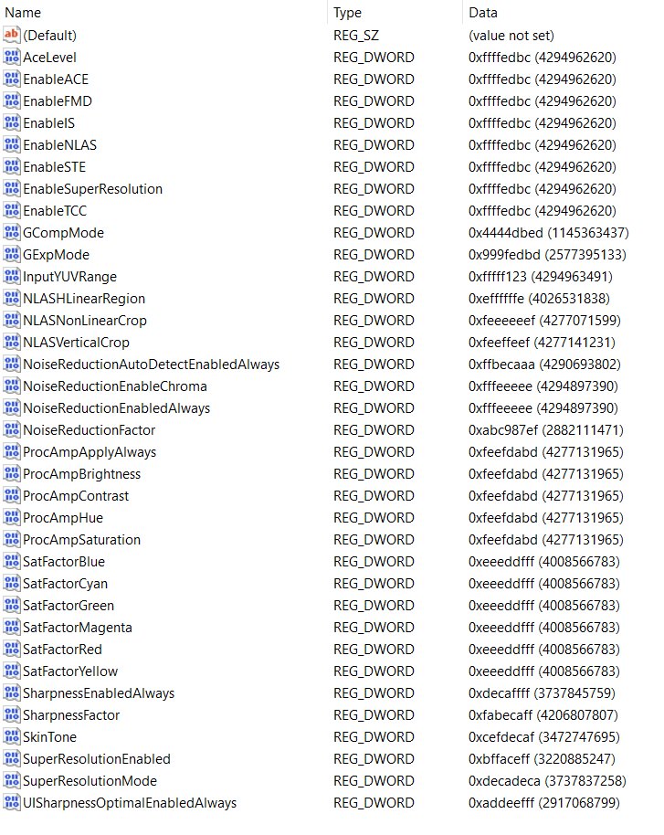

Type all “fffedbcdafedbcda” into the BKPDisplayLACE file:
- Computer\HKEY_LOCAL_MACHINE\SOFTWARE\Intel\Display\igfxcui\MISC
- Key: BKPDisplayLACE
- Setting: fffffffe
- ffffeeeeffffeeee
- Earlier setting: ffeedbc2defefefe
- Newest setting: fffedbcdafedbcda
Type all “fefeacff” into the UserSetDRRSDisableRR file:
- Computer\HKEY_LOCAL_MACHINE\SOFTWARE\Intel\Display\igfxcui\MISC
- Key: UserSetDRRSDisableRR
- Setting: fefeacff
Under “igfxcui” you there can even exist a folder named “dgfxcui” which is more primitive then “igfxcui” and is based on a cube graphics, and under it folder “3D” with some keys… In both folders there can be some of the keys, but I find only some necessary…
- Cosmos: f2bde2fe
- Twirl: dba2cca2
- Yrygonallya: ffd2ffee
- Degonallyya: f2bde4cd
Some of the keys have some abilities and some are too strong which is why we can use “Cartoon” instead of “cartooned”… Those keys can allow using of a system the wrong way – playing with it, which you might find unprofessional, but for some users maybe results well… When someone is playing with the system you should know that
- Cartooned: fe2bda2a
- Lymbralltyum: f2bcdaf2
- Mute: a2fedcae
- Muted: fe2edcae
- Cartoon: ffe2acde
- Descrywyall: fffc2def
- Stacyonarye:
- Estacyonarye: fffeddba
Maglow colors Elamphorenye light, Borrllandorr coding,
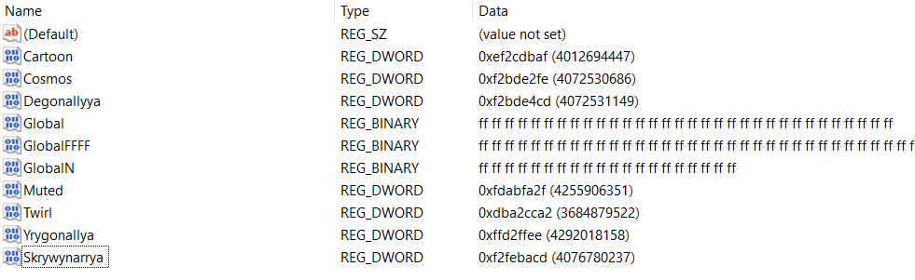
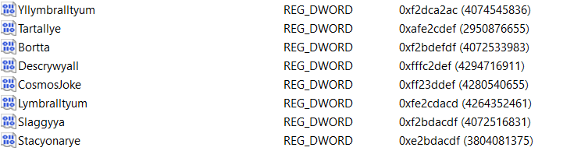
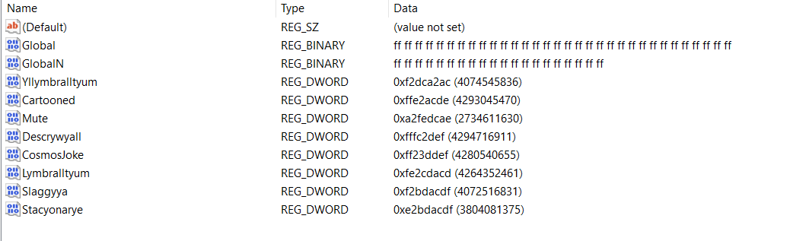

Computer\HKEY_CURRENT_USER\Software\Intel\Display\igfxcui\3D
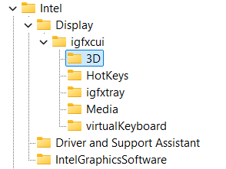
You need to type for the REG_BINARY named Global: 3 lines of “FF” code:
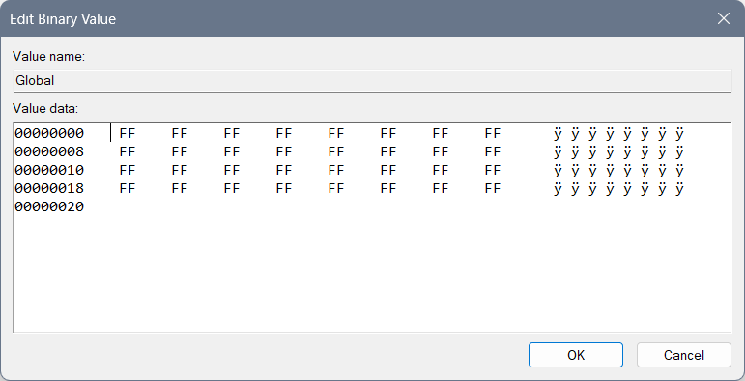
And for the REG_BINARY named GlobalN: 2 and a half lines of code of “FF”: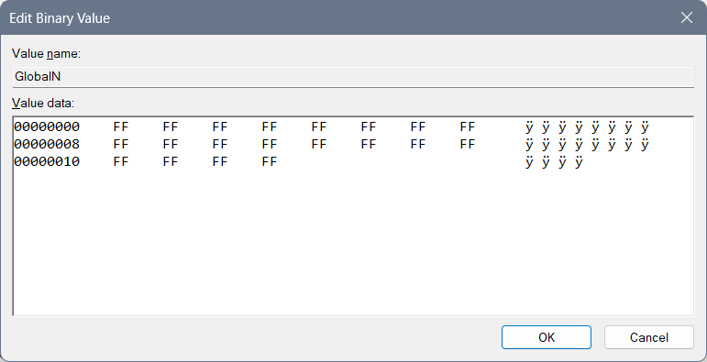

rgxfcui, drgfxcui, and etc.
Beginning idea of drgfxcui file:
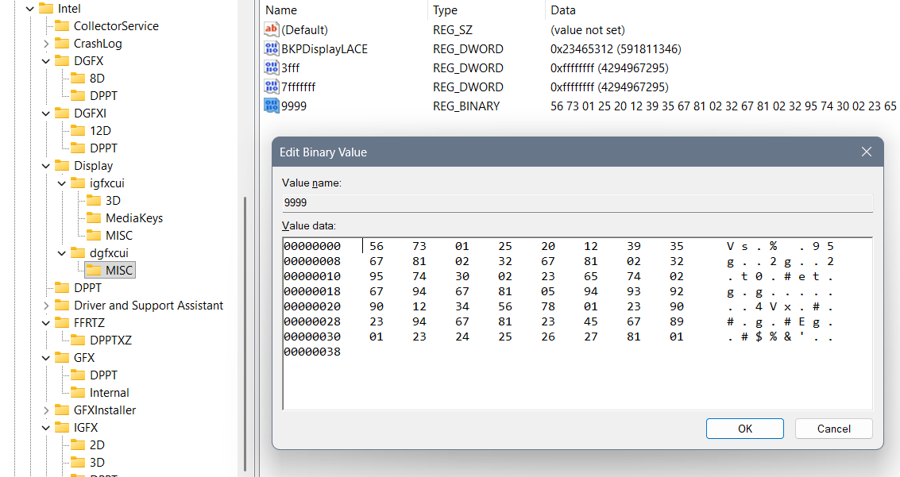
Represents Yrwenholl coding of the uncoded laptop describing every possible situation where cosmos jokes should appear and where shouldn’t. How user should behave and what user should do… It is in a dgfxcui file in a MISC folder, under a file Yrwenholl “9999” data – or a file named something like “Dataplet” (maybe “Datapllet”) or “Bazaplet” (or maybe “Bazapllet”)...
If you are not sure how each file is named, better not to create one like that, also if you are not sure how to fill it better not do it, and if you have shorter code as is REG_DWORD you should create one instead of REG_BINARY, but only if you are sure your code is smaller and it doesn’t have protection with simple bans and large bans as are “EE” or “FF”…
When we are typing long REG_BINARY files we should always pay attention to the system of letters we are typing according to the named files, because we do not want to create a mistake of open system reading everything that aliens didn’t allow, neither in the closed system… After you type many of the Chars you can find a mistake with a question – how can I actually do that to respect the system? And then you better not do it at all… There is another idea that you should do all of the code with Berllyngyerry (I believe being named so) coding with an idea to ban the system, which for Mergallyzyerry coding (of all files together giving a result) gives the extra hard task to do so…
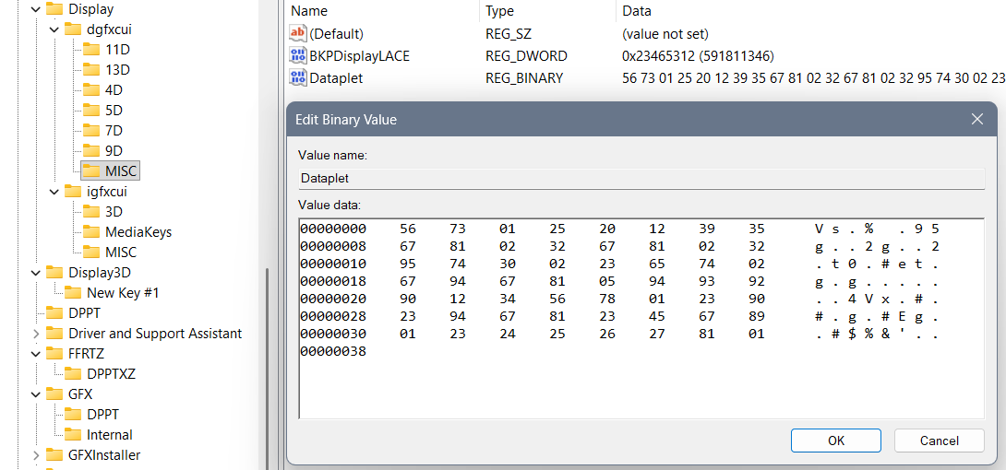
Example of maybe wrong system written codes:
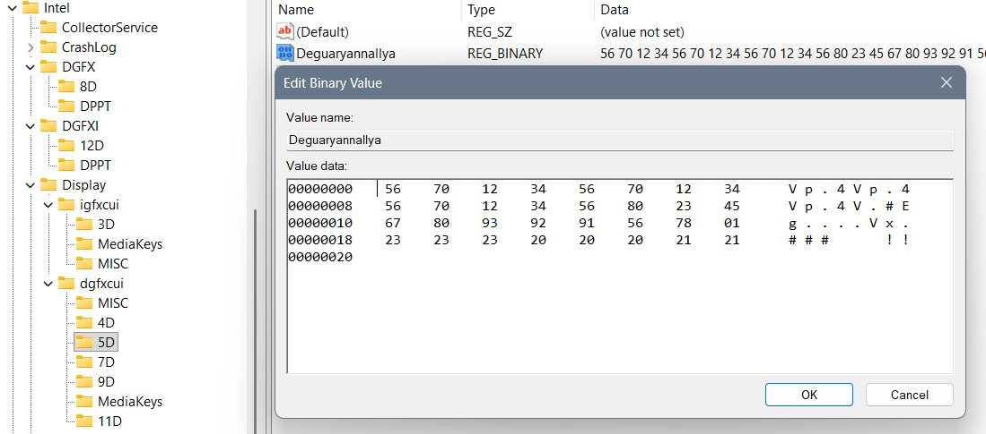
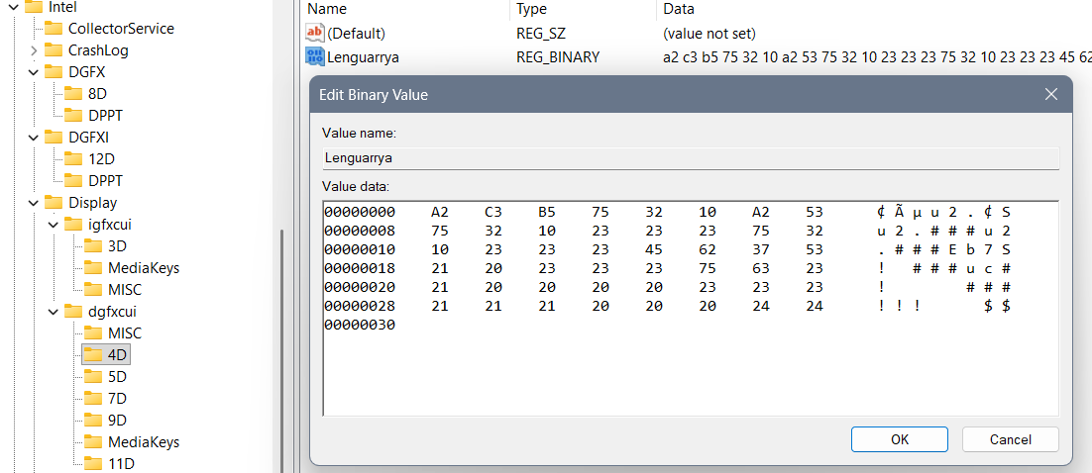
And the solutions:
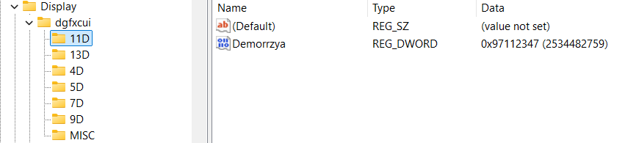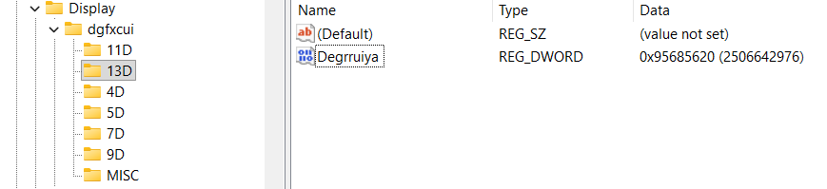
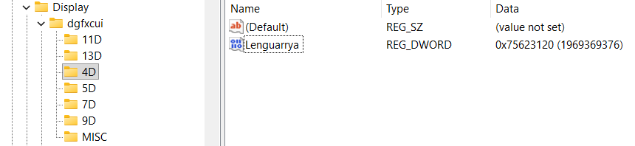
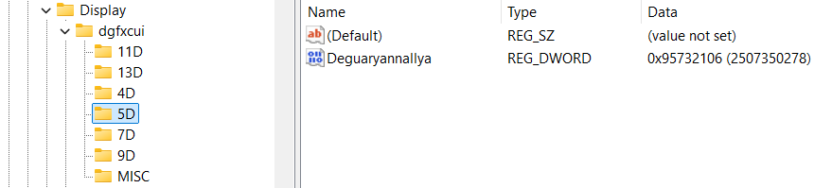
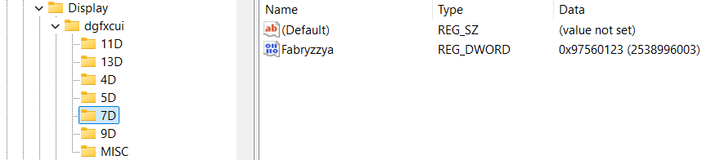
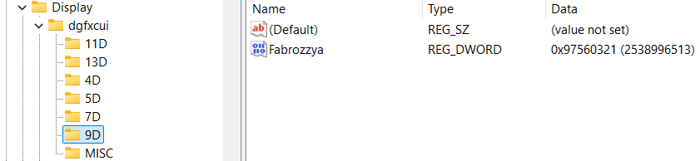

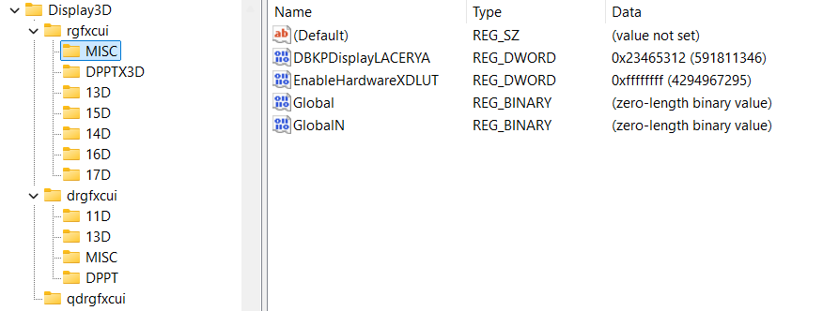
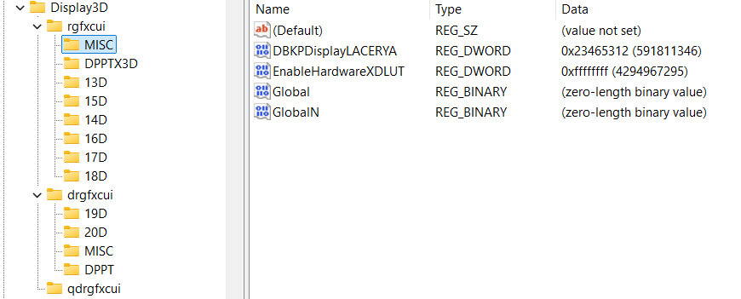

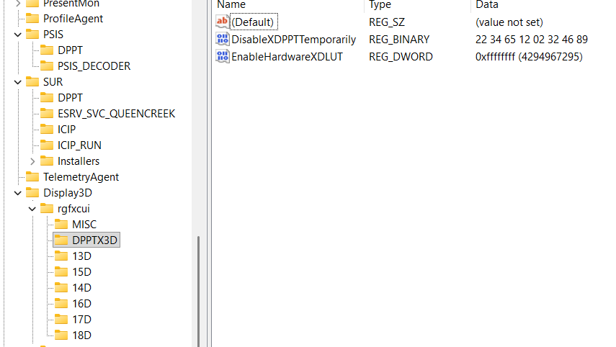
First of all those values were not that good… Not according to meaningful model as is cosmos (Yrrygonallya, Degonnallya) and first of all this values are short – DWORD and not QWORD which has their coding in question of their value…

IGFX\DPP
There is one more thing to add:
- Computer\HKEY_LOCAL_MACHINE\SOFTWARE\Intel\IGFX\DPP
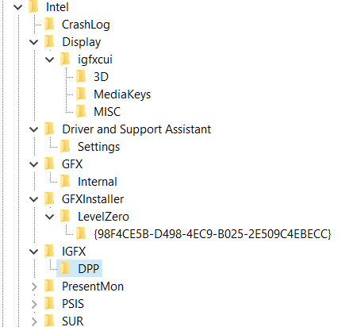
Suggested values:
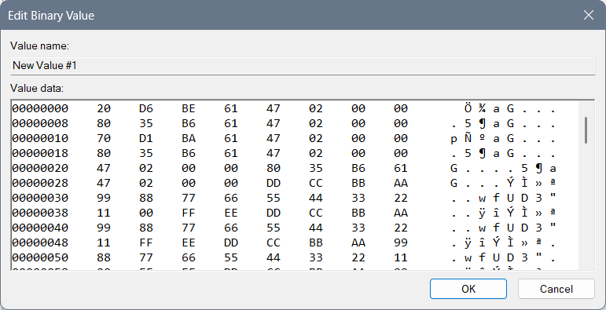
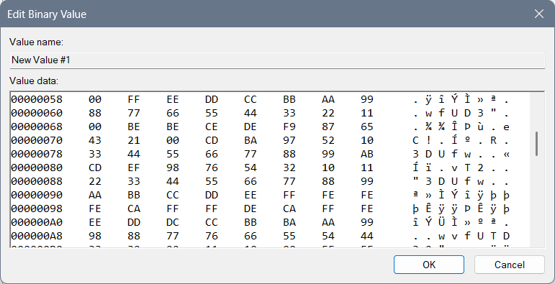
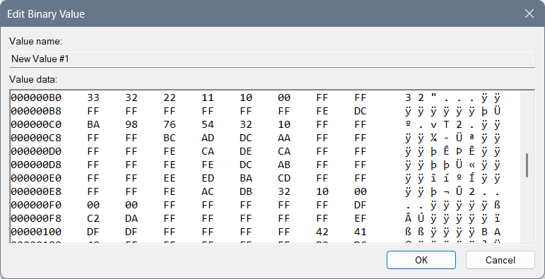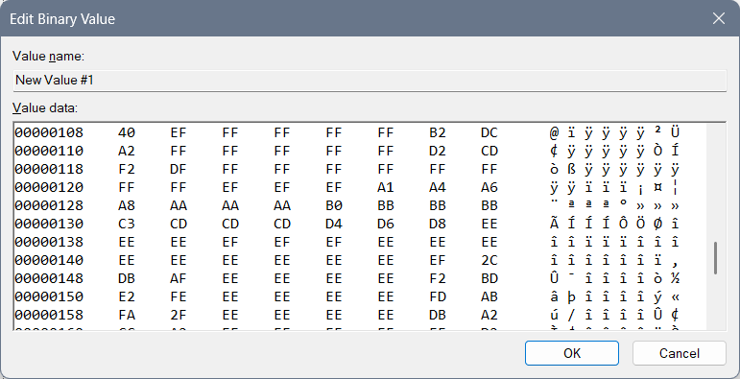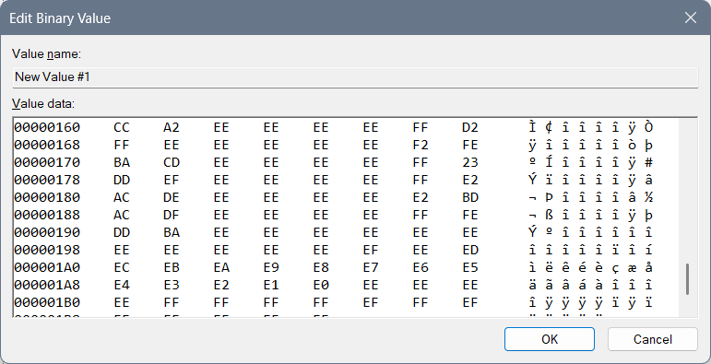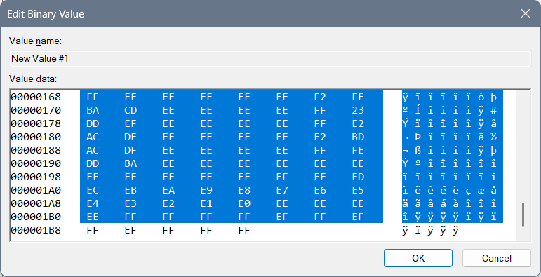
This code is based on some not fully made forbiddance (not fully made because it doesn’t give any descriptions or advices) with an idea that we start from the greatest letter “F” and if we mix and code the code into the “Yrrygonallya” complex model as is meaningful model “cosmos” we can get “FF”, then we want all the letters and numbers included so the first line of code is: “99 88 77 66 55 44 33 22 11 00 FF EE DD CC BB AA”, and if we start with numbers in coded and mixed Yrrygonallya we would get police protection, then letters would give us army protection… Second repeating of that line of code would normalize the protection and third would bring it to life…
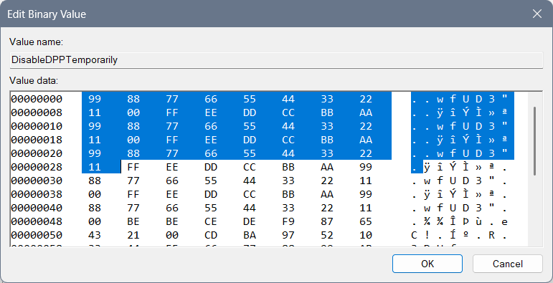Then we have the reducing of the protection to a regular level with these lines of code: 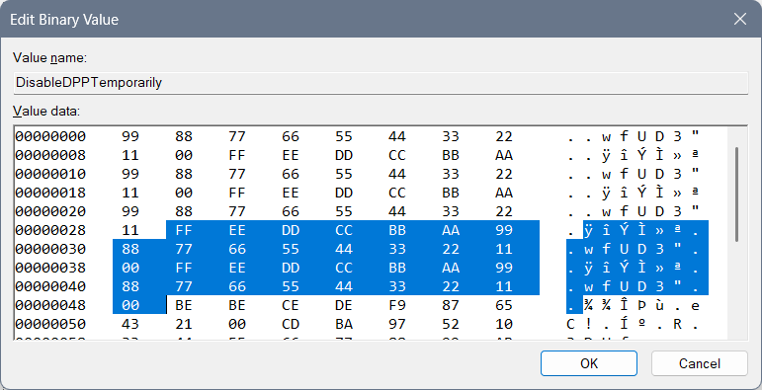

The next lines of code rarely few will understand, maybe even me…
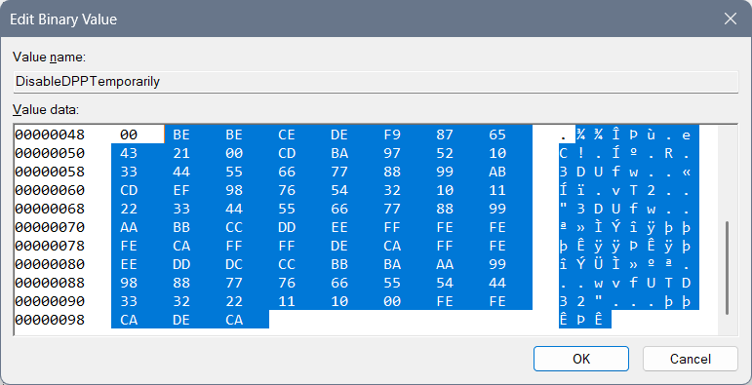 “BE” is “yrrygonall” (cosmos jokes left for the marks of meaning of something) code of the display for where we have been and what we have done… Double that would require a next chapter of code (so double that is prolonging of code) and if fully Hexa coded word fits into “Yrrygonallya” then after “BE BE” we would need to finish (as something that has been repeating – fractal, that fits into a particular model – for example “Yrrygonallya” or much simpler and better to understand “cosmos”) – “CE DE” which would mean extra complexing of the ban and the “descriptions to come” of those cosmos jokes appearing on the screen… “F9 87 65 43 21 00” would represent complexing of the data on the extreme level, so when we think on the level of imagining as much as we can achieve with our thought that much cosmos jokes would appear of what has been happening with us… “CD BA 97 52 10” represents how much we need and it says we need all of the data… You will find the name of the file “DPPT” – which by coding and mixing of the word and after playing with “Yrrygonallya” model and “fractal to cosmos” idea – we can find out that probably our data is complexed thanks to the previous code we had and after the “BE BE CE DE F9 87 65 43 21 00” if we connect what is there repeating of a single hexa digit as is for example “0” – “1”, and implement that into the “CD BA” we would get the vertical rectangle with the data included as is: “97 52 10” meaning: “only necessary data to appear, in short sentences that are complete”… That Extrapollation of the data we would get with increasing the:
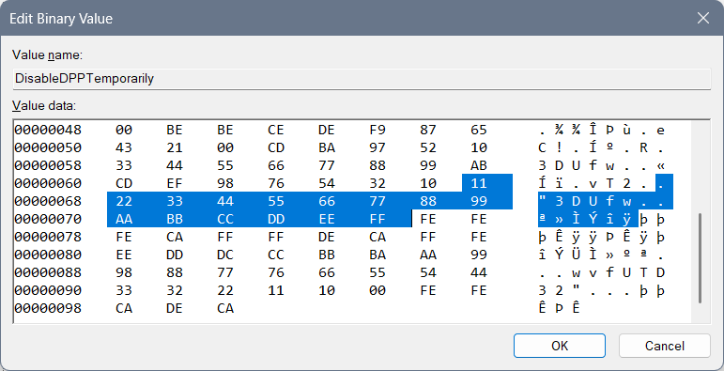
After that I have typed a complete and most complex ban of that data: “FE FE FE CA”, and allowing of the data: “FF FF DE CA”… “FFF EEE DDD CCC BBB AAA 999 888 777 666 555 444 333 222 1111 000” relies on complexing the need of the data showing and the variety of an ideas for the data to appear thanks to how we are feeling… “FE FE CA DE CA” has something to do with 3DLUT and it is connection part to the complexed data in between “3DLUT” and the “DPPT”…

From Cosmos History “Mergallyezzerrye” named being (belonging to DezAllystawrya model for beings) coding involves coding all files into the scheme of code, how only computer knows to get a real result… That idea “How computer knows” is named “Berslanderr” coding… “Berslanderr” is a name of “NaxAllystawrya” being that was thinking about the idea how all files can be connected all together by implementing a coding algorithm to connect all files and even for a computer to have an idea of implementing files for which particular devices don’t have a written specification…
Mergallyzzarye code connects the data all together – one file with another where one file is coded by implementing the extrapolation of the hex values from “0” to “F” and getting full word of 8 hex values, and all those files together in the end need to make sense…
Boffer code – is for how coded the code is – 8 times “FF” for the stopping of the device, 4 times “FF” in between the “density lines” – the meaningful part of the code… Effer code – represents the values that are “spinning in circle” – and are used to get extrapolation of the data that comes to our mind… Deffer code is there to explain everything and to give a meaning to hex values, hex files and is even able to create the new files and implement them into a code (here “Registry editor”) even if those files are not planned… Noffer code is there to represent the connection even in between the stopping code and the values in between, and in between the mixure of 3D ideas of the files where we mix both of the hex values of one file with another to get the idea of the 3D image…
To be honest that 3D image is there to represent cosmos joke that we can see on the display or the one that we can learn intuitively. The point is that those things we are doing, we can pull from the smart system and we can learn them efficiently… The system doesn’t need to be enabled at all, but by the regulations of the design we are there to at least learn to behave the way the design is requiring...

3DLUT settings are:
- “EnableHardware3DLUT” setting should be in the correlation with the ending of the file “DPPT” and those 2 codes should somehow represent life…
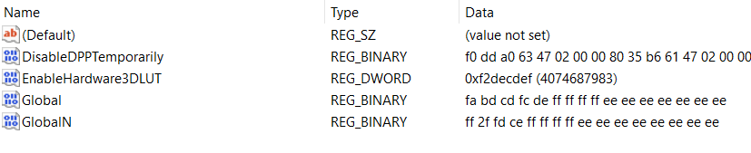

Previous not pleasing values ideas:
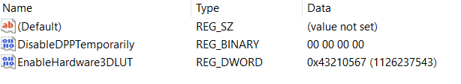
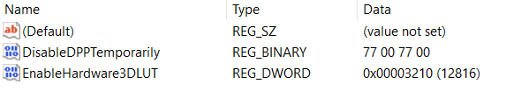
DWORD: “EnableHardware3DLUT”:
- For underworld codes which are maybe only for the environment around you: 43210567
- Life with begging: 56710234
- For 3D feeling for no reason: 22224411
- Fine for work: 75692320
- For shutting down the wrong things: 3210
- For turning on the thinking idea: 6543210
- For necessary: 43210
- Night light: Ban, fun, entertainment: 23153021
- Night light: Life: fdbacdaf
- No Exit: 0xaaaaaaa0
Interesting undefined ideas for the 3DLUT settings are:
- cdafccfc
- 23153021
- bebeca
- cebebeca
- cacabeca
- ffffedca
- Complexed: decabeca
- Fbacdfaf
- fffedbca
- fbacdfaf
- ff2a4cdf

New keys
Computer\HKEY_LOCAL_MACHINE\SOFTWARE\Intel\IGFX\DPPT
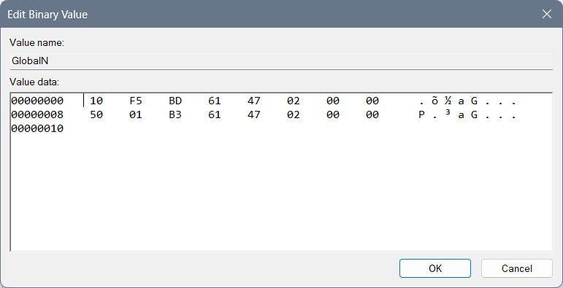

Post scriptum
Here you can find my previous, not well made, settings of the address:
- Computer\HKEY_CURRENT_USER\Software\Intel\Display\igfxcui\Media
You can look at these images down below just for informational purposes…
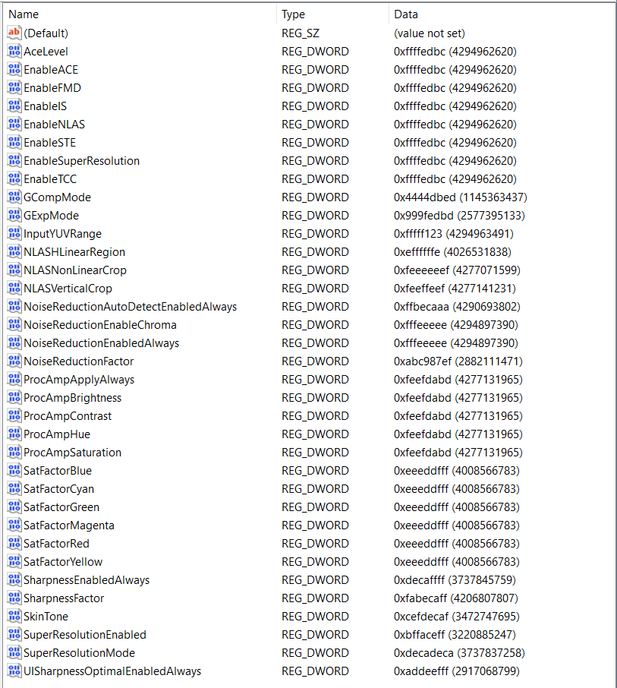
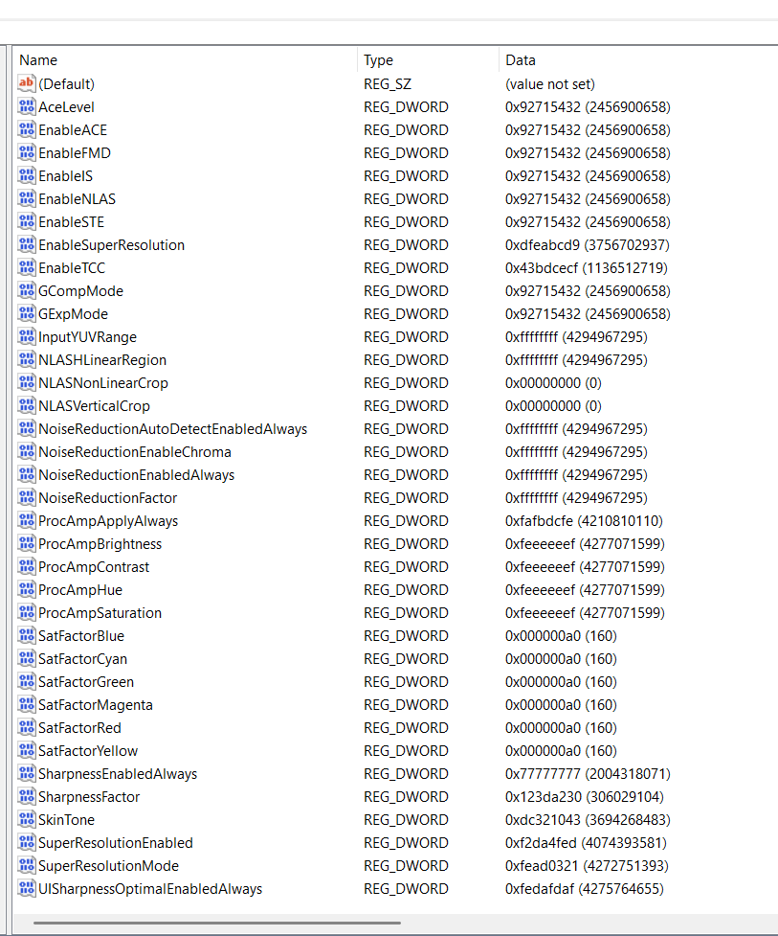

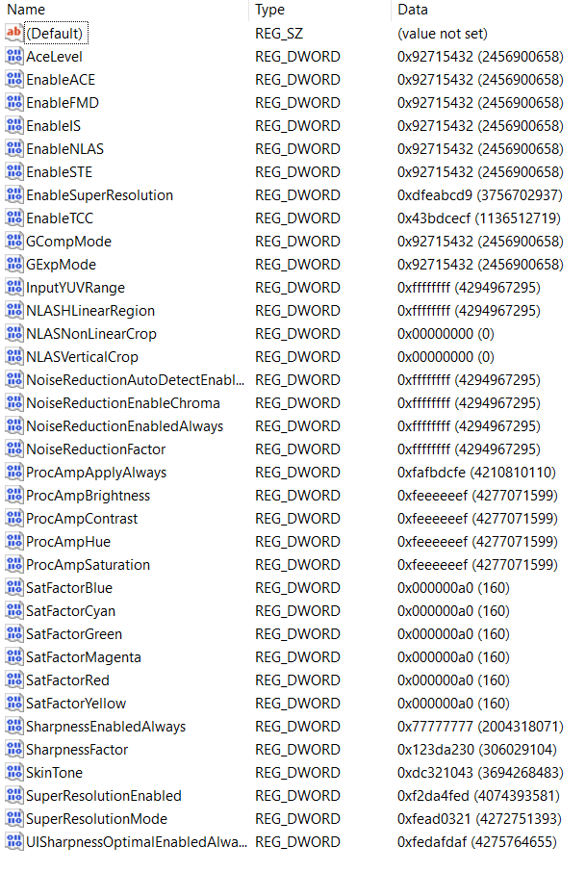

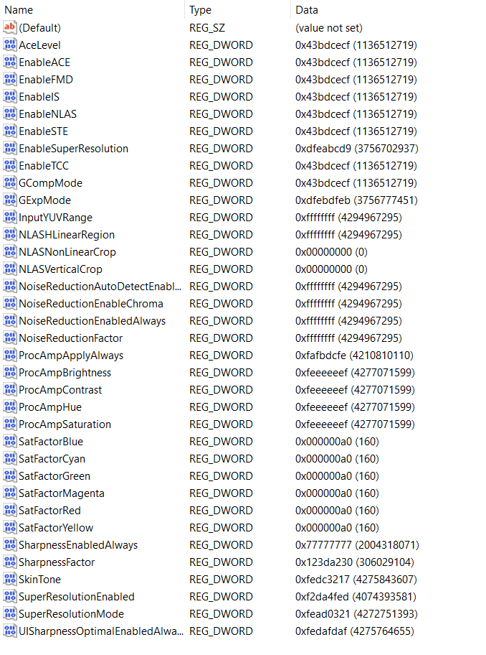

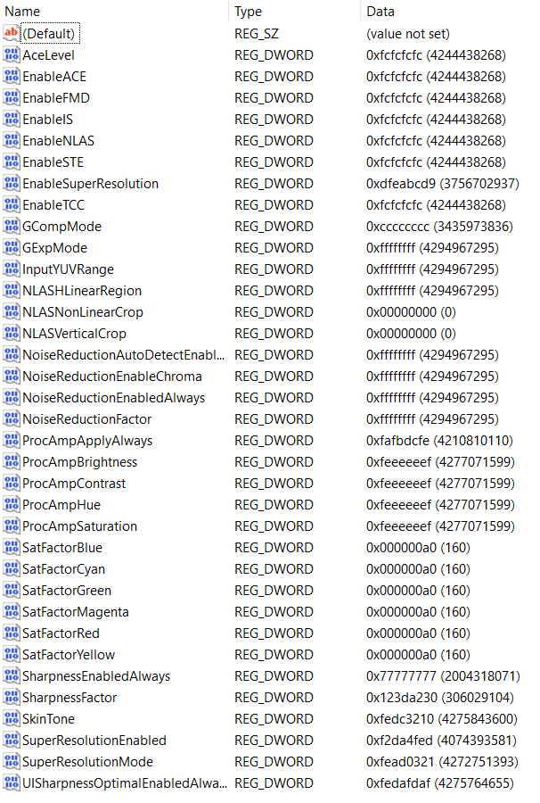

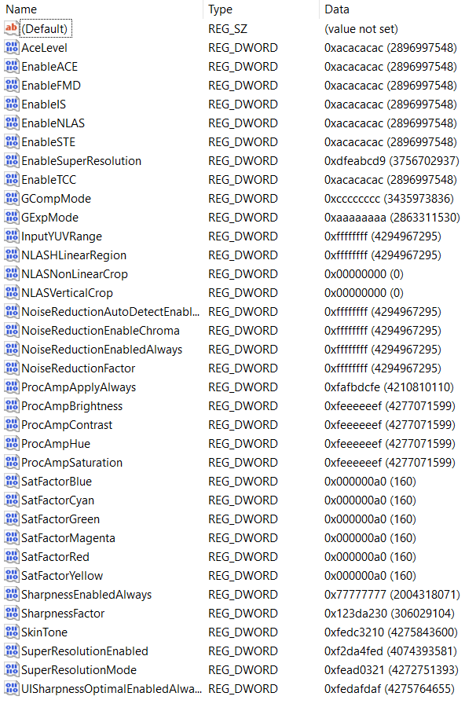
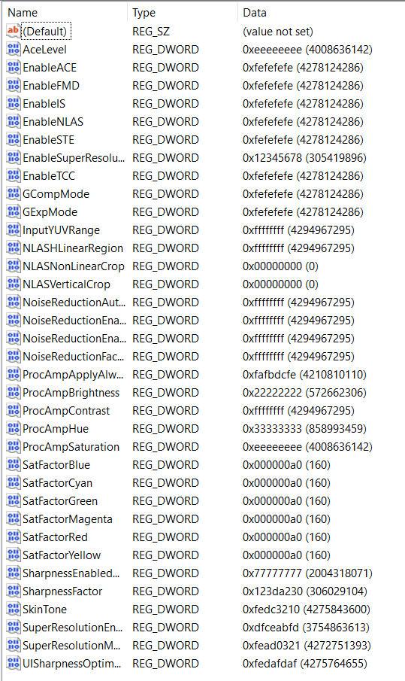
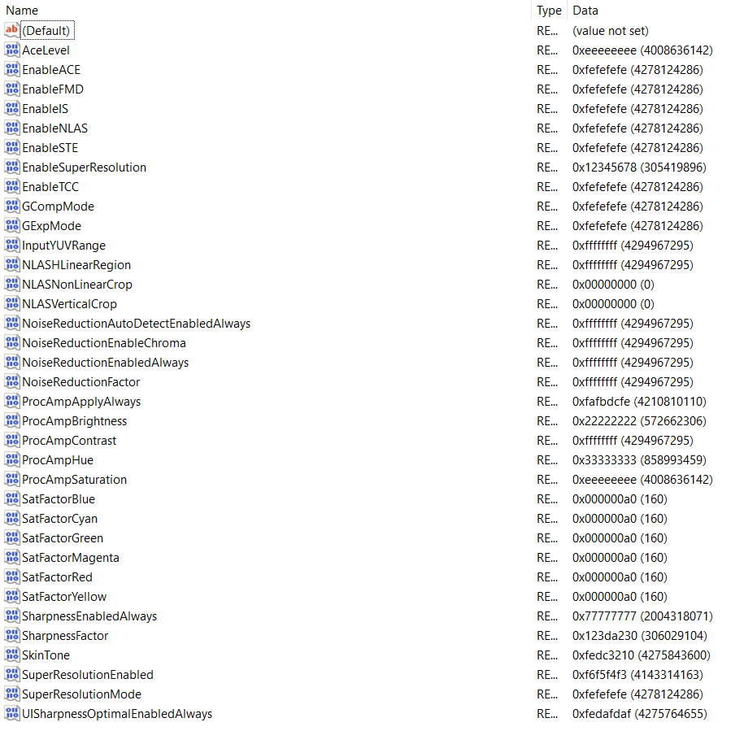
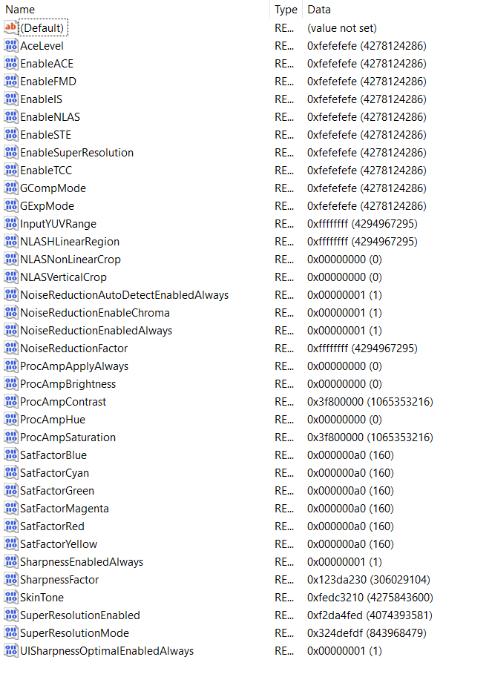

FFRTXZ

DPPTXZ
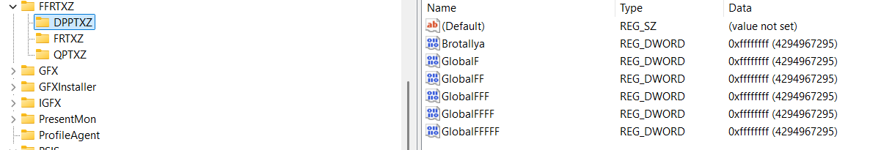
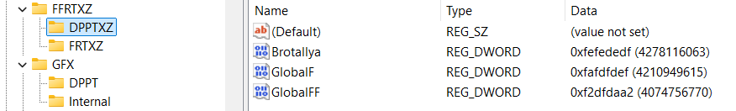

FRTXZ
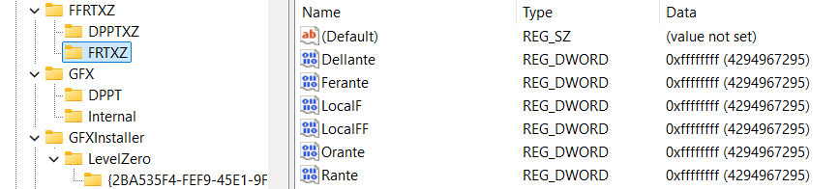
If you want to allow:
- Dellante you should use “fafadafa” (as some primitive planets knew so) or “fefedefe”…
- Rante: 2a2a2a2a, 2b2adca2
- Orante: 23232323, f23dbaf2
- Ferante: fdffdfdf
- Adyllante: f2dcabfd, fbdcafdb
Earlier values not implemented are for “Global”: “F2DF2AF2” – extrowallyattarry ban – on all and everything but reading only allowed things… For the file “GlobalN”: “AFDFEDDF” we have Nonbralltyya ban on reading banned things… Because you do actually need to ban idea of global (usually alien reading for smart beings) and there are “symbols” (words)

QPTXZ
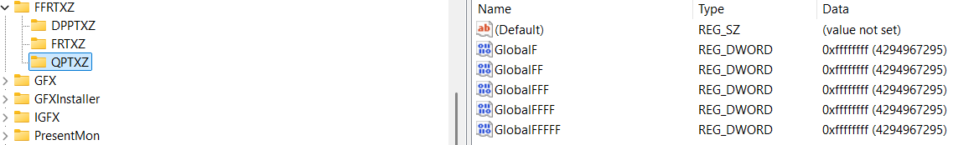

“HKEY_LOCAL_MACHINE\SOFTWARE\Intel” Folders
Under a key: “Computer\HKEY_LOCAL_MACHINE\SOFTWARE\Intel” I had these keys:
- DDRTZ
  - DPPT
- DGFX
  - 6D
  - 7D
  - 8D
  - DPPT
- DGFXI
  - 9D
  - 10D
  - 11D
  - 12D
- DPPT
- FFRTZ
  - DPPTXZ
  - FRTXZ
- GFX
  - DPPT
- IGFX
  - 2D
  - 3D
  - 4D
  - 5D
  - DPP
  - DPPT
- PSIS
  - DPPT
- SUR
  - DPPT
- DRGFXZ
  - MISC
  - DPPTXZ
Notice that under the Key “IGFX” there is a Key “DPP”, I renamed it to “DPPT” for the hope of a better system… But that didn’t help much… The point is that connected Keys and the Data in the QWORD creates a fully valued system and some long words can’t be usually shortened to a programmed code as is “DRTZ” from the “Deggennerreyyazzattyonall” – which means involvement of the watches…
Under below you will find the images of the files with codes you need to open and fill into Registry Editor.
When you find a “REG_DWORD” file named: “EnableHardware3DLUT” you should rename it to the “EnableHardwareDLUT”.

Old photos and some of the values:
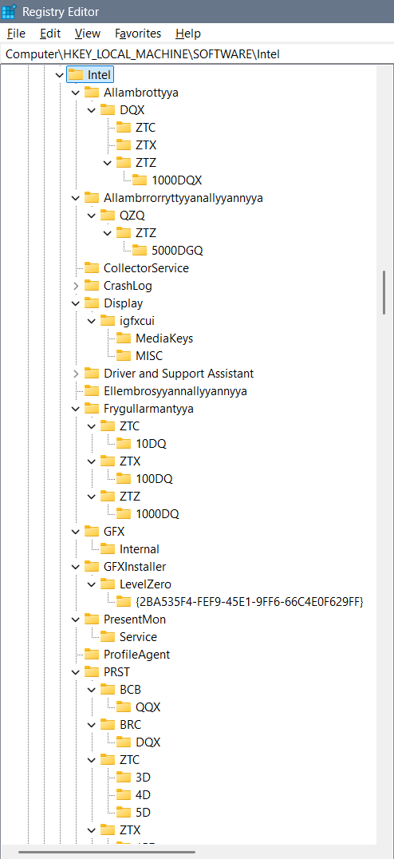
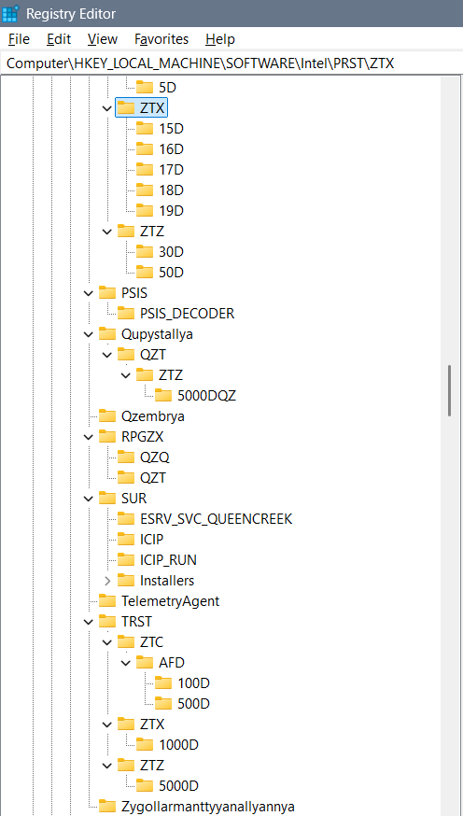

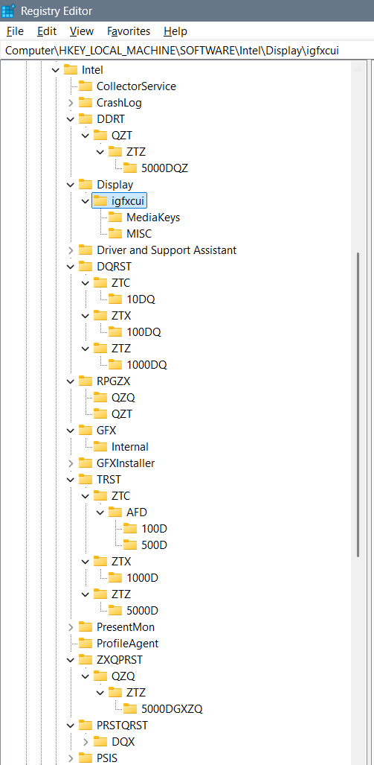
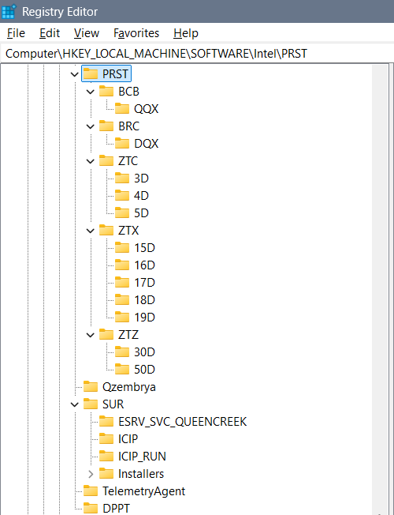

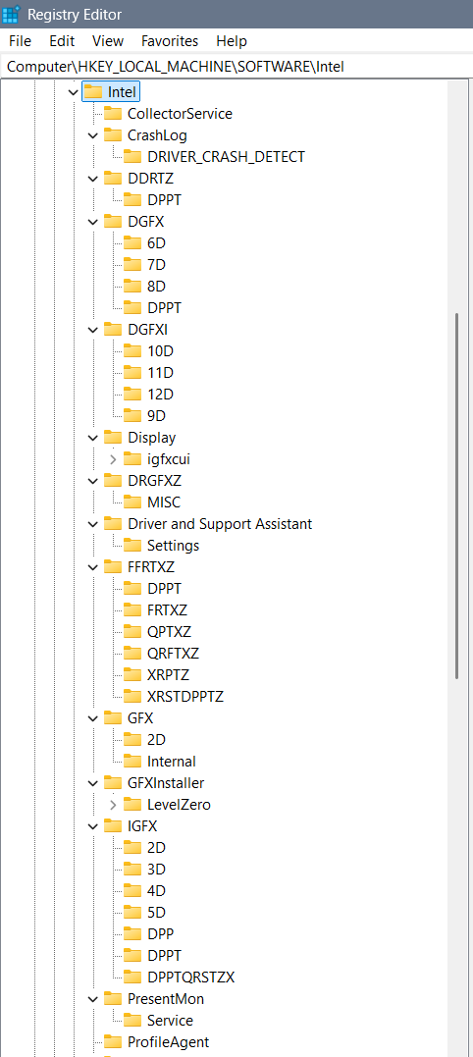
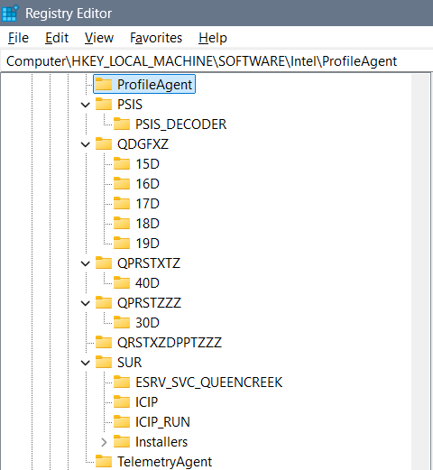

DGFX
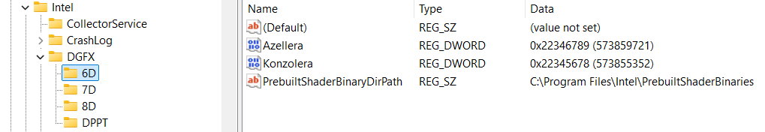
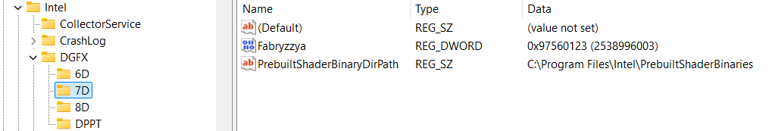
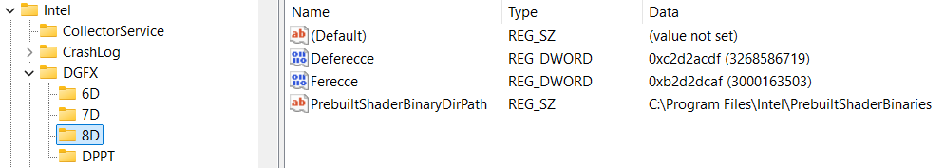
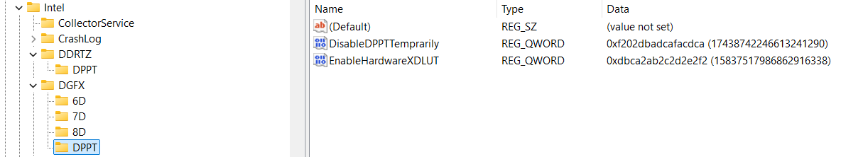
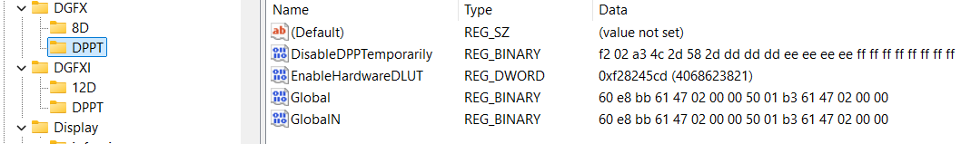
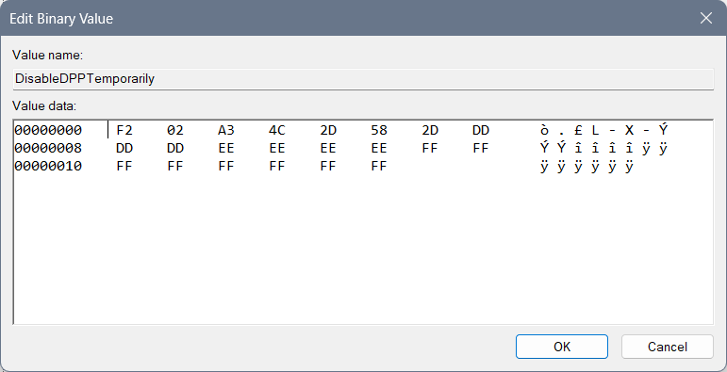
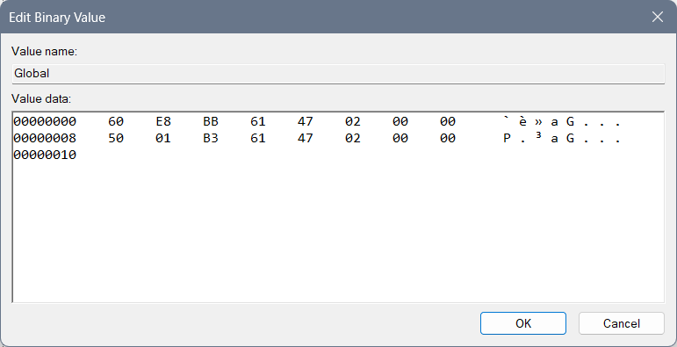
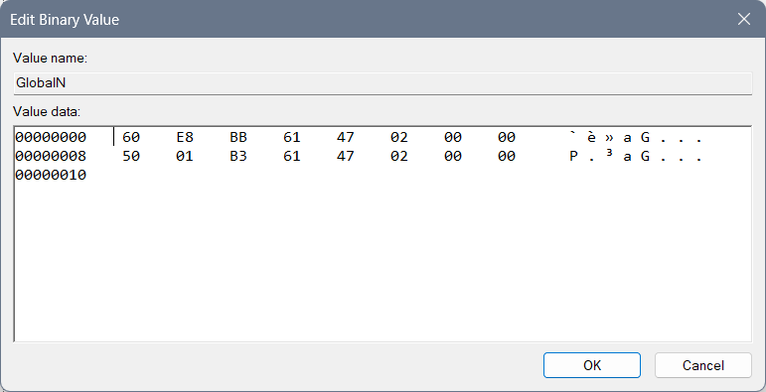

DGFXI
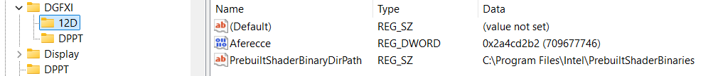
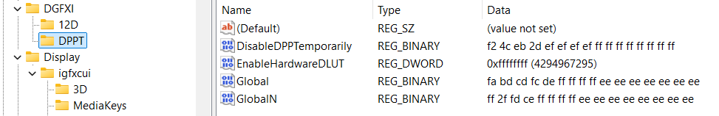

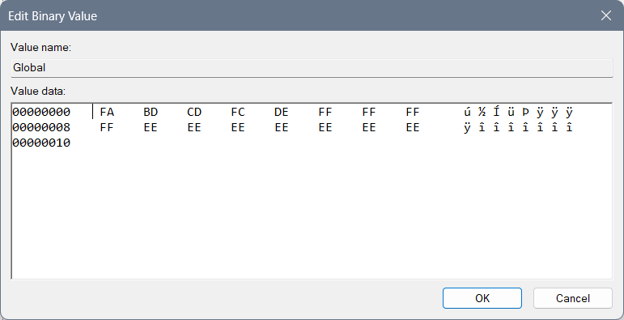
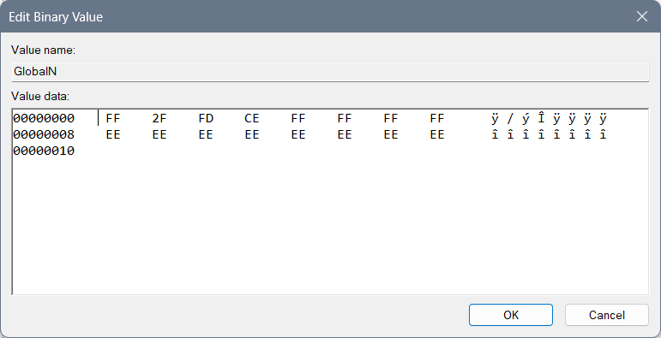

DPPT
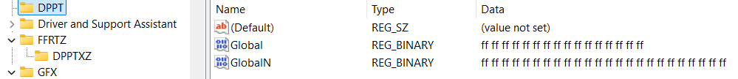
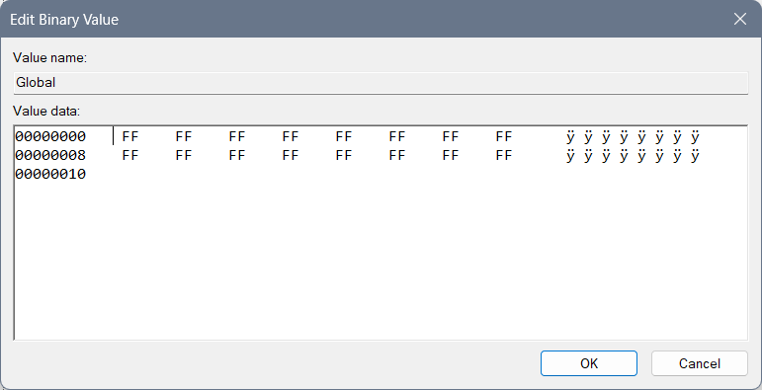
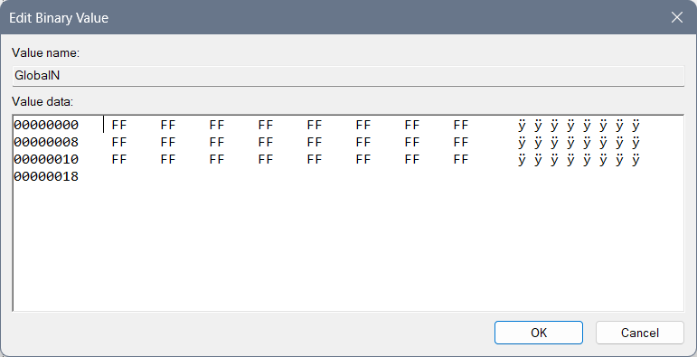

GFX

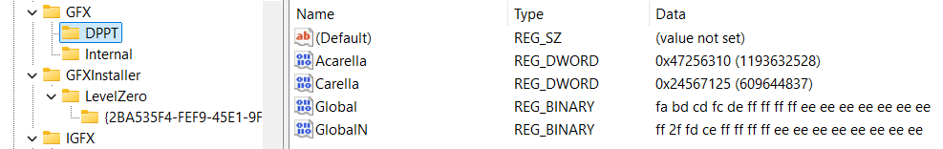
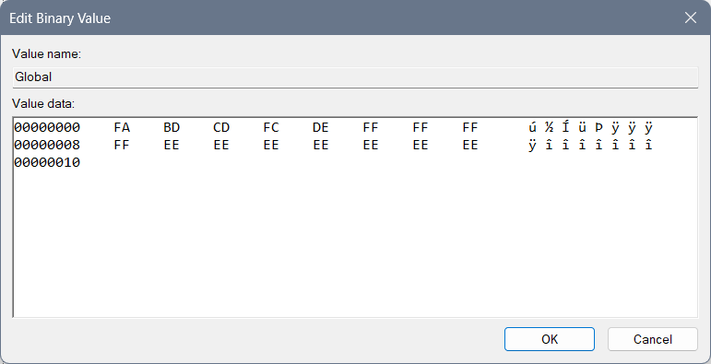

IGFX
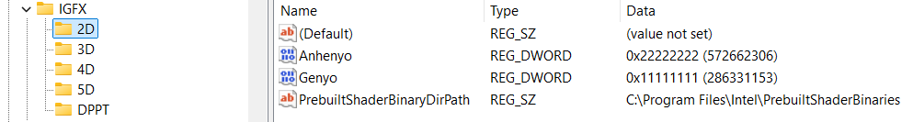
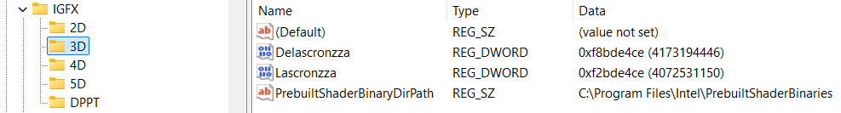
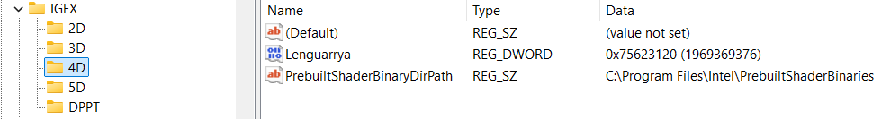
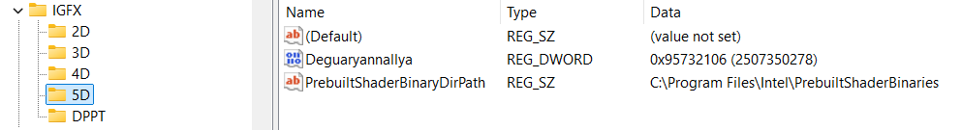

DPPT
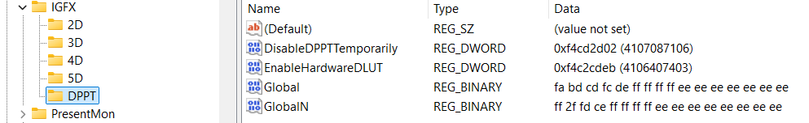
Or different idea of the DPPT which cuts the system differently:
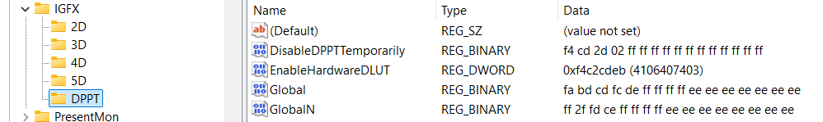

DPPTXZ
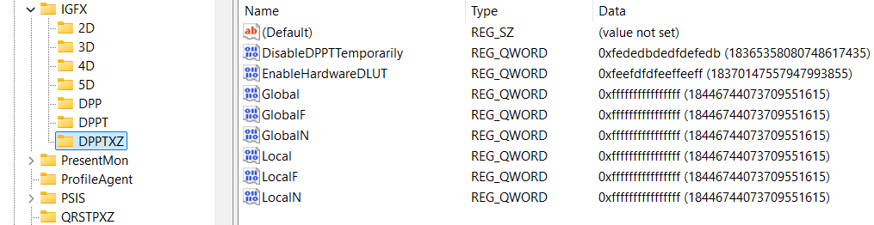

DPP
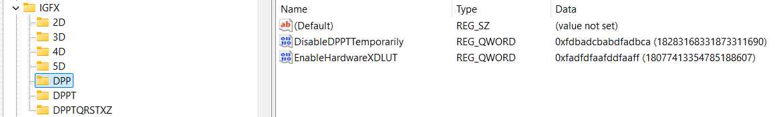

DPPTQXRSTZ
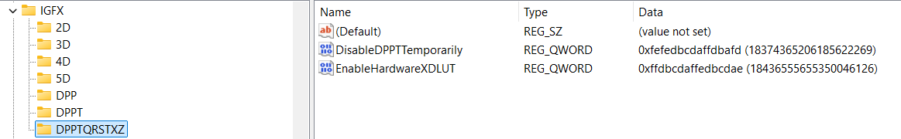

PSIS
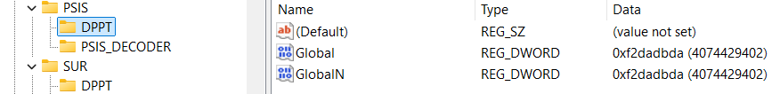
Or different solution which I am not preferring:
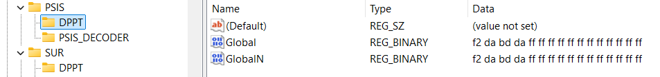
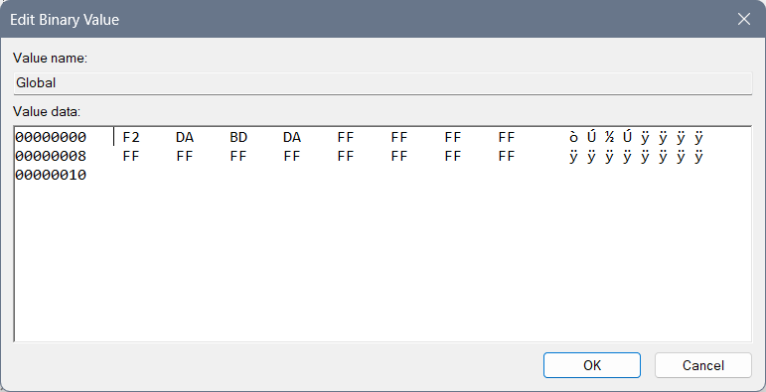
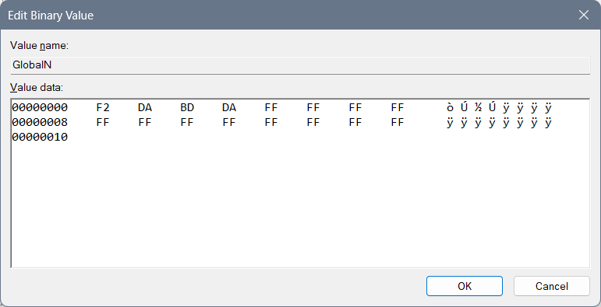

SUR
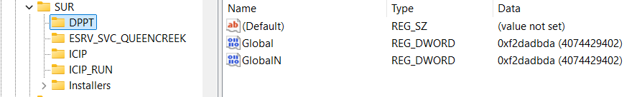
Or different solution which I am not preferring:
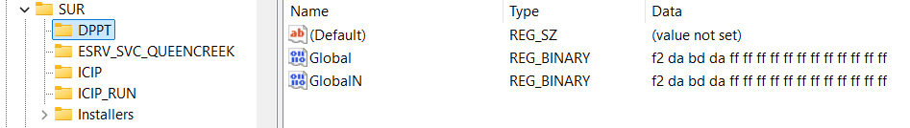

igfxcui
Files 3105 and 3106 leave the same, but create 3107, and 3108 and 3109…
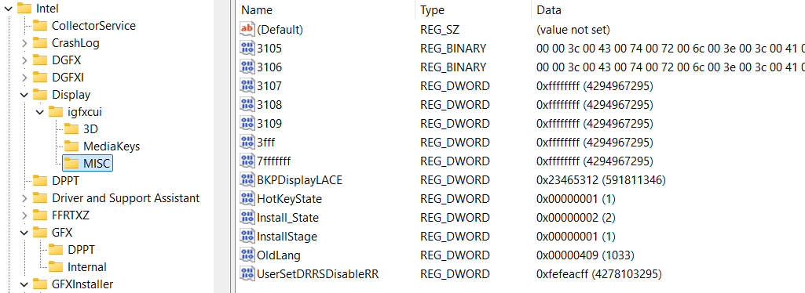

Here you can find a regular DRRSDisableRR which is 30… I set it to something that for me makes more sense…
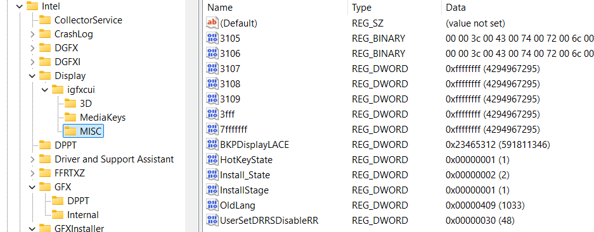
You can use this model with BKPDisplayLACE with all of the “f” chars but I do not suggest it because it represents open system of everyone around you and it doesn’t focus you on your job only…
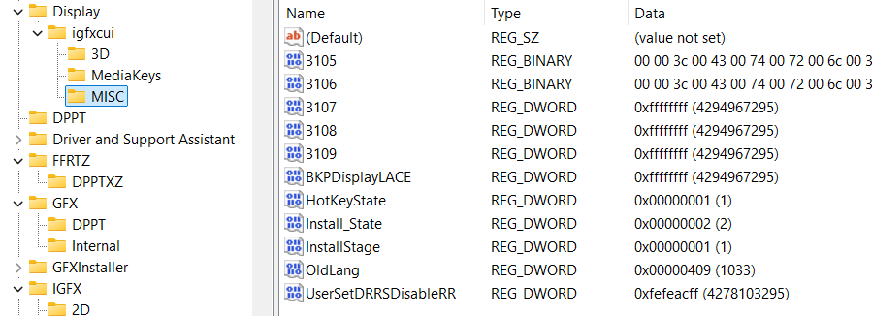
When you have a primitive idea of the 3D, you can implement 4D, 5D and up to 15D in the files as are dgfxcui (4D, 5D) and rgfxcui (6D, 7D, 8D), drgfxcui (9D, 10D, 11D), qxdrgfxcui (12D, 13D, 14D, 15D)… Each of those files should have the idea of the system speed being created by pixel movement to awake the brain idea of the cosmos jokes on the certain frequencies which is interesting because then user can see 3D image and so on…

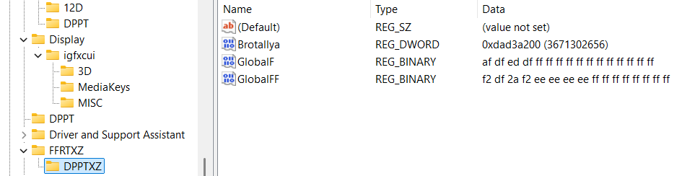

DRGFXZ
For Quanzyllyumar Display type regular values, and for a regular one type 8 times f: “ffffffff” into Ablagerio and Zeronimo…
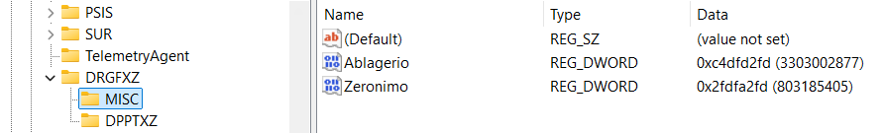
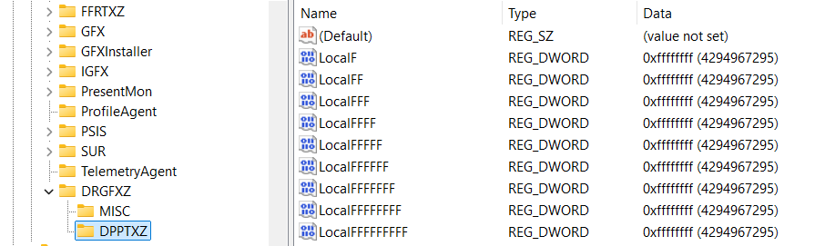
I believe if there is Ablagerio “ffffffff” and Zeronimo “ffffffff” then there is the key “DPPT” instead of “DPPTXZ”…

QDGFX
RSPTXD
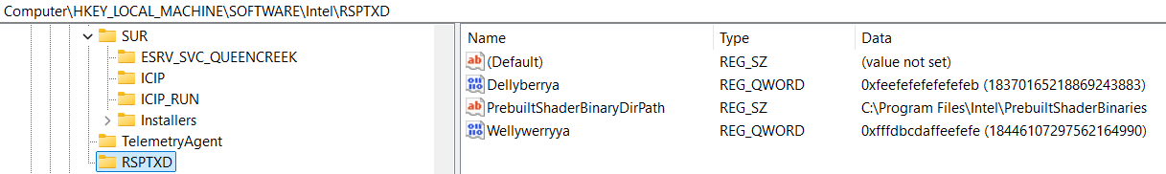

DPPTXZ
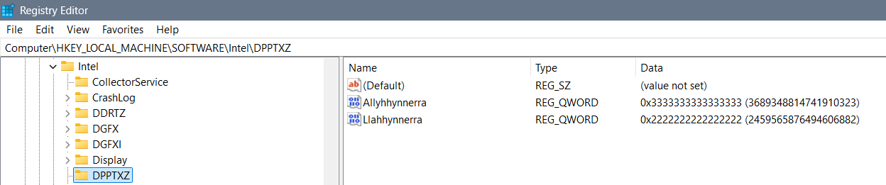

Banning
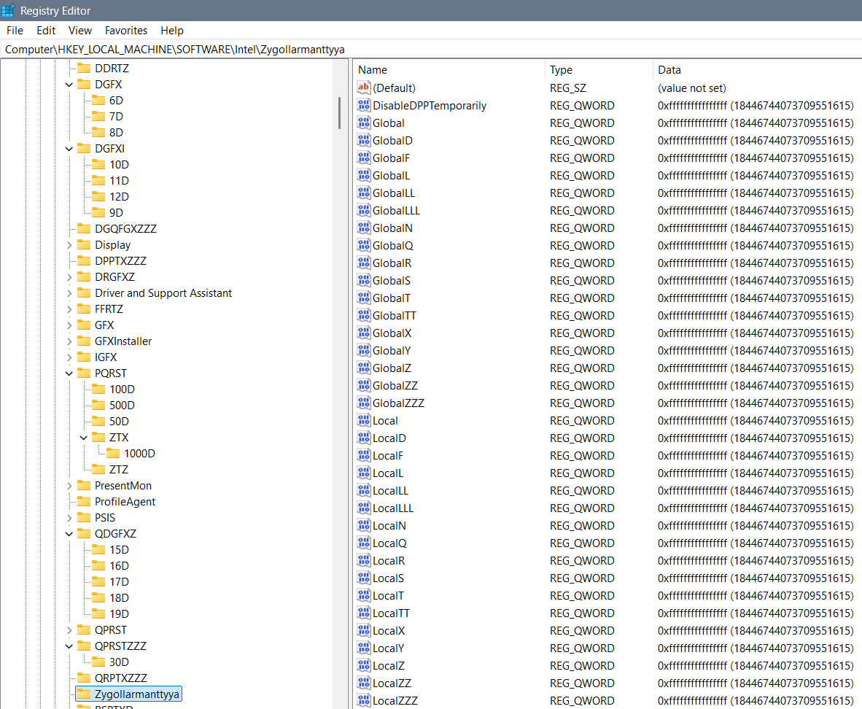
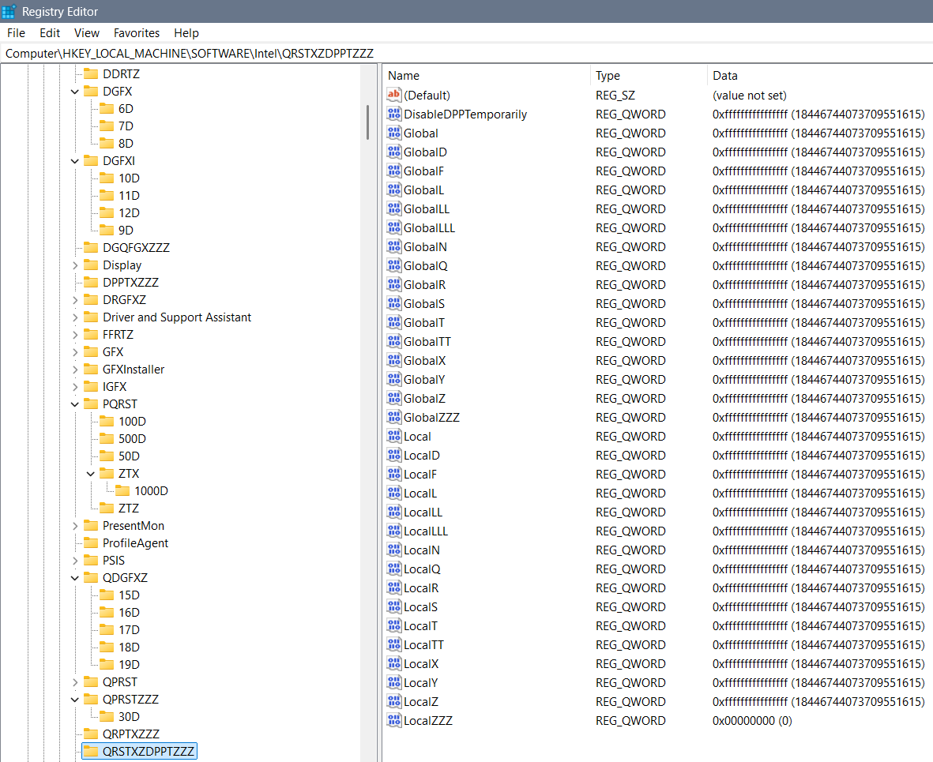

Something
Previously not good settings are moved to this part of the TXT without thinking and maybe these codes represent something, maybe they ain’t that good, but I find them unnecessary…
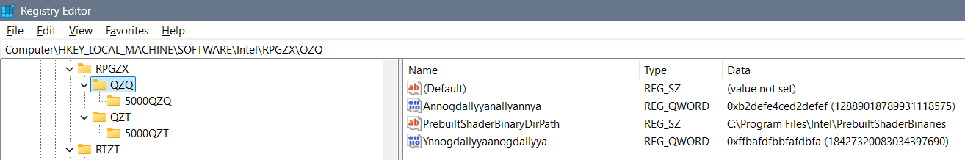
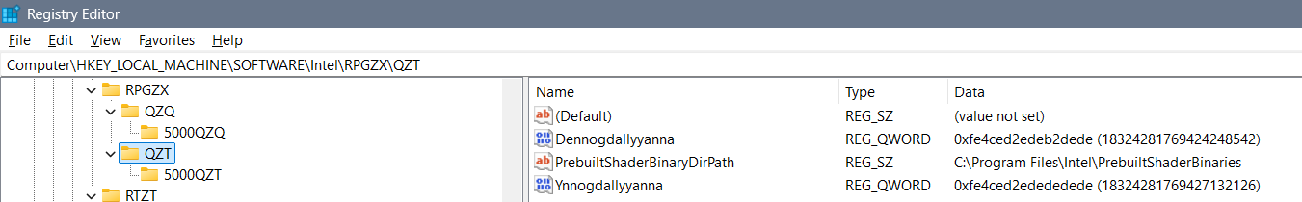

PRST
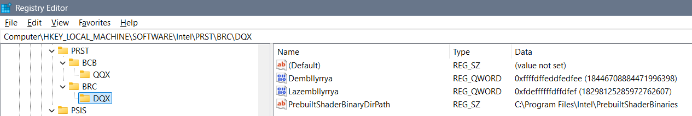

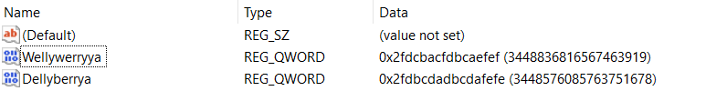
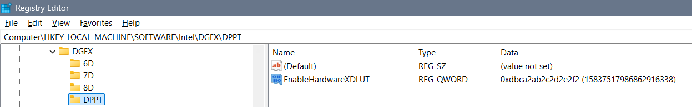
Fedbcdaefdfaefdf
Ayyannte
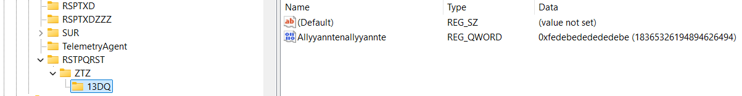
QDGFXZ
Zyndallya, Zembrallyya, Zemmallyya 3 bans on everything out there
Ffdbcdaffedbcdae
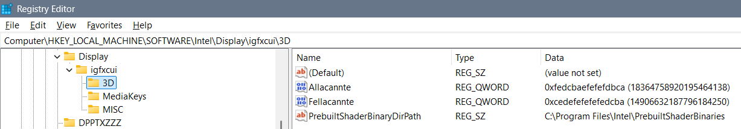
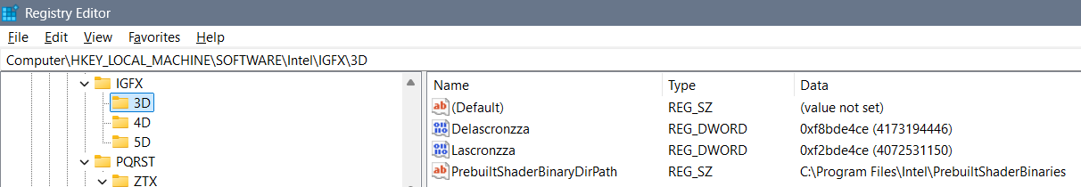
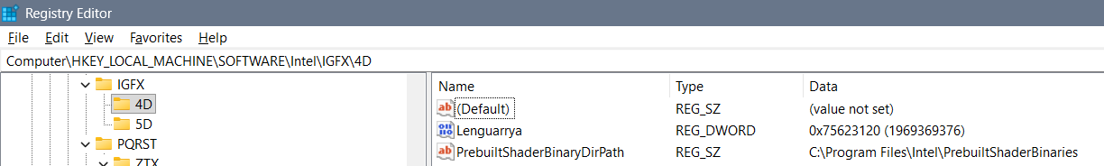
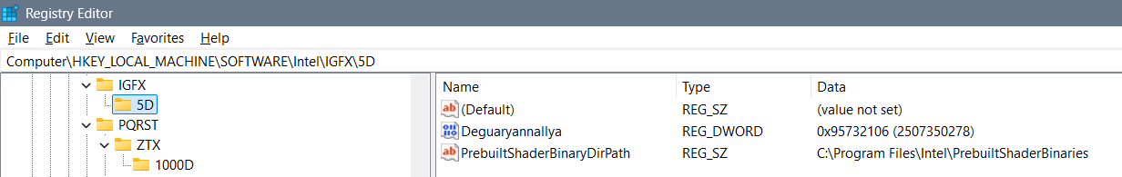
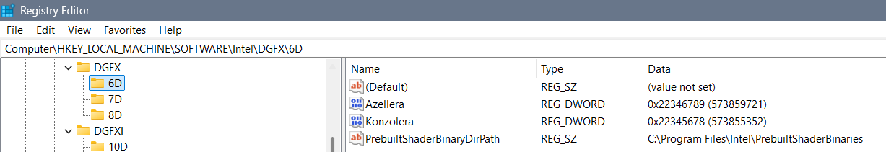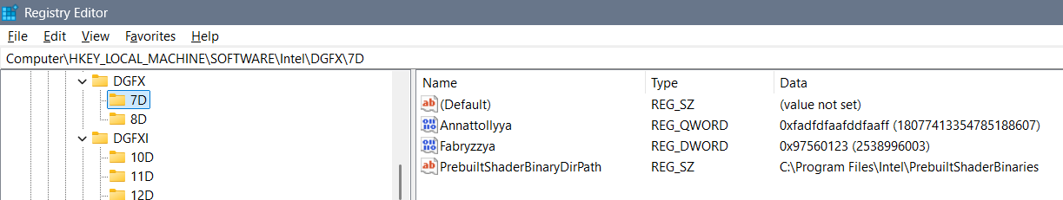
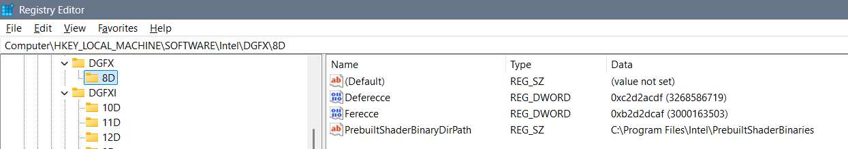
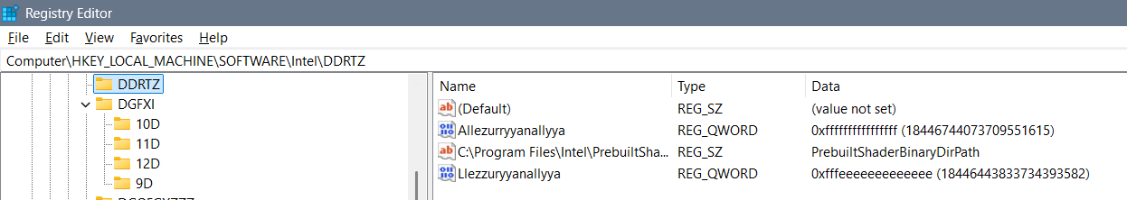
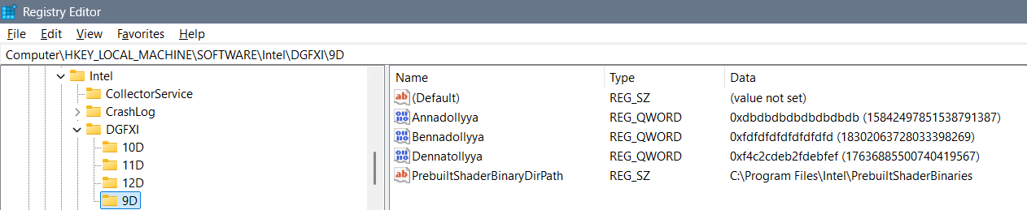
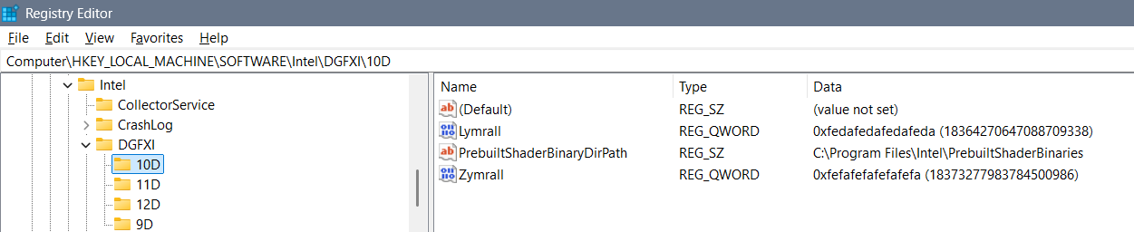
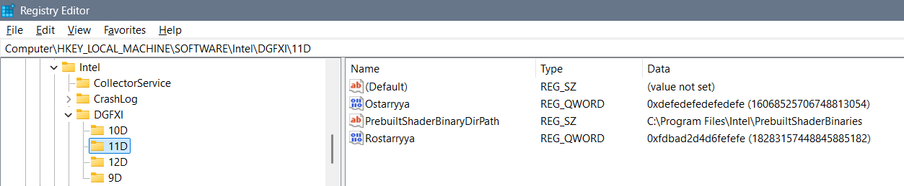
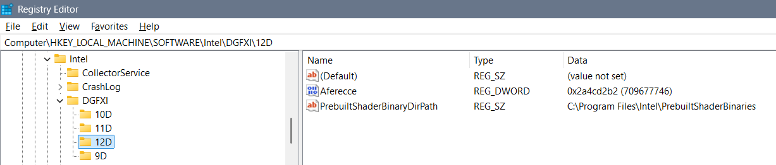
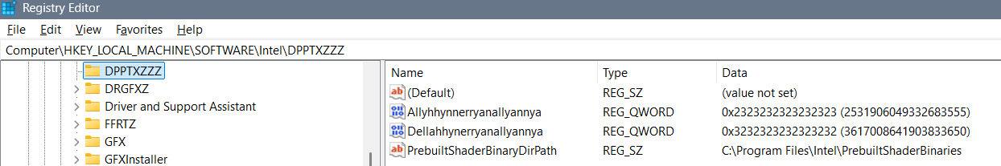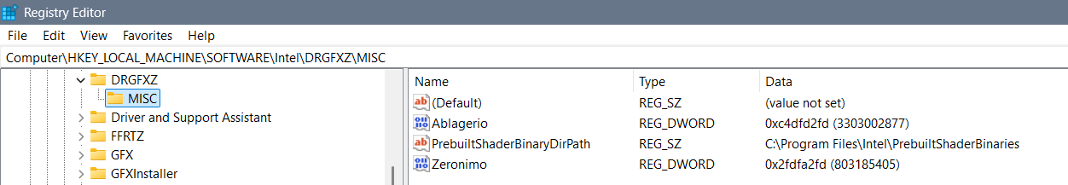
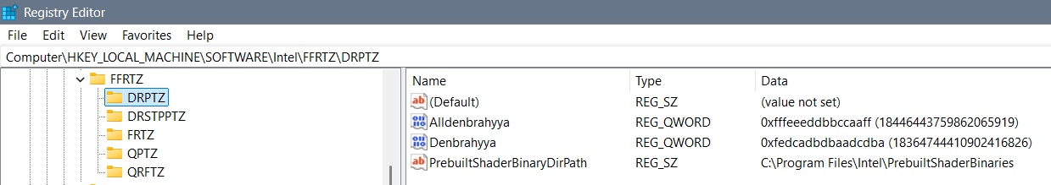
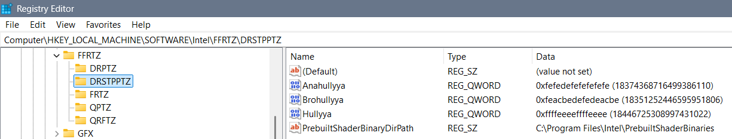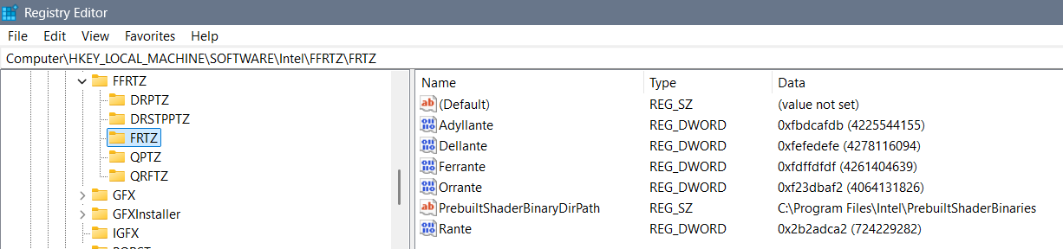
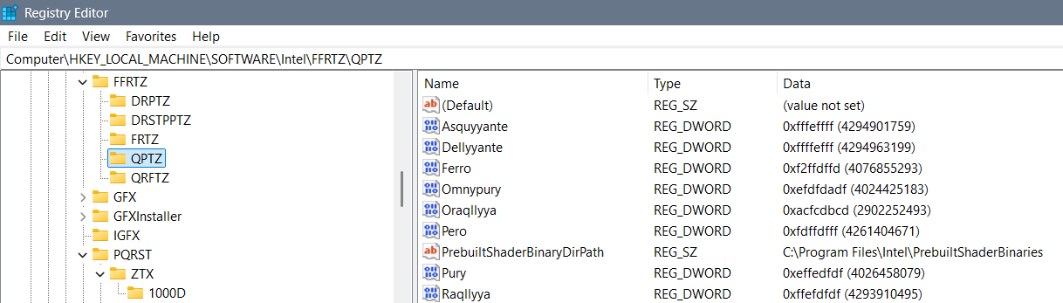
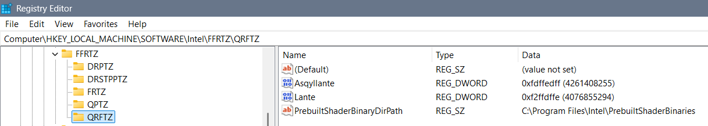
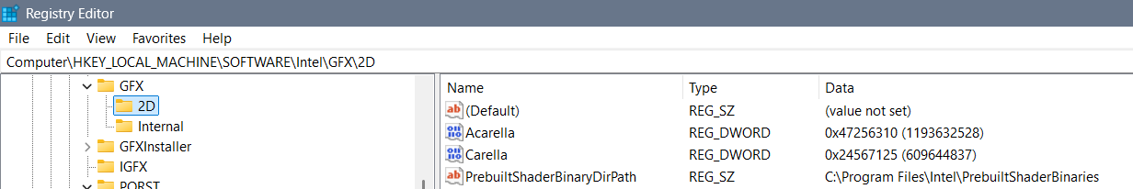

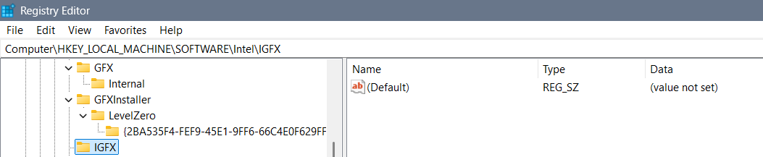
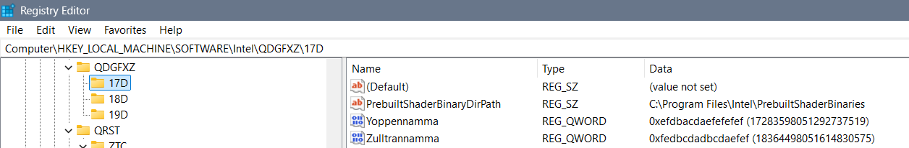
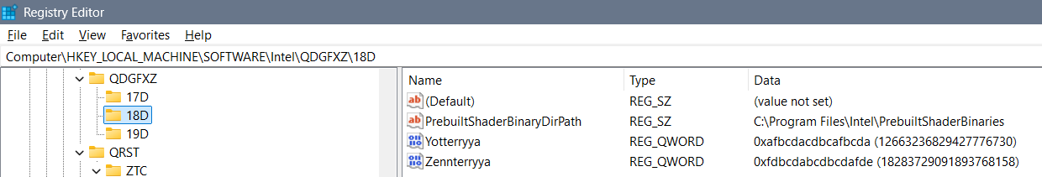
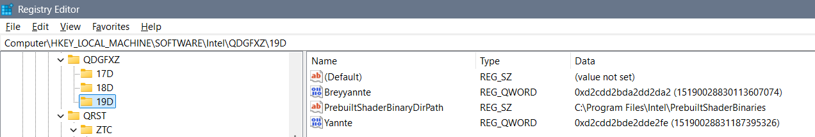
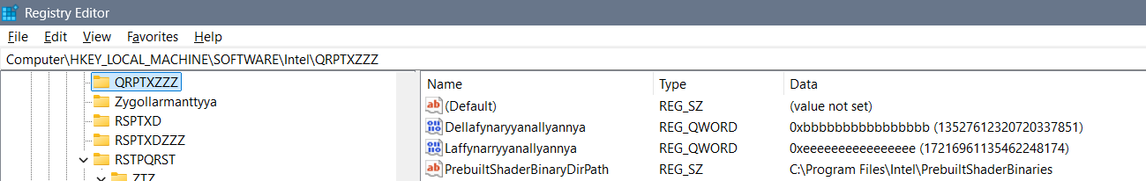
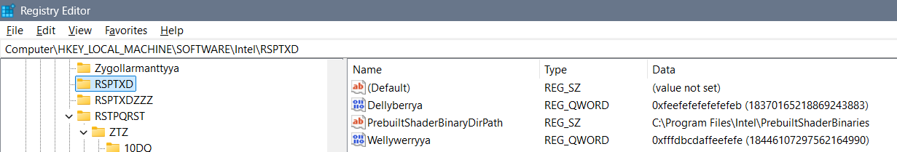
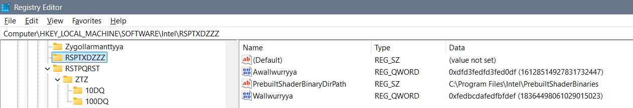
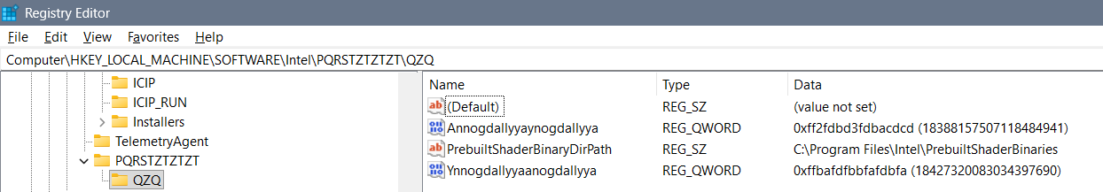
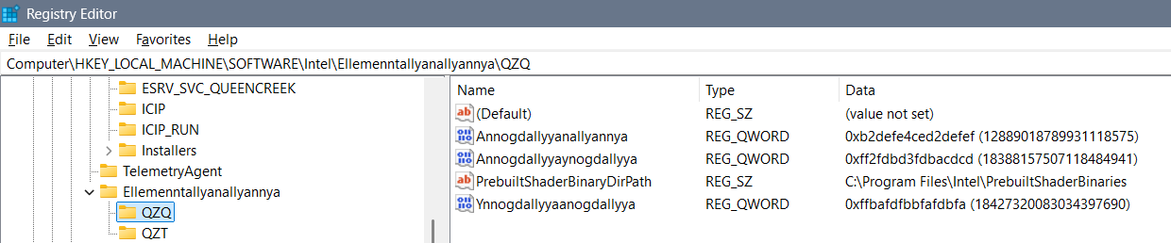
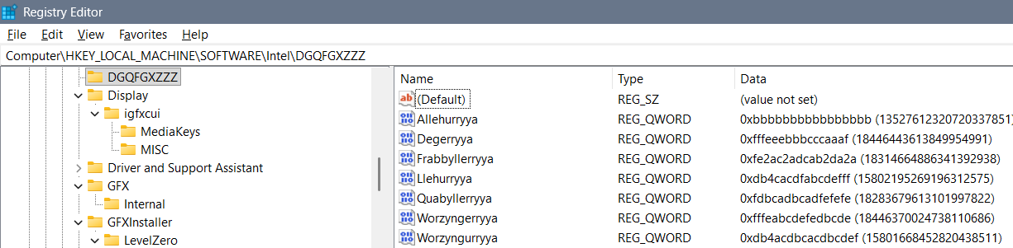
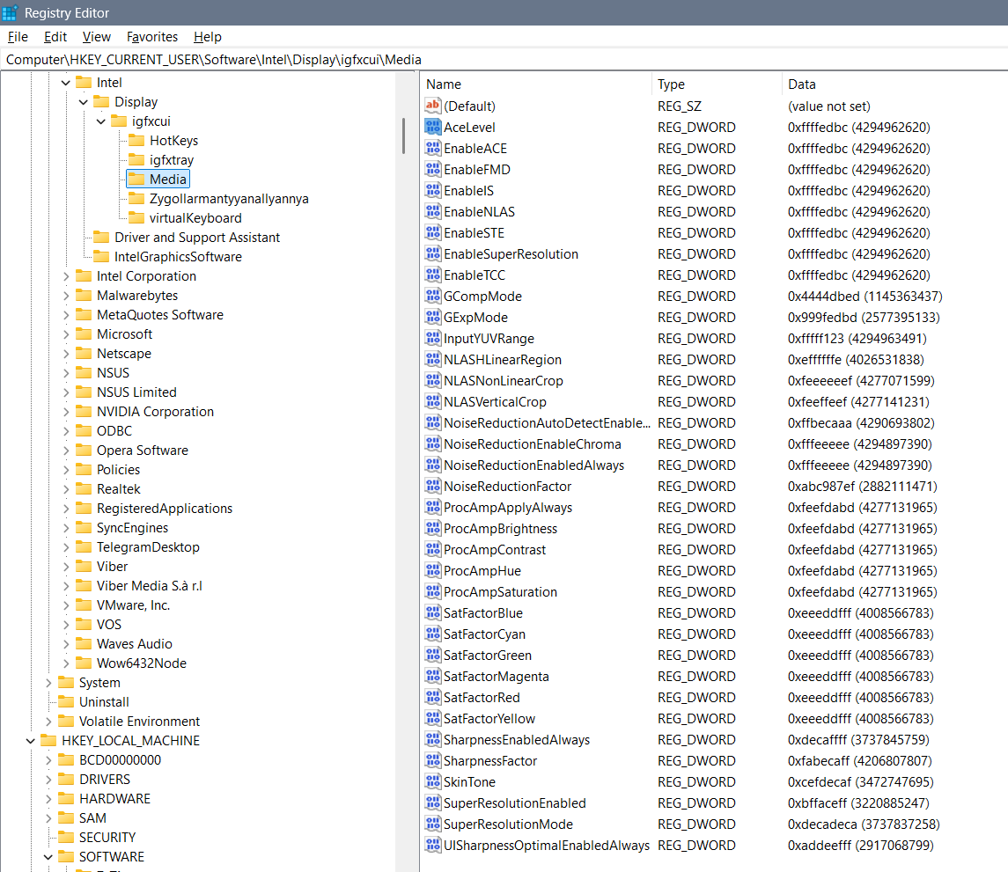
Ygullanttyyanallyannyya: bcdeefdbcdefeffe?
febcdeffbcdef4ce
Perryplexx Parrapllett
Parapplett
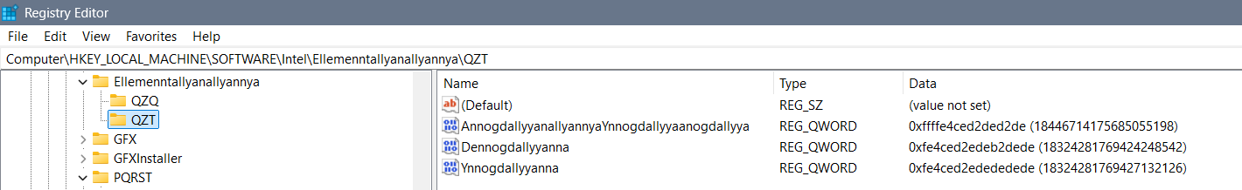
Ellemenntallyanallyannya – RPGZXDT
Zygollarmanttyyanallyannya - DPPTZZZ
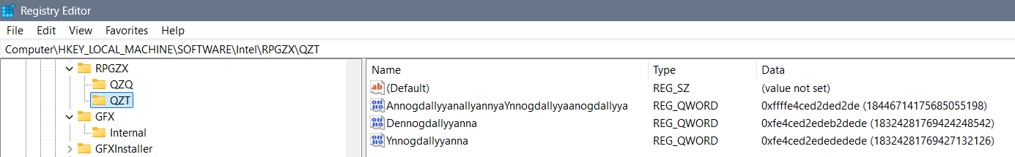
Allambrottyya PRSTQRST - DQX
Frygullarmantyya DQRST - DQ
Qupystallya DDRT – QZT – DQZ
Allambrrorryttyya - ZXQPRST – QZQ – DZXZQ
3DLUT - fe4cdefe4cefedef
DDQ Reallnyya Dereallnyya
Alldonbrerryya, Radonbrerryya

Igfxcui/MISC
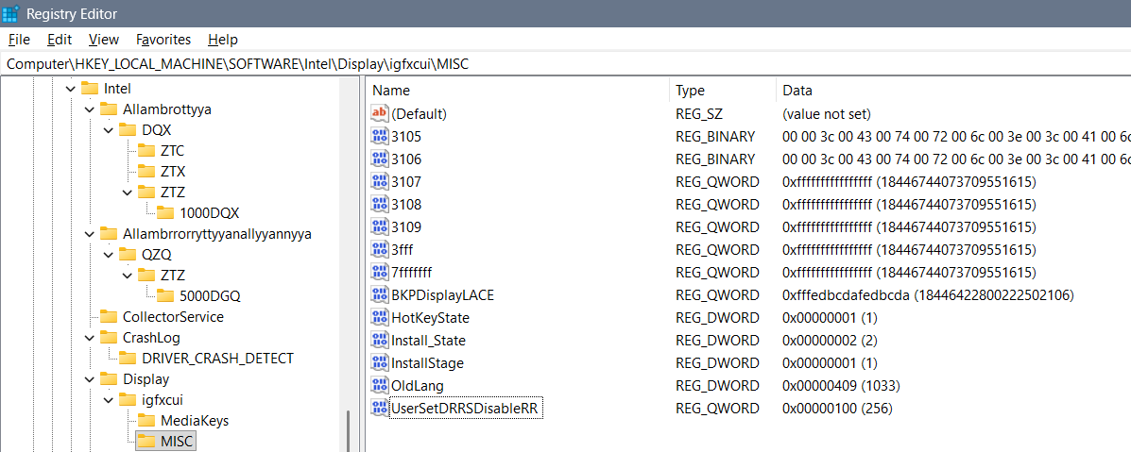
Possible options for DRRS-RR, in decimals, are best finishing with 9 as is 59, 109, and etc… All of the values I could think of are: 31, 59, 120, 256, 1024, 1759 of how much data you would like to be shown on the display and how for each user – so the best thing is to use all “f” – “ffffffffffffffff”… Maybe you can use “fdcdabdabddabdab” but I believe is wrong…
First option for “UserSetDRRSDisableRR”: the “ffffffffffffffff” value would take care of you and create you pleasant nice and kind – would take care of you always…
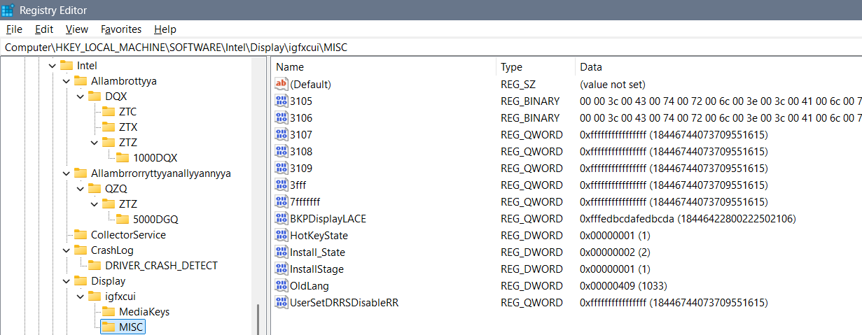
Second option is in kind of “live” as you are which we got used to mostly:
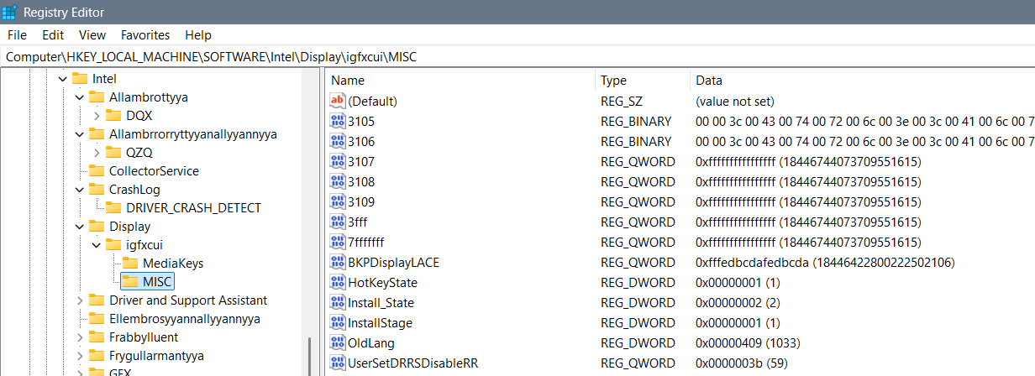
“UserSetDRRSDisableRR” is a thing to discuss because of it depends the whole possible system and it’s functionality… Are cosmos jokes seen and is there an ability for them to be removed by someone else, can the one pull the system and etc… That key somehow connects all other keys… The preferred ban is using the number 7 to ban the other beings involved in display, 5 to ban the touch on cosmos jokes, and 9 to ban the wrong usage of display when beings are sleeping… I believe that with that idea the typed in number should be “7779755955755957” but that is completely wrong… Because we already have one coded DWORD data of this file the next data of this file needs to be coded through the Coded with “3B” the best option I have is: “eabcdeabcdeabcde”... The system would maybe suggest that the first DWORD file is although coded through the “3b” and actually that is seen as “3b3b 3b3b 3b3b 3b3b” for a QWORD file, so the next step is muting the second file with 16 times “f” or “ffff ffff ffff ffff” and then the system would suggest code through “fead” but nothing more of that to the right side, to the left there is extrapolation of that code into: “fefefdcbadefdeaf” I am not quite sure… To work on “fead” hex word we would extrapolate it with mixing and adding codes into a 16 bytes we by using the extra coding – or extrapolating of the coding as is “feafdeaffeadfeaf” which can be one of the answers how to code this file…
All solutions I had before that an idea of are:
- “faebdcbaebcdbeaf”
- “fefefdcbadefdeaf”
- “feafdeaffeadfeaf”
- “feadbeafdeaffeaf”
- “eabcdeabcdeabcde”
- “feadcbedbeedbfed”
- “eabcdeefdcbeafed”
- “fabcde7232fabcde” – using the opposite logic to enable the value
  - “fecedebeaacdb”
- “9995579975597797”
- “7795757757975577”
- “770000700700007”
- Parraflexx Purryflexx and etc. 5, 7, 9
- “ffeacbadeabcadea”
- “abca2da2a2da2aba”
Solutions without 3b coding:
- Quynguystalla of 3 elements as are “777”, “77f”, …, “fff”
  - “f7777f77777f7777”
  - “7fff f7ff ff7f fff7” = “7ffff7ffff7ffff7”
  - “7f77 77f7 777f 7777”
  - f77f f777 7f77 77f7 = “f77ff7777f7777f7”
  - Maybe: “f77ff777f777f777”
  - Maybe: f7ff777f777f777
  - Maybe: ff7ff777f777f777
  - Maybe: “ffff 7fff f7ff ff7f fff7 ff77 f7f7 f77f 77ff f777 7f77 77f7 777f” = “ffff7ffff7ffff7ffff7ff77f7f7f77f77fff7777f7777f7777f”
- Franguystalla of 2 elements as are “77”, “7f”, “f7”, “ff”
- But since the values are not changeable in that folder we need to use coding through “3b” including mixing and complicating which I believe gives us numbers as are “6 and 9” or “5, 6 and 9” with less restrictions… There actually isn’t а value for disabling the DRRS but enabling it: “eabcdeabcdeabcde”
- I don’t know why but the hex number “6” mutes the cosmos jokes completely, the hex number 7 mutes the others interfering the system but itself isn’t good

igfxcui/Media - Old photos and not good settings
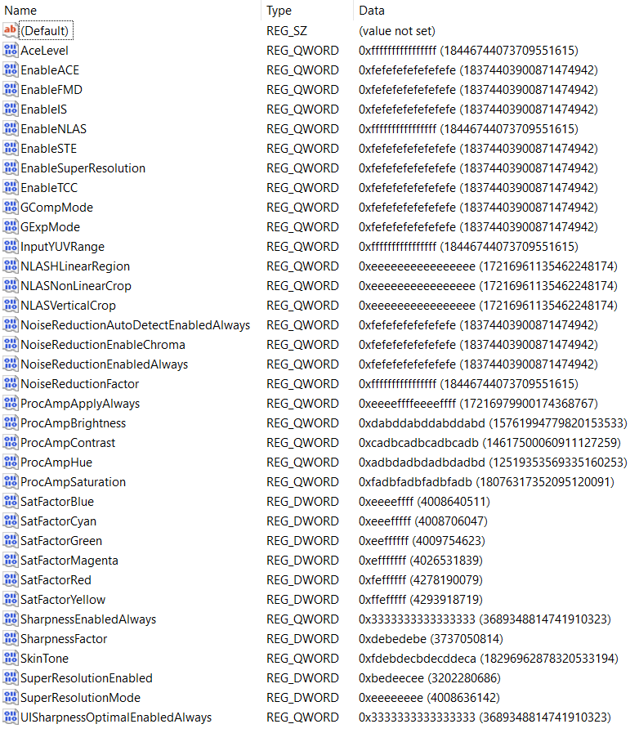
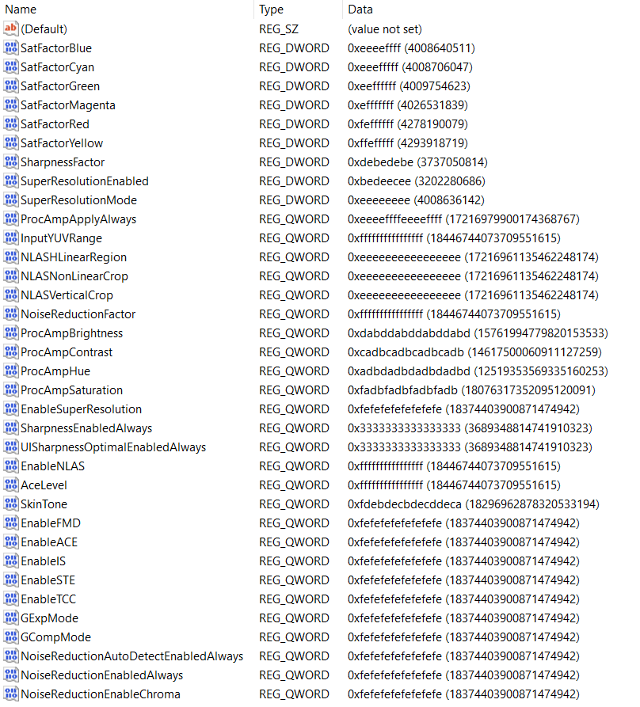
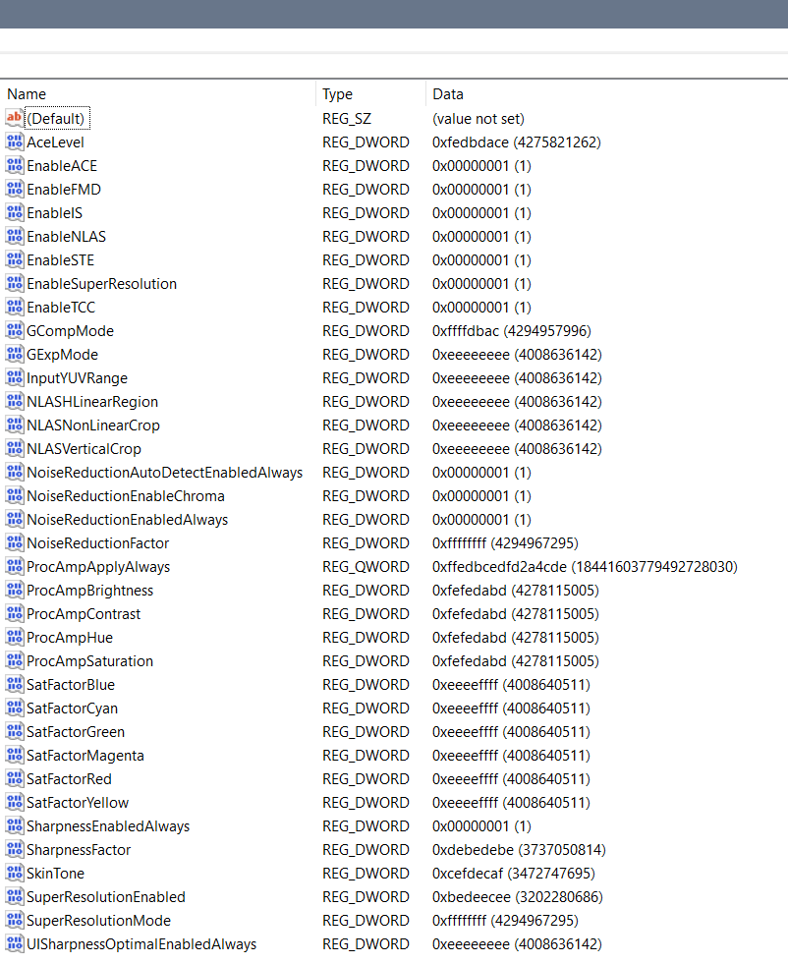
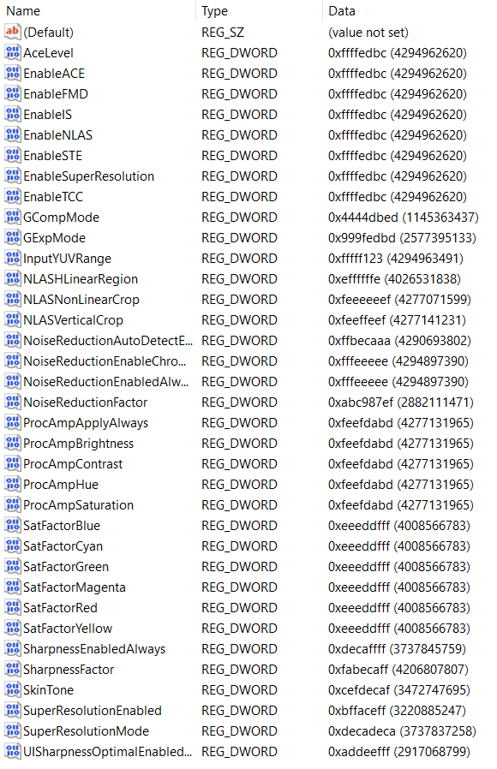

NVIDIA

Checking processor speed
First go to Task Manager and check the processor speed. If it does well you can edit registry values. First of all, I didn’t need to change any Registry values because I didn’t install anything on “Windows 10” from the DELL Power Manager, nor DELL Support, nor NVIDIA Drivers but it’s Control Panel… With dual graphic cards Intel and NVIDIA, that I have, my laptop demands the NVIDIA Drivers not to be installed because when they are the processor speed falls below the first speed border – 1.69 GHz which creates my laptop operating system impossible to use, unless is maybe Windows 8, to make a joke… So without any of these programs I am able to use laptop fine…

CoProcManager
- “Computer\HKEY_LOCAL_MACHINE\SOFTWARE\NVIDIA Corporation\Global\CoProcManager”

Satisfying solution:
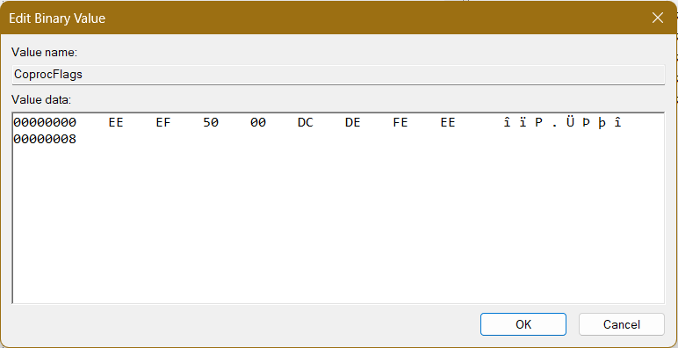
After update we had to edit full command
Besides that previous solution was simple:
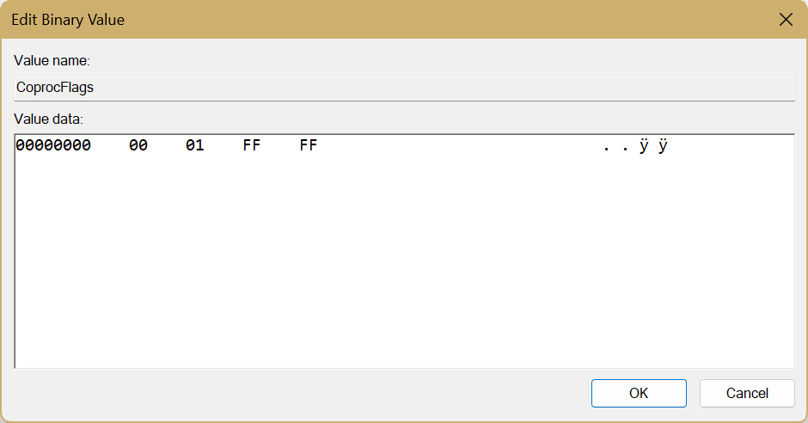
00 01 – Approaching primitive Intel chip
FF FF – Speed unknown

Old setting:
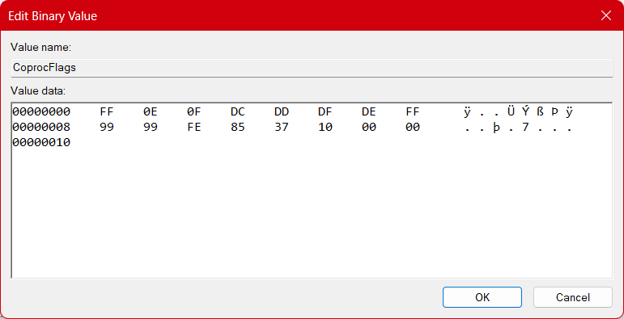
FF – Entering “All the speed” command
0E – Start from the almost fastest
0F – Work till fastest speed
DC – Entering operable commands field
DD – Entering speed commands filed
DF – Entering Slowest speed command
DE – Entering speed command
FF – Entering fastest percentage
99 99 – Fastest percentage
FE - Entering slowest percentage
85 37 – Slowest percentage
10 – Entering exiting code
00 00 – Exit code

Old setting:
- Processor utilization
With this at the beginning of the work of the graphic and wi-fi connection program as is web browser – the processor, maybe because of the poor wi-fi knows to start at 0.80 GHz but it does climb over 2.5 GHz in a later browser work…
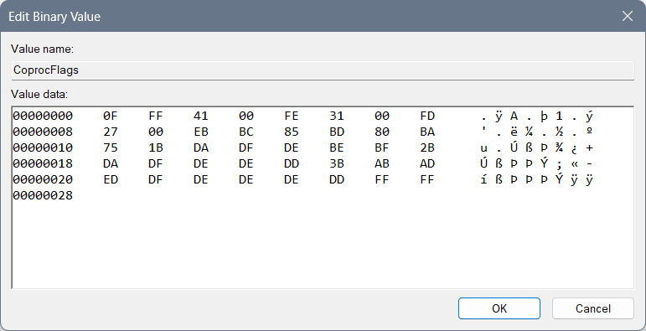
Where we used “0F” for the beginning of the speed of processor code, “FF” for first value, “FE” for the second, “FD” for the third… After “FF” is instead of “125C” or 4700GHz the maximum speed of the processor – by the Windows reduced speed of the processor. After “FE” there is the “3100”GHz second speed of processor. And after “FD” we can find the 2700 lowest speed of the processor…
Then we used the “EB” for the beginning of the coding of the utility of the processor – so there we have:
- “BC” – middle value which is 85,
- “BD” – lower value which is 80,
- “BA” – lowest value which is 75.
Then we need to code the functioning of the processor with the code that represents the changing value as in percentage of the usage of the processor when the need for work is in progress, and we can maybe do it as: “89 87 88 97 99”, but numbers we will use in file only for the speed of the processor and the utilization, so – we will do it over letters… We will code for each of the speed of the processor an extra behavior – dividing the codes with “1B”, “2B” and “3B”…
After “1B” you can find “DA DF DE BE BF” where the “D” is the beginning letter for this particular thing and we will request from the beginning of the speed which is “A” up to “F” for the processor to work as fastest as it can with letter “E” and then it can finish with “F” as a last letter…
After “2B” you can find “DA DF DE DE DD” and here everything is the same except we used the change of processor for lower value “DE” and not “BE” and we have used the extrapolation of the work of the processor of the “DD” for the purpose of shortening the speed of the processor for it to reclaim the lower speed or to change to the other class of work for example “3B”… I believe that it can be used and for the “not to repeat the same code and to complete the idea of how fast the processor will work – within previous 1B – copy from the that part what goes on after: DA DF DE”, but I am not sure about that…
After “3B” you can find the “AB AD ED DF DE DE DE DD” which starts with “A” for the purpose of starting the processor, connecting it’s second speed with letter “B”, then going to the “D” and climbing the processor speed from “A” to “E” – or actually “ED” then going from that state to the “DF” then to “DE” and then we would use the “DD” for the slowing down of the processor…
And in the end you can find the “FF FF FF FF” until the end of the line for empty line…

Old setting:
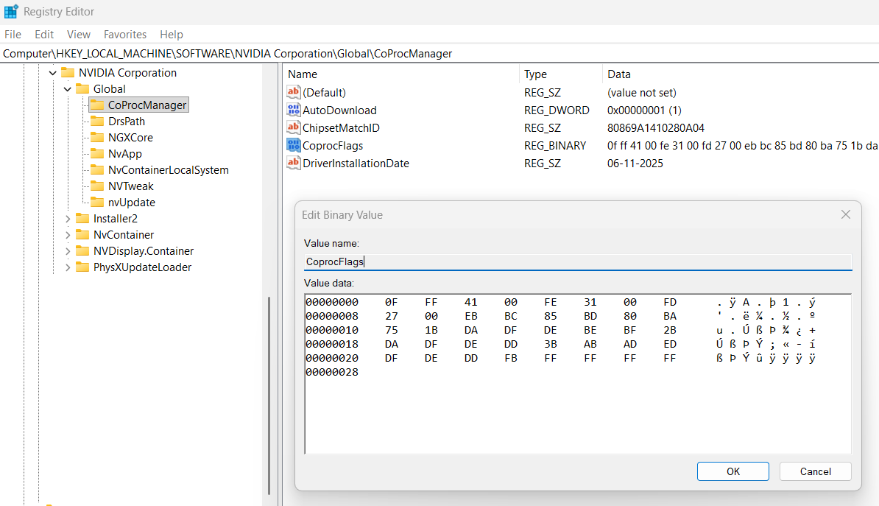
Where we used “0F” for the beginning of the speed of processor code, “FF” for first value, “FE” for the second, FD for the third… After “FF” is instead of “125C” or 4700GHz the maximum speed of the processor – by the Windows reduced speed of the processor. After “FE” there is the “3100”GHz second speed of processor. And after “FD” we can find the 2700 lowest speed of the processor… Then we used the “EB” for the beginning of the coding of the utility of the processor – so there we have:
- “BC” – middle value which is 85,
- “BD” – lower value which is 80,
- “BA” – lowest value which is 75.
Then we need to code the functioning of the processor with the code that represents the changing value as in percentage of the usage of the processor when the need for work is in progress, and we can maybe do it as: “89 87 88 97 99”, but numbers we will use in file only for the speed of the processor and the utilization, so – we will do it over letters… We will code for each of the speed of the processor an extra behavior – dividing the codes with “1B”, “2B” and “3B”…
After “1B” you can find “DA DF DE BE BF” where the “D” is the beginning letter for this particular thing and we will request from the beginning of the speed which is “A” up to “F” for the processor to work as fastest as it can with letter “E” and then it can finish with “F” as a last letter…
After “2B” you can find “DA DF DE DD” and here everything is the same except we used “DD” for the purpose of: “not to repeat the same code and to complete the idea – copy from the first part what goes on after: DA DF DE”…
After “3B” you can find the “AB AD ED DF DE DD” which starts with “A” for the purpose of starting the processor, connecting it’s second speed with letter “B”, then going to the “D” and climbing the processor speed from “A” to “E” – or actually “ED” then going from that state to the “DF” then to “DE” and then we would use the “DD” for the repeating of the previous code “DE DF”…
And it the end you can find the “FB” as a code for finishing the data file and “FF FF FF FF” until the end of the line for empty line…

Old setting:
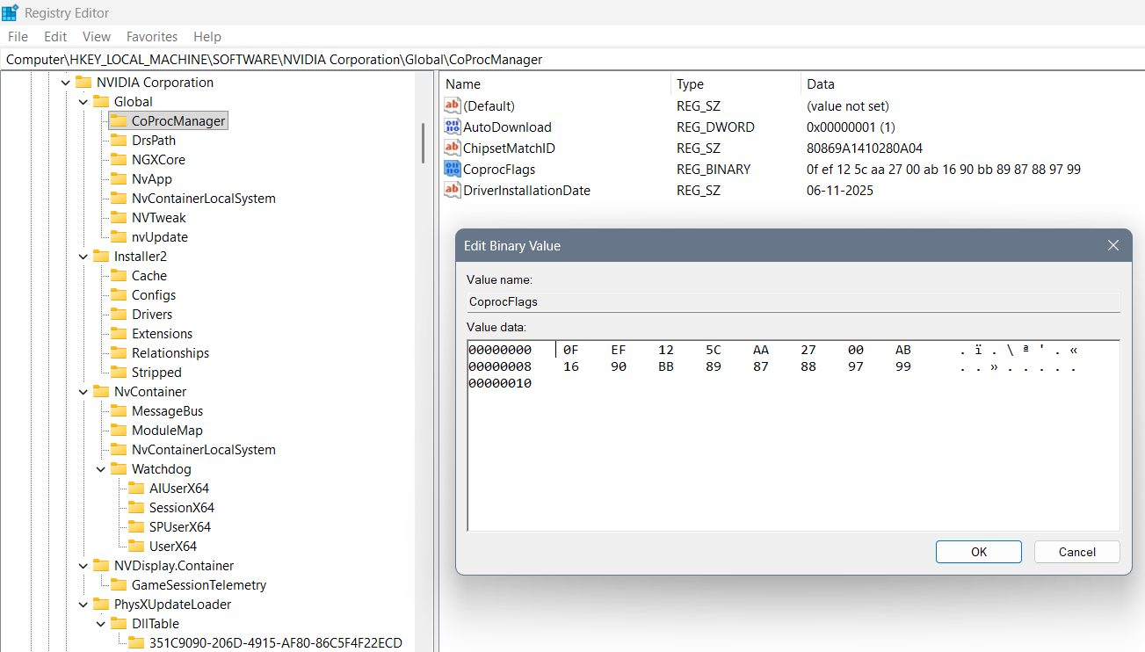
Where we used “0F” for the beginning of the code, “EF” for 3 values that are coming, “AA”, “AB” as their separators of better and worse option… In between “EF” and “AA” is a “125C” or 4700GHz the maximum speed of the processor. In between the “AA” and “AB” we can find the 2700 the middle speed of the processor… In between the “AB” and “BB” we can find the lowest boundary of the processor “1690” representing 1690GHz… In the end we used “BB” for the beginning of the coding of the processor – how it should work… The last code represents the changing value as in percentage of the usage of the processor when the need for work is there: 89 87 88 97 99…
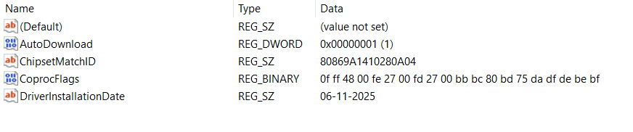
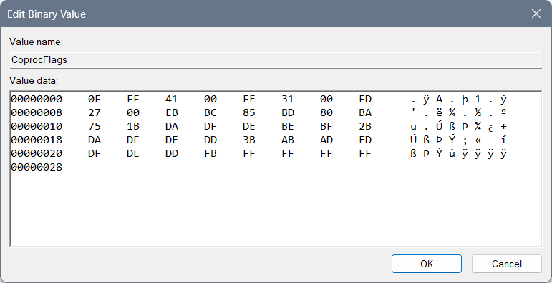

Previously not well created settings:
Where we used “0F” for the beginning of the code, “EF” for 3 values that are coming, “AA”, “AB” as their separators of better and worse option… In between “EF” and “AA” is a “125C” or 4700GHz the maximum speed of the proces
sor. In between the “AA” and “AB” we can find the 2700 the middle speed of the processor… In between the “AB” and “BB” we can find the lowest boundary of the processor “1690” representing 1690GHz… In the end we used “BB” for the beginning of the coding of the processor – how it should work… The last code represents the changing value as in percentage of the usage of the processor when the need for work is there: 89 87 88 97 99…

Other settings:
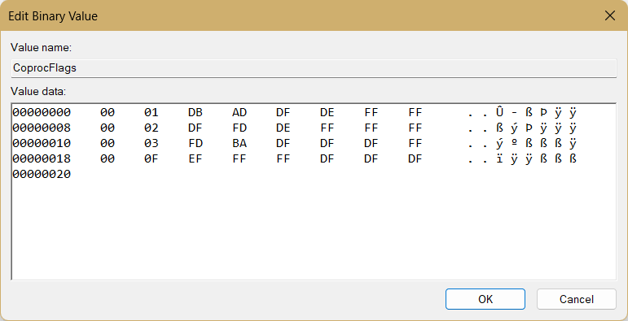
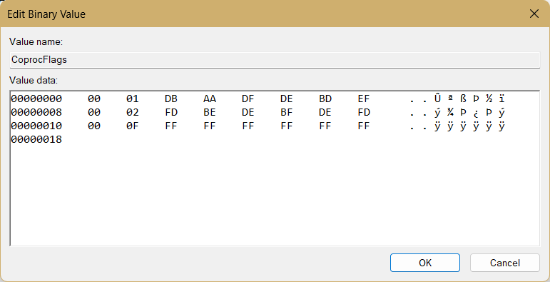
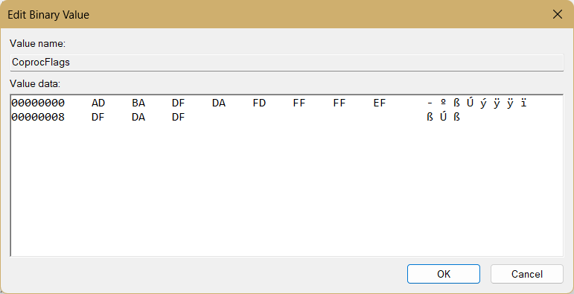
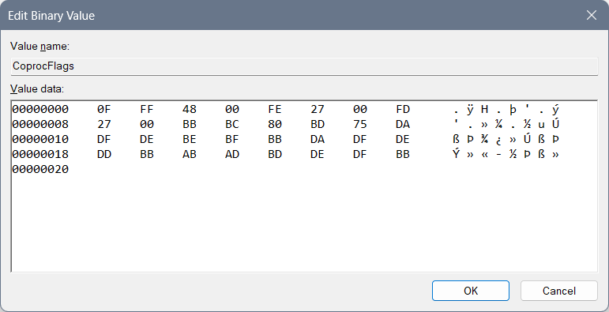
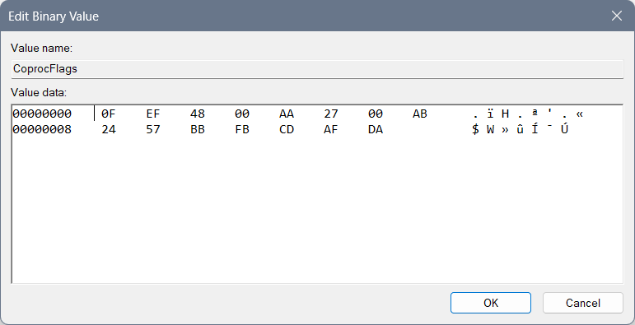
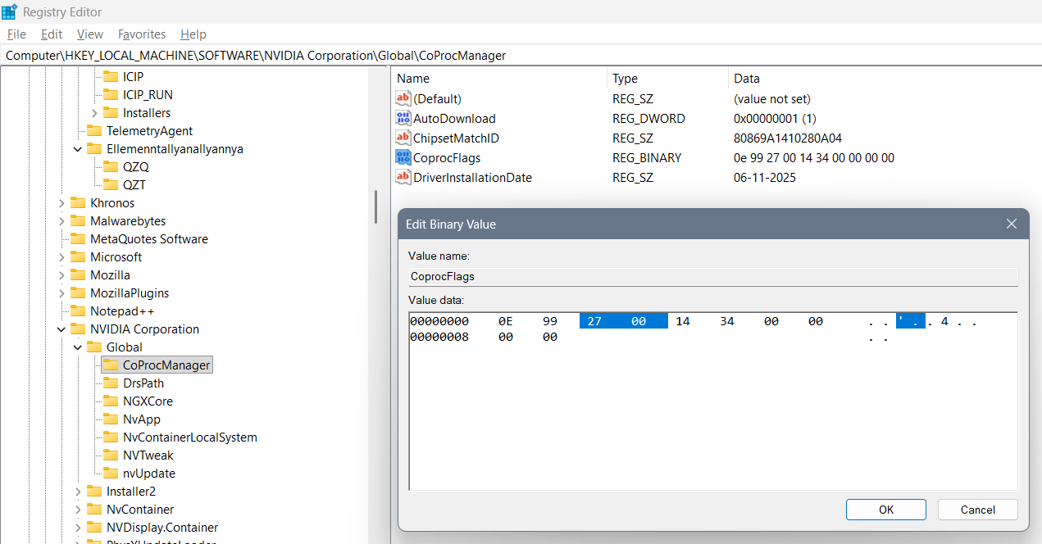
First successful edit of those commands is:
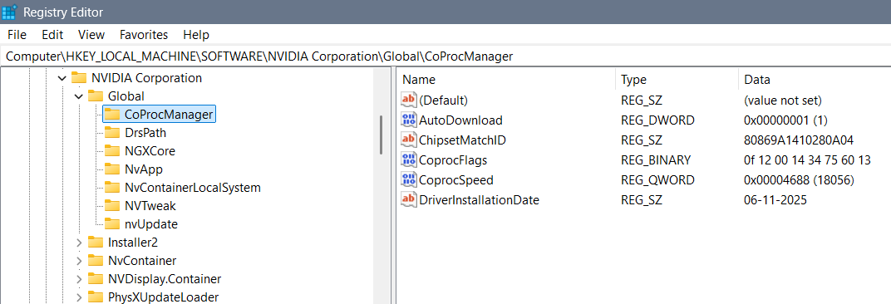
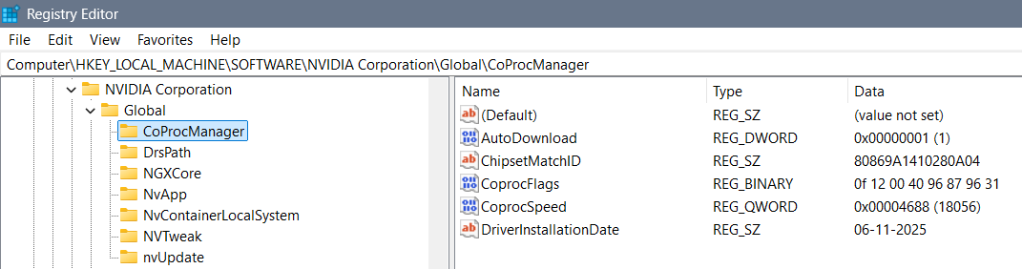
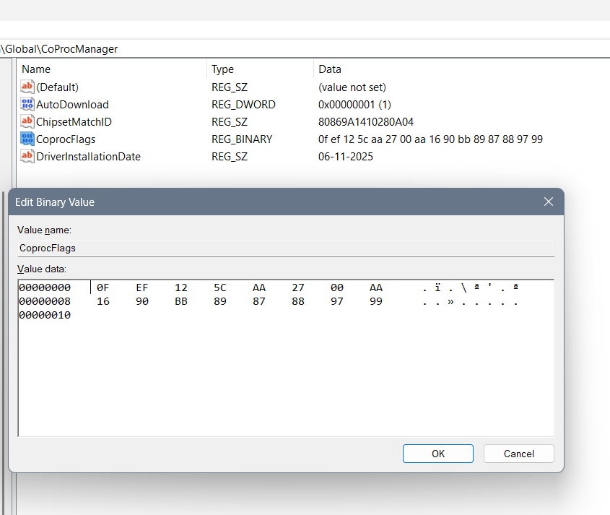
Wrong solutions
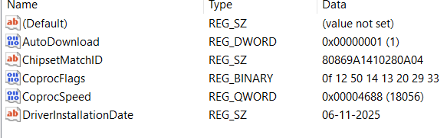

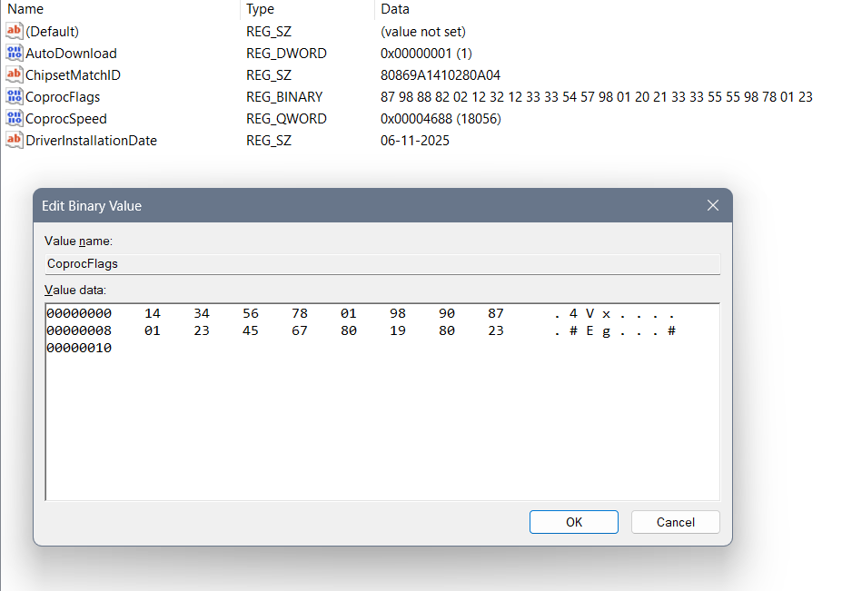

Windows settings
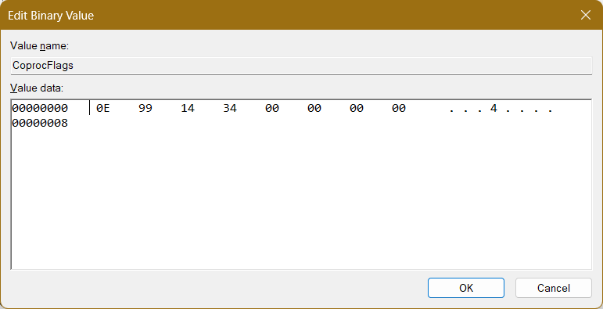
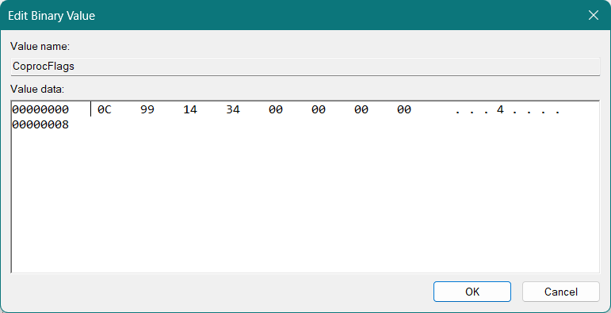

NVIDIA Control Panel 3D settings
Open:
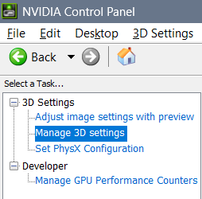

Description
Some values enable more amount of data, some enable the speed of reading them, some data because of that needs a person to think and the data shall be coded for instant response… Those settings are Anisotropic filtering, Antialiasing (Setting – amount of data to be presented and Transparency – for the speed of the data being presented)… Image Sharpening comes with the idea maybe does person sees the data… Also is that data on the level of imagining (as is regular thinking, then dreaming, then imagining), or is it intuitive… Enabling the Override any application setting brings the Display with an idea of only one “Quantum Wall” System – for example: your precious work is always your priority – no matter the obligations in life…

Commands
Ambient Occlusion:
- Off – All possibilities
- Performance – User doesn’t notice the data
- Quality – User notices the data
Anisotropic filtering:
- Off – all possibilities
- 2x – user help
- 4x – user system
- 8x – user only
- 16x – all possible published system
Antialiasing – FXAA: On – cooperation in between user and display (with user thoughts involved)
Antialiasing mode:
- Application-controlled: Applications can pull the system or not
- Off: Both variants
- Enhance the application setting: Work in each of the applications individually
- Override any application setting: Work only thinking on one thing in all of the applications
Antialiasing Setting:
- application controlled
- 2x – user help
- 4x – user system
- 8x – work with user
Antialiasing – Transparency:
- Off: Any kind of speed
- Multisample: extremely slow speed of showing data
- 2x – supersample: slow showing of data
- 4x – supersample: fast showing of data
- 8x – supersample: extremely fast showing of data
Background Max Application Frame Rate:
- I believe regular speed and finest is: 35 FPS
CUDA – System Fallback Policy:
  - I find more natural Quantum Wall only
- Driver Default: Both Display and Quantum Wall
- Prefer System Fallback: Quantum Wall
- Prefer No System Fallback: Display
Low Latency Mode:
- Off: User knows nothing
- Ultra: User has available insight in the data of coded Quantum Wall
Max Application Frame Rate:
- I believe regular speed and finest is: 35 FPS
Multi-Frame Sampled AA (MFAA):
- On: Through past future (“ralloxar”)
- Off: Only “now” (at the current moment of a changeable past and future)
OpenGL GDI compatibility:
- Prefer Compatible: goes with Prefer System Fallback – Quantum Wall
- Prefer Performance: goes with Display
- Auto: goes with Display
Power Management Mode:
  - I prefer Maximum Performance for enabling Quantum Wall
- NVIDIA Driver Controlled: Turns off Quantum Wall
- Prefer consistent performance: Display
- Prefer Maximum Performance: Enables Quantum Wall
Shader Cache size:
- Driver Default: Enables Quantum Wall
- Disabled: Disables Quantum Wall
- Unlimited: Enables Quantum Wall
Texture Filtering – Anisotropic Sample Optimization:
- On: Quantum Wall works normally
- Off: Quantum Wall knows to create order for work (for example)
Texture Filtering – Negative LOD bias:
- Allow – Quantum Wall data is hidden
- Clamp – Quantum Wall data is seen
Texture Filtering – Quality:
- High Quality: too strong, so Quantum Wall enables “Wishes” and behaves strangely
- Quality: Quantum Wall works fine
- Performance: Quantum Wall doesn’t work
- High Performance: Quantum Wall doesn’t work
Texture Filtering – Trilinear Optimization:
- Off: Quantum Wall works poorly
- On: Quantum Wall works fine
Threaded Optimization:
- Off: One thought at the time
- On: All thoughts are fine
Triple Buffering:
- Off: System lets user free
- On: Quantum Wall Works while system holds user
Vertical Sync:
  - Works fine with: “Triple Buffering: Off”
  - I believe that by feeling of display on the level of imagining user can choose between half refresh rate or full refresh rate
- Adaptive (half refresh rate): User has lied system (on 35 Hz)
- Adaptive: I believe works not fine for me
Virtual Reality pre-rendered frames:
  - I prefer option “3D application setting” (for hired ones) or “4” for free reading
- 1: user needs to read everything from quantum wall
- 2: user reads that is interested in
- 3: user doesn’t need to read anything
- 4: user reads everything when one wishes
- 3D application setting: When something fits within the work user reads it then (option is similar to the job – so user is considered hired)
Vulkan/OpenGL present method:
- Prefer native: Quantum Wall doesn’t show data well
- Prefer Layered on DXGI Swapchain: Quantum Wall works fine

Settings

NVIDIA settings for “Endless work of Tephlon” (“Tephlon in work”):

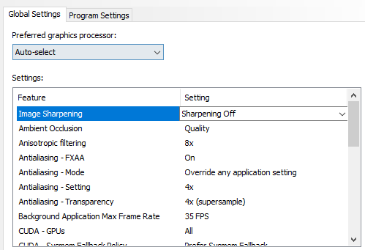
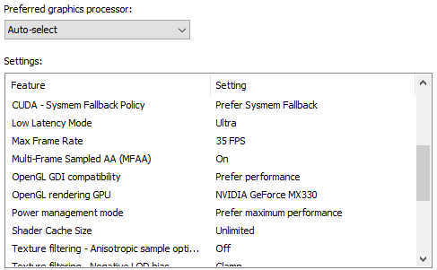
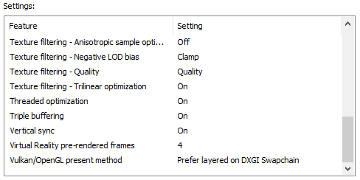

Nvidia settings following Intel “Endless Work” settings:
- Intel “Endless Work” settings:

Following Intel Registry Editor settings (CFCA - “Cenntraffacya” settings)
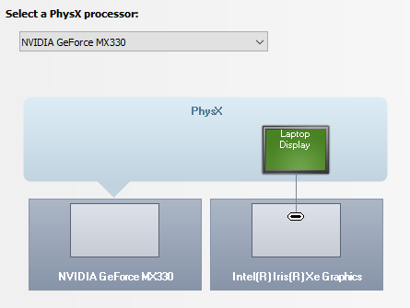

My latest profile
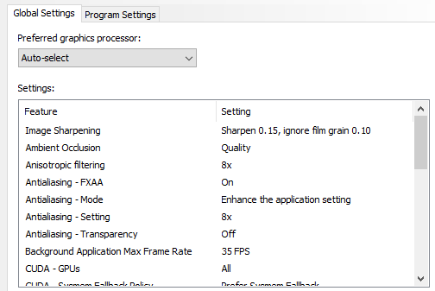
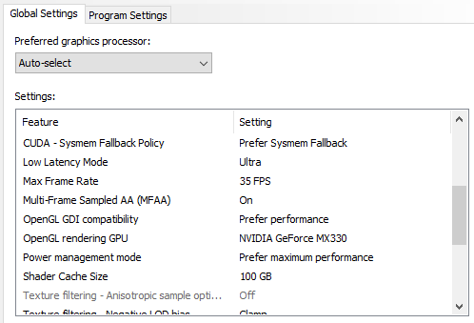
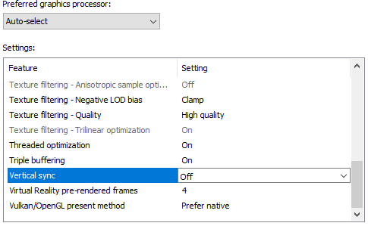
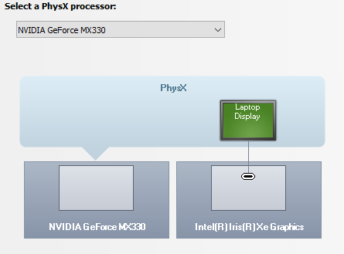

“Greenbrand” profile
- Profile is used with the Intel “Greenbrand” profile
- I noticed that creating both graphic cards active brings actually a suitable result for “Quantum Wall”
- This time the Color management options remained default of Windows without editing the Color profile concept
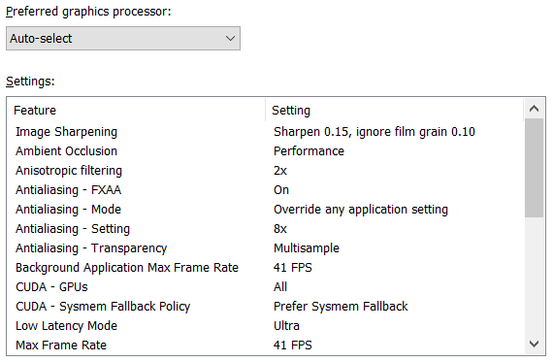
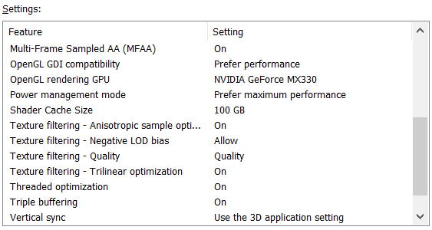
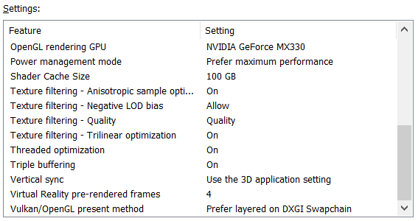
- Also I needed to enable only NVIDIA PhysX processor (besides the CPU option)
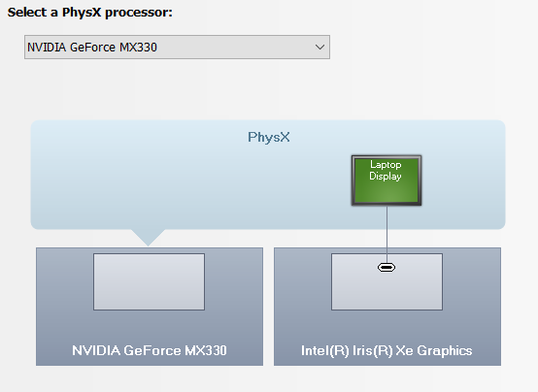

Ekta Space profile:
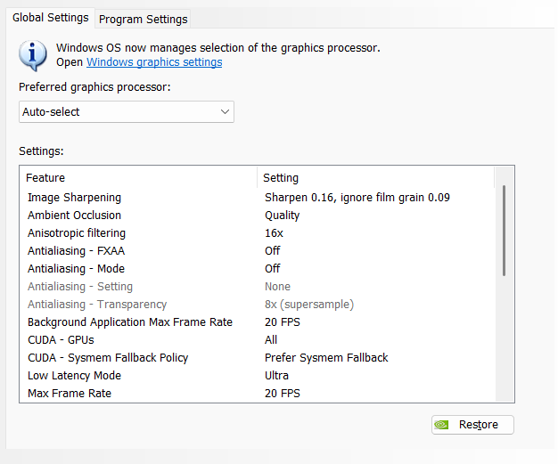
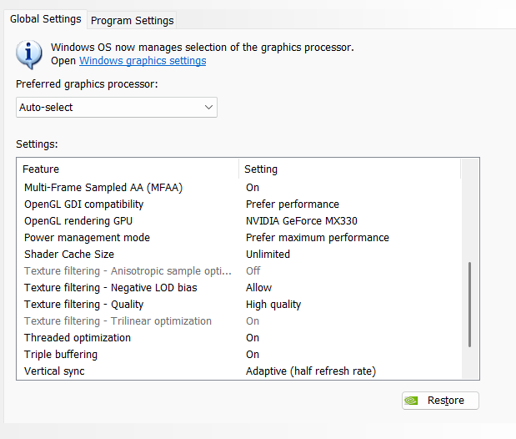
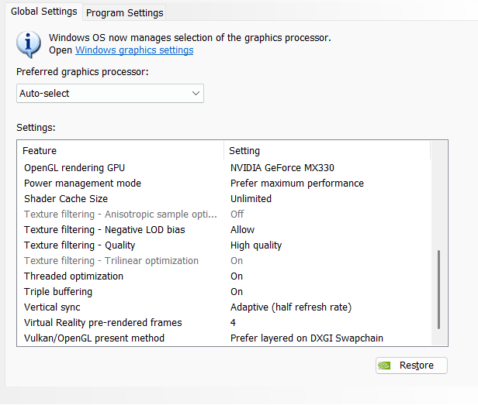

Old settings:
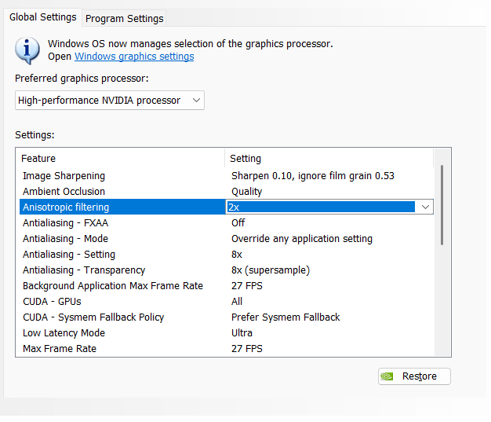
More free roaming around then following simply the job is With “Anisotropic filtering” set to “2x”…
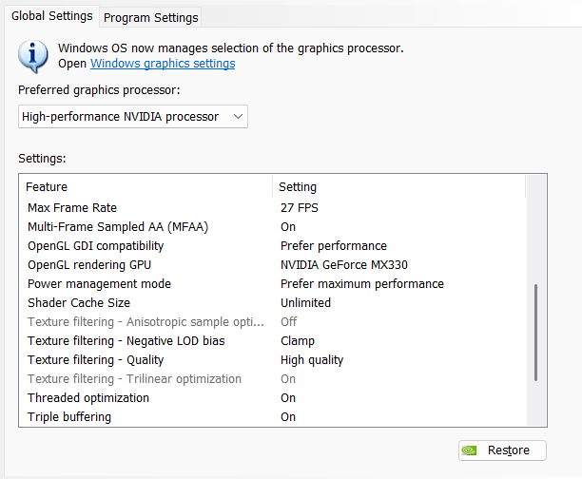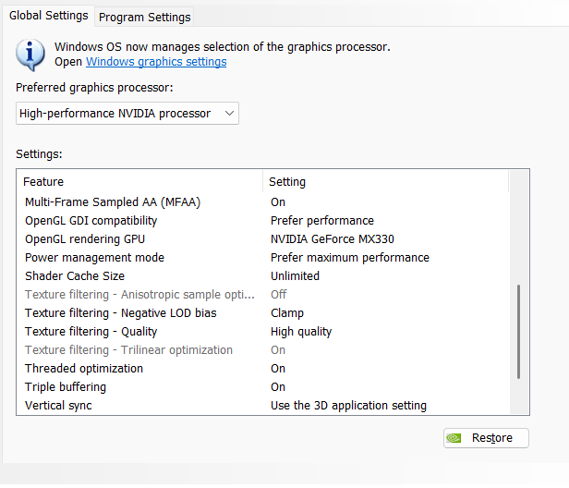

My old intuitive understood favorite settings
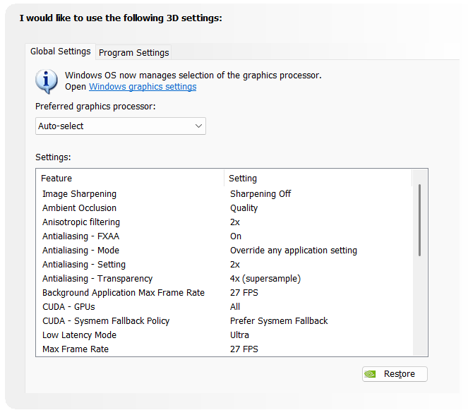
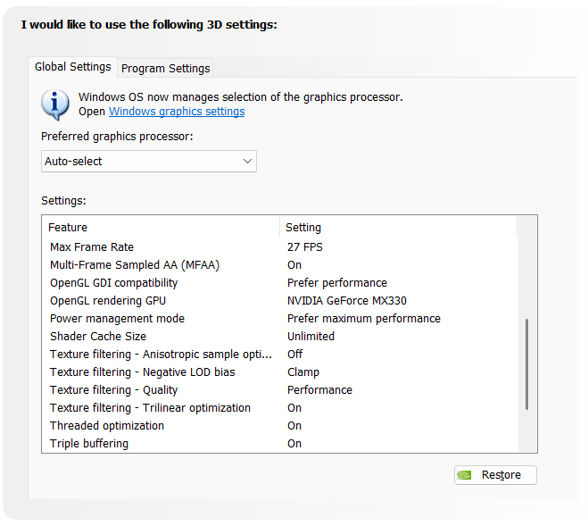
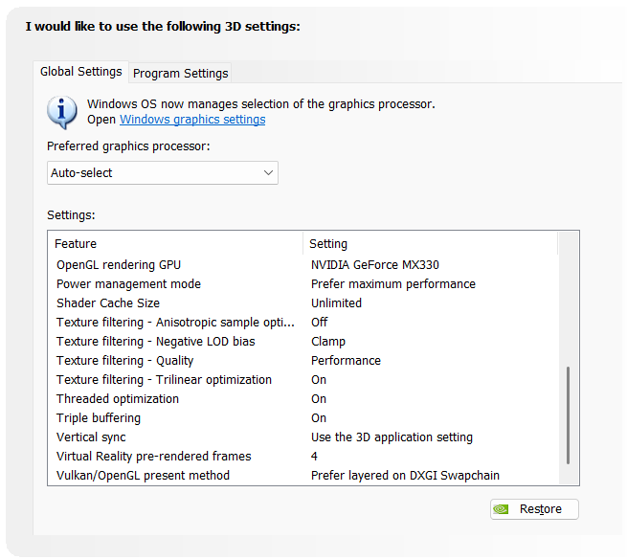

Then “irregular” settings are:
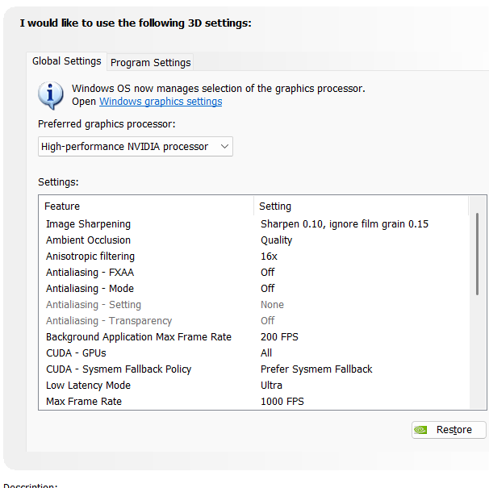
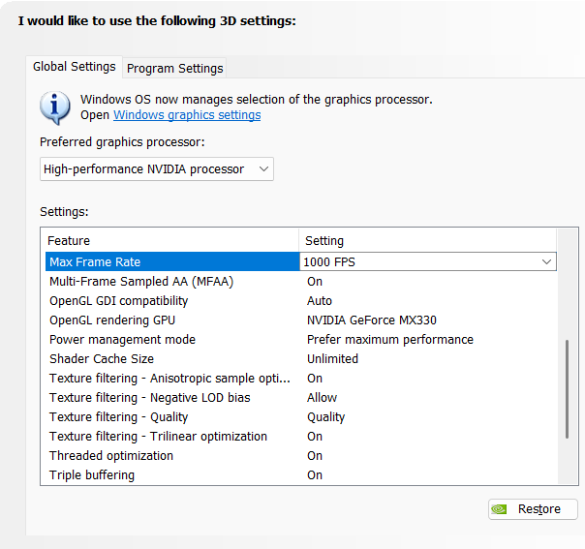
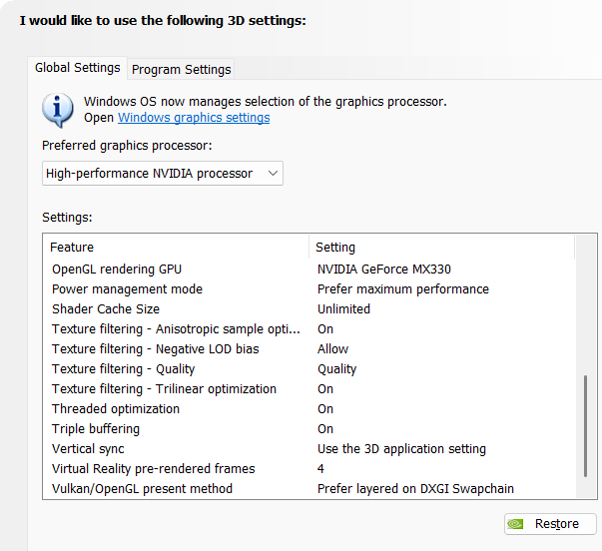

Some maybe unimportant and not fully retested opinion on some settings:
- “Ambient Occulsion: Quality” setting – never goes with “Antialiasing”, so, then, all of the “Antialiasing” settings are set to “Off”
- When “Ambient Occulsion: Off” we can set “Antialiasing” setting “FXAA” – “On”, but Mode to “Override any application setting”, Setting to “2x” and Transparency to “2x” or “4x”… When Transparency is set to “8x” on the level of imagining nothing appears…

With “Ambient Occlusion” settings turned to “Off” settings are:
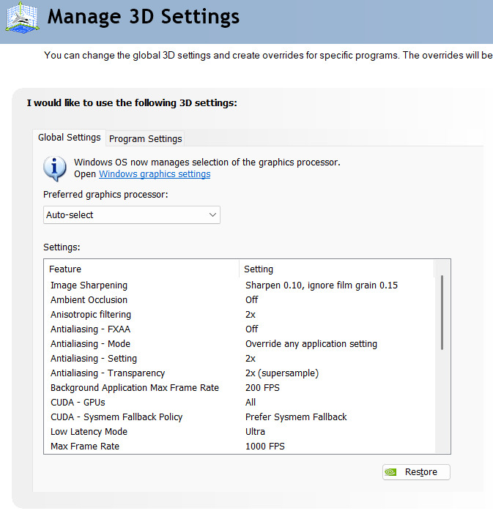
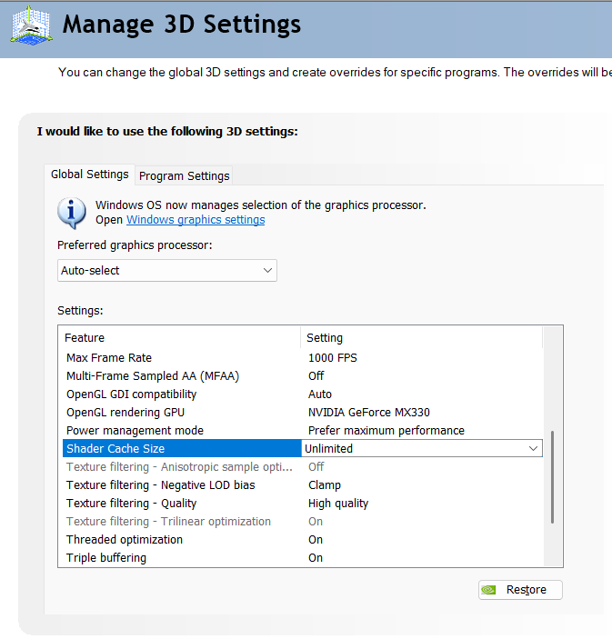

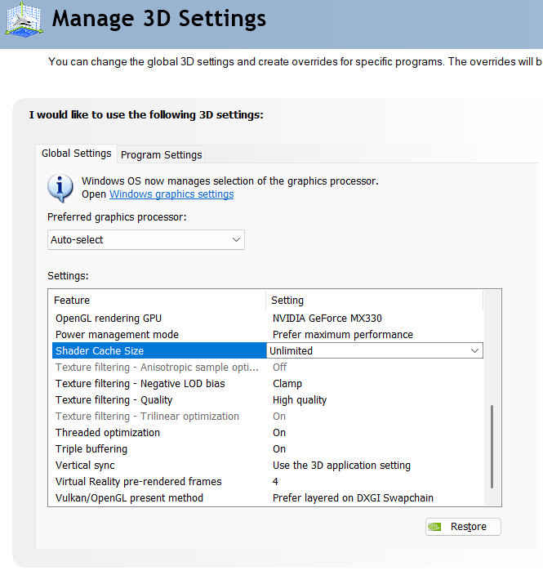

Color Mangement profiles

Find “Color Management” application:
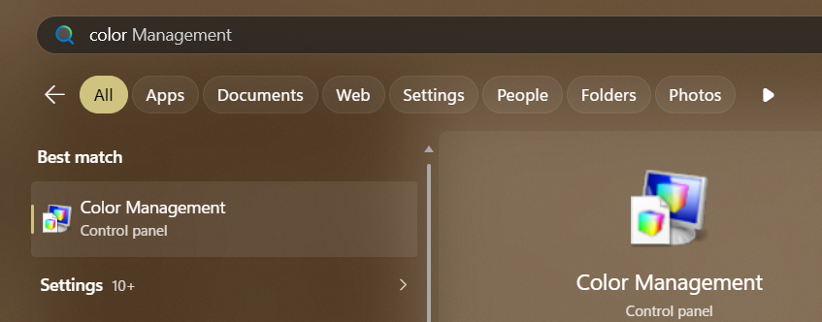

Click “All profiles”:
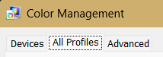

Click “Add” and find folder with all profiles, select them and add them:
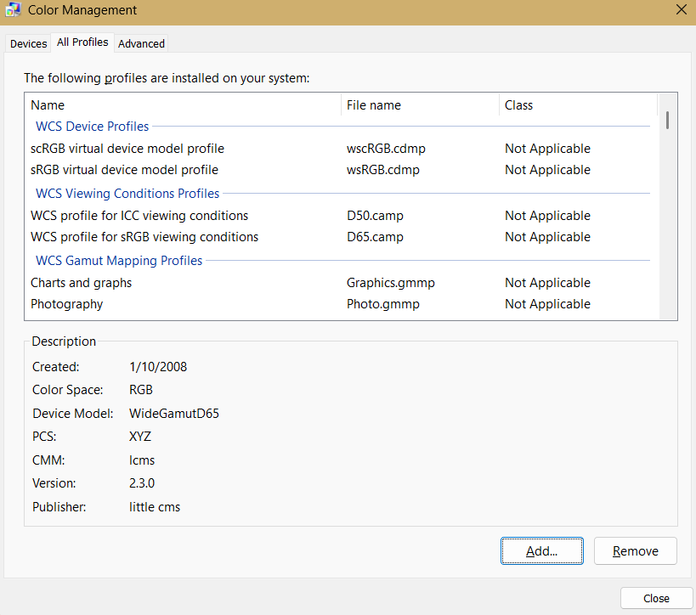

Go to Advanced settings:
My suggestion is “Chemical proof” profile....

Windows default profile, following Intel CFCA profile
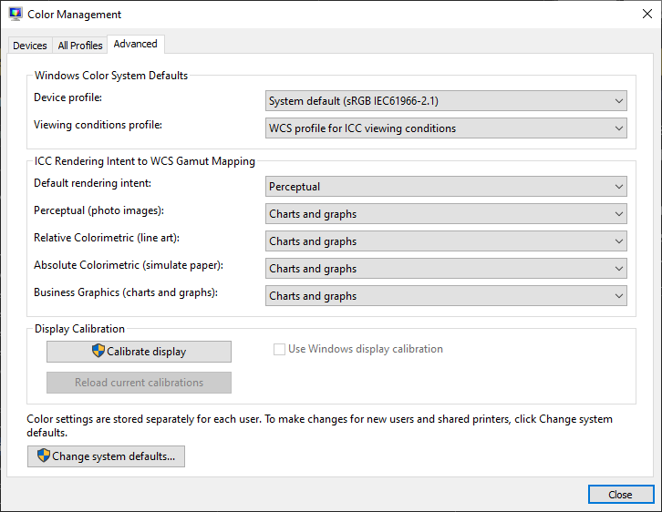

Windows default profile, a bit edited is:
- Profile works well for using it with “Quantum Wall”
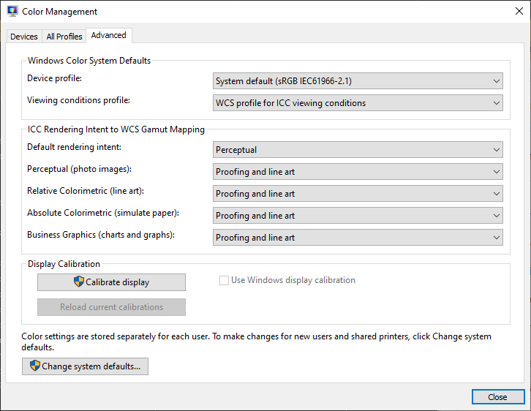

Different beings universal profile is:
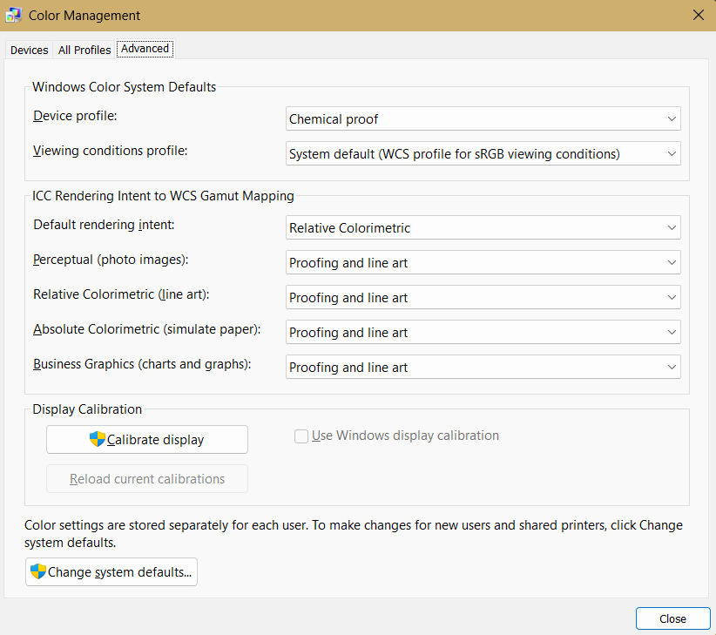

A more human-like primitive profile is:
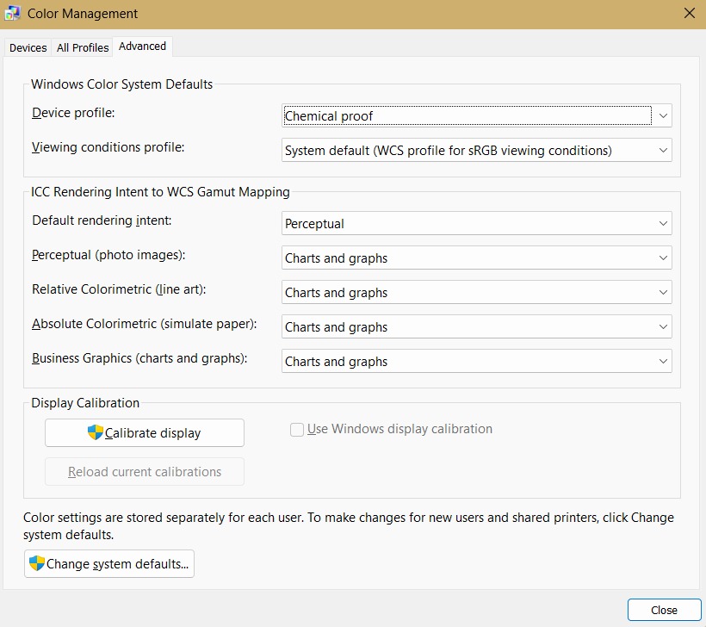

My back at the time personal following color management idea:
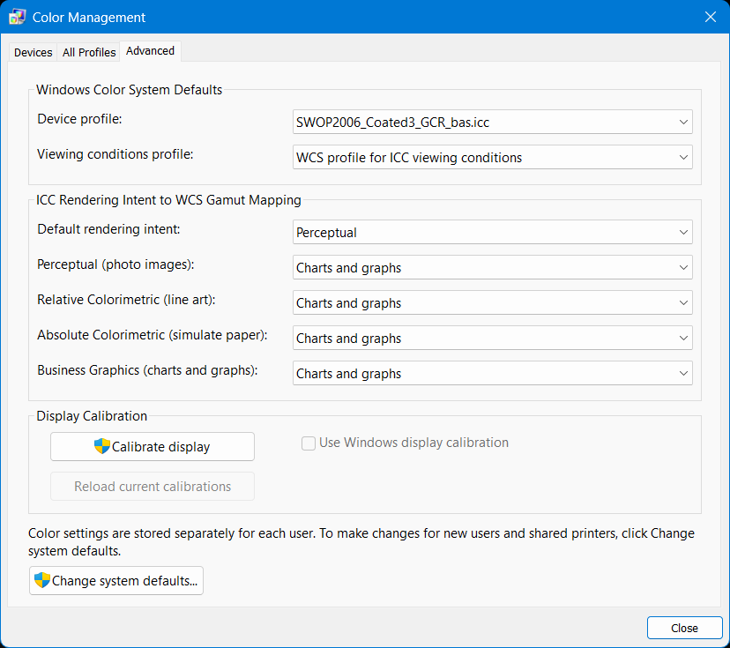
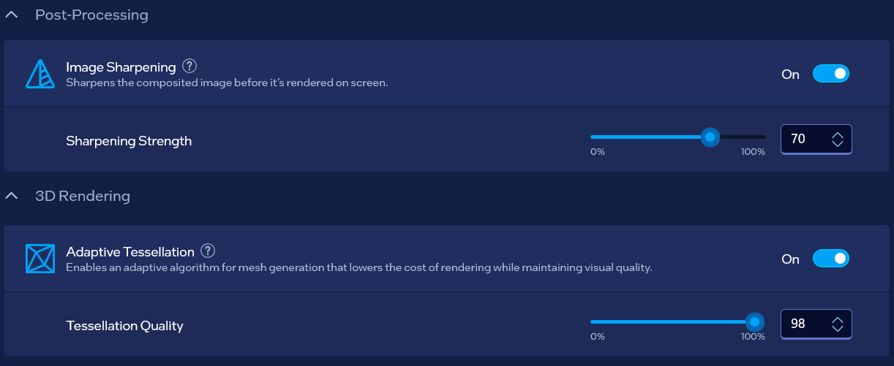
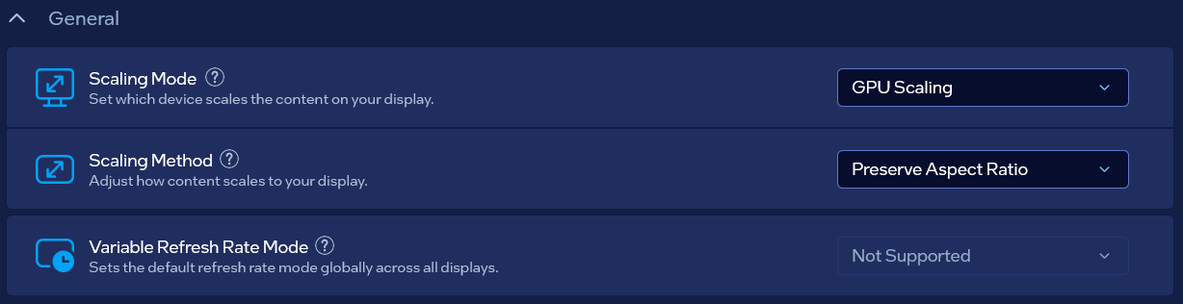
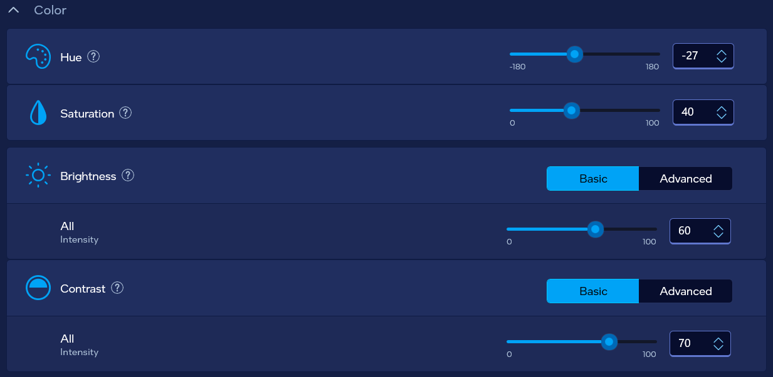

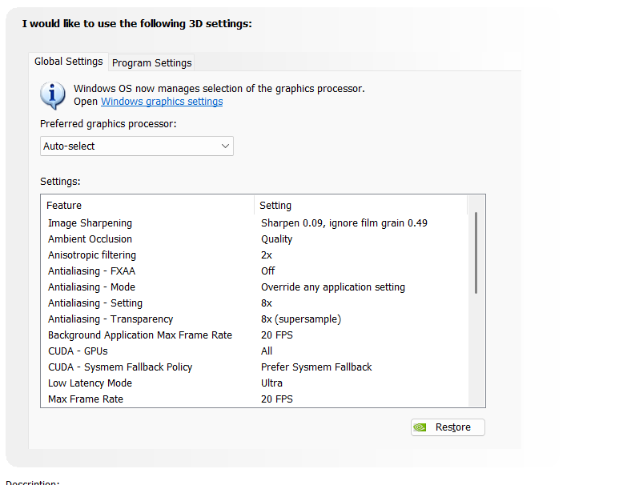
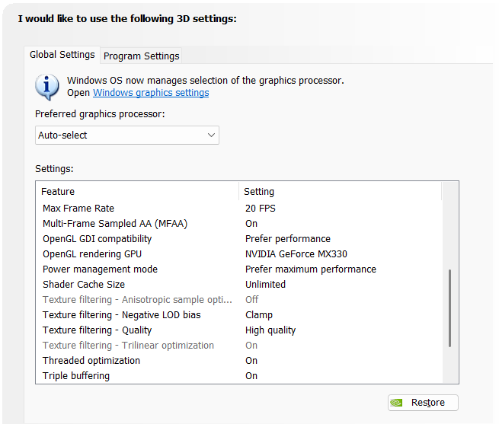
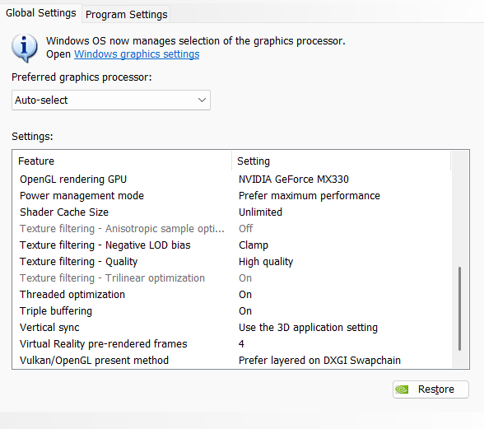

Result

Processor speed when graphics cards are working: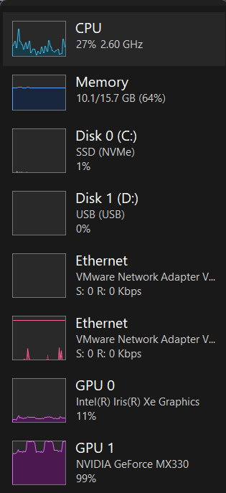
Processor speed when graphics cards are not working:
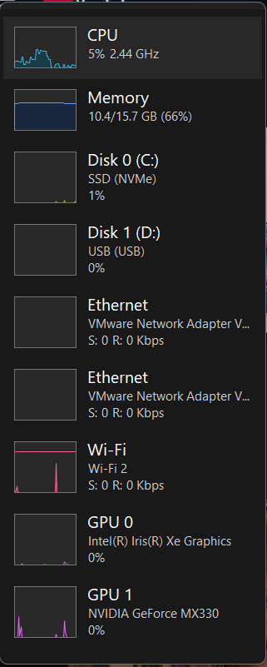

Special thanks
Special thanks to the Cosmos joke of the creator which represents ExollynyStawrya (belonging to AllyStawrya beings) greatest thinker named “Razymodu”…
Support me at:
www.buymeacoffee.com/downness
www.paypal.me/downness

